Indian Overseas Bank Finacle Implementation Project - Finacle End User Training Manual

###### Table of Contents

1. OVERVIEW OF FINACLE – A CORE BANKING SOLUTION 4
2. LOGIN TO FINACLE 5
3. SSO (SINGLE SIGN ON) 8
4. USER MAINTENANCE (In FINCORE) 10
5. LIST OF SCHEME TYPES IN FINACLE 16
6. CUSTOMER RELATIONSHIP MANAGEMENT 17
7. INVENTORY MANAGEMENT 25
8. TRANSACTION MAINTENANCE 33
9. SAVINGS BANK SCHEME 40
10. CURRENT ACCOUNT 43
11. HANDLING VARIOUS TYPES OF OPERATIONS IN AN ACCOUNT 45
12. ACCOUNT LIEN MAINTENANCE 53
13. OVERDRAFT ACCOUNT 54
14. TERM DEPOSIT 56
15. STANDING INSTRUCTION 61
16. POOL CONCEPT THROUGH HSWEEPS 63
17. LOAN 68
18. COLLATERAL MAINTENANCE 82
19. COMMERCIAL LOAN 86
20. GUIDE TO SYNDICATED LOANS 101
21. LIMIT NODES 104
22. TEMPORARY OVERDRAFTS 110
23. CLEARING 114
24. DEMAND DRAFT 136
25. BILLS 143
26. SWIFT 151
27. ASSET CLASSIFICATION 156
28. FORWARD CONTRACT 159
29. BANK GUARANTEE 164
30. DOCUMENTARY CREDIT 172
31. SIGNATURE VERIFICATION SYSTEM (SVS) 205
32. GENERAL LEDGER BALANCE PRINTING 211
33. GENERAL INQURIES RELATED TO CUSTOMER / ACCOUNT 213

## OVERVIEW OF FINACLE – A CORE BANKING SOLUTION

**Finacle is an integrated, web centric, enterprise banking system designed to provide the "e platform" for the global banking industry.**

This complete web-enabled solution is a centralized, multi-currency, multi-lingual, functionally Rich solution that addresses the retail and corporate banking requirements. Anywhere, AnytimeBanking is possible through Finacle.

**Centralised Database**:The data of all the branches covered under the project will bestored at one place called Data Centre. In effect, it means that all the operations at the connected branches shall take place at one place i.e., Data Centre.

**Enhanced Security** features can be implemented as Server is located at one place andaccess control can be effectively managed on need to know basis.

**Back Office functions:** The branches which will be called Service Outlets (SOLs),Finacle Software will not need to take backup as the same will be done at Data Centre. Many of the back office functions will be handled at Data Centre only.

**Effective MIS:** As the data of all connected branches shall be located at one Centralisedlocation, the MIS information can be extracted without the same being provided by branches. The branches can be spared the burden of providing information by way of returns/reports etc.

**Integration with Core Module:** Integration of CRM, Loans Originating System, e- Channel (various facilitates delivery channels like Internet Banking, ATMs etc.) with the Core Software.

This Software is functionally rich and caters to almost all the facets of banking. Some of the salient features of the Software are as follows:

* Every customer of the branch is now a customer of the bank, as all the customers will have unique customer ID across the bank.
* The Software encompasses all the retail functionalities like Savings, Current, Cash Credit, Overdraft, Term Deposits, Term Loans, and Safe Deposit Vault etc. The security features include Maker-Checker Concept, Audit Trail etc.
* Business can be leveraged to suit ever-changing needs like introduction of pooled accounts, commercial loans, loan syndication, multi-currency etc.
* Trade Finance module includes Inland/Foreign Bills, Documentary Credits, Guarantees, Remittances, shipment Credits and Forward Contracts.

5

* Customer Relationship Module (CRM) - Loans Originating System (LOS) supports initiating account opening process at the backend.
* E-Channel to support various delivery channels like Internet Banking, ATMs etc.

## LOGIN TO FINACLE

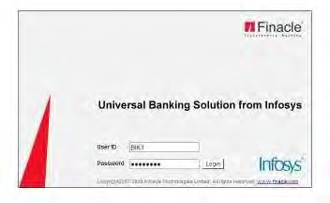Double Click on Internet Explorer Icon. The following screen will appear: The userId and password are case sensitive.

Type your User-ID against the User Name block and press <Enter> or TAB

Type your Password and click on Login box. Upon successful login, the following screen will appear:

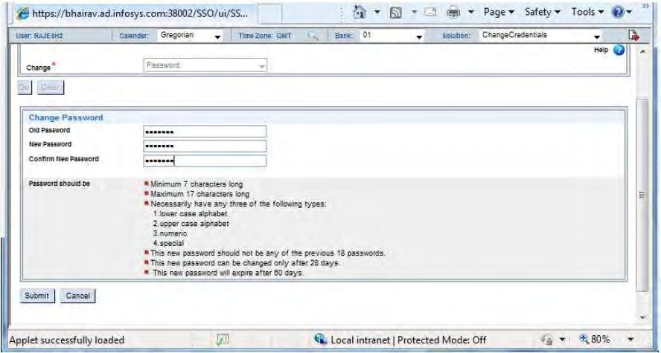

The user has to enter the initial password and then the new password and confirm the same.The minimum requirements for the password should be :

1. Minimum 7 characters long
2. Maximum 17 Characters long
3. The password should necessarily have any three of the following types:
   1. Lower or Upper Case Alphabet,
   2. Atleast one Numeric Character and
   3. At least one Special Character.
4. This new password should not be any of the previous 18 passwords.
5. This password can be changed only after 28 days.
6. This new password will expire after 60 days.

The user has to log out of the system and then login to the application with the new password.

The user has to click on the Finacle Core banking button and once the user clicks on the core banking button then the following screen is displayed:

**NEVER USE THE BACK BUTTON ON THE BROWSER AFTER LOGGING IN. IT WILL TAKE YOU OUT OF THE LOGIN SESSION.**

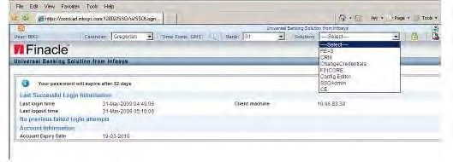

User should select the MODULE name from drop drown to which one has to work on. For accessing to different operations within SSO framework the user should have been

given access rights to Administration.

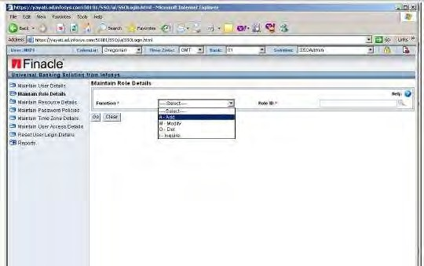

The system displays the logged in user id on the right hand top corner. It also displays brief details of the Password expiry, last login information of the user.

To logout from the application, the user has to click on <Logout> link.

## 3. SSO (SINGLE SIGN ON)

Single sign on framework enables the application users to access multiple applications through a single login id and password. All the login related validations happen in SSO. Single Sign on (SSO) framework enables application users of Finacle suite of products (Finacle Core and CRM) to log in once and get authenticated to each application for which the user has the valid user id and access permissions.

SSO being an authentication framework that works with unique user ID, would use only one schema and database even when each Finacle solution integrated in SSO could work with multiple schemas. Entity ID‟s would be stored in SSO database by the Finacle Installer as seed data. In SSO database, User would be mapped to an entity ID.

The sequence of processes is given below :

* Role Definition
* Password policy configuration
* User Creation
* Assigning of Roles to the users
* SSO profile creation
* Assigning Access rights to SSO administration and applications
* Creating user profile for the application
* Password changes for a user
* User id management(Resetting login attempts, login attempts and password changes)
* Report generation(Audit, User and Role based reports)

1. **MaintainRoledetails:**

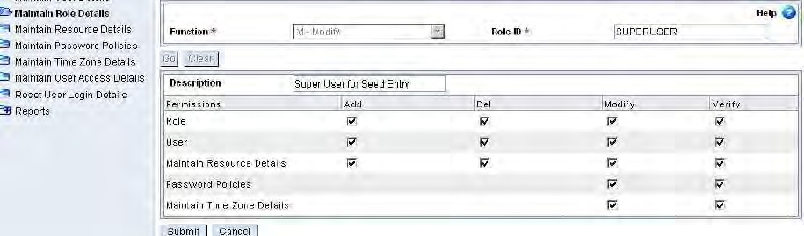

**PERMISSIONS:**

Permissions can be defined for Role, User creation, Resource and Password configuration functions of SSO.

This enables the user to define the privileges available to the user with the specified Role. Permissions can be defined for Role, User, Resource and Password configuration functions of SSO. The tabs available within Administration tab are dependent on these permissions. To get access to a specific tab at least one of the functions within each process should have been checked.

1. **Maintain User details: Maintain Role details**

Creation of user/Role/Resource can be done through SSO Admin only at data centre

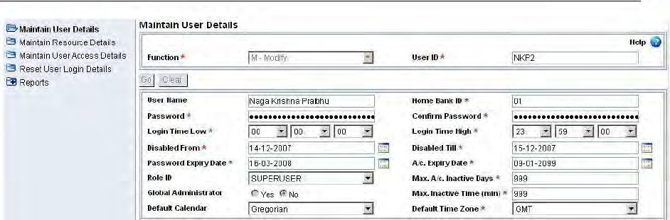

Maximum Inactive Time: Specified in minutes. Maximum is 999 minutes. This is for specifying the idle time after which the user is automatically logged out of the system. Global Administrator: Yes/No.

FEATURES:

* SSO profile for the users
* Password policy configuration
* Resource allocation to multiple applications User Profile management
* Toggling across multiple applications in a single SSO login session Verification process for creation/modification
* Report generation –Audit of activities, User and Role based Reports Default login page after successful login

LOGGING OUT OF THE APPLICATION

To logout from the core application, click on the logout icon. When the user clicks the Logout button, then the system logs out of the core application. If the user wants to log out of SSO Login then the user has to click on to the logout icon on the top.

###### The Background Menu

Click on the Background button on the top of the bar. The Background Menu as shown in the Screen below will be displayed. The user should enter the choice at the “Make or print a report generated.

For quitting the Background Menu the user should click MENU Button on the top of the bar.

## USER MAINTENANCE (In FINCORE)

##### WORK CLASS

Each user is associated with a work class. This work class is also associated with each of the menu option available in the application. Since this work class is associated both with the user and the menu, access rights for a particular person or category of persons can be decided using this feature. Different persons in the same category can be assigned with different responsibilities with reference to the application by assigning different work class.

ROLE PROFILE MANAGEMENT

This enables the user to define the privileges available to the user with the specified Role. This is maintained in Role Profile Maintenance (HRPM) which is discussed in detail in Master Data.

All the possible roles (e.g. manager, clerk etc.) in the bank are created using this menu option and are assigned to the user profiles. Access to the scheme types, scheme codes, GL sub head codes are specified here and also the images and currencies to which these roles should have access are specified. This is defined through the menu option HRPM.

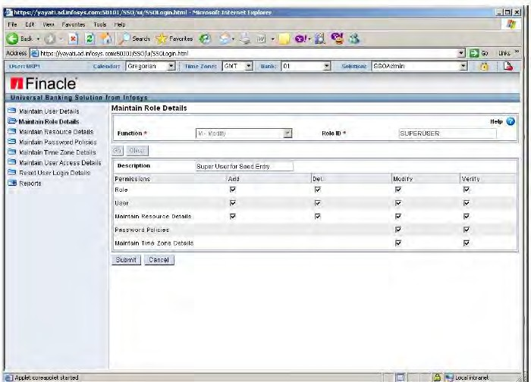

System Administrator has the right to create ROLE ID for different user .Click on <Role Administration> to create new roles.

CAPTIVE

The user with a captive status can access the data belonging to any service outlet but can put throughhis transactions on the accounts belonging to the SOL to which he is attached to.

FREE

The free user can access the data belonging to all service outlets and put through transactions to accounts of all the SOLs. Accessing all menu options depends on whether the menu is free or not.

USER ID VERIFICATION

Once the user / Role has been created or modified, verification process is required for authentication of activity.

During first time login by the user the system forces the user to change the password.

CORE USER PROFILE CREATION

This facility is available in case the User is created and given permission for Finacle core application Through SSO framework.

For creation of user for Finacle Core application, the following set ups should be available:

* Employee record creation
* Role Profile creation
* Certain reference codes set up. (Work class like Manager, Clerk, Officer etc.)

EMPLOYEE FILE MAINTENANCE

The employee id is created using the menu option **HEFM** of Finacle Core and The employee ID created in EFM should also be present in SSO user list. One can access Finacle Core by clicking of Finacle Core tab

USER PROFILE CREATION –HUPM

Any user who wants to log into the FINACLE CORE application should have a valid SSO user id. This user id is created using SSO Admin. And again same user has to be added in Finacle core through menu option **HUPM** of Finacle Core for access into core banking functionality

The creation and maintenance of the user record for Finacle core application is handled through the menu option HUPM of “Fincore‟. This record contains all the information on the user with regard to his/her branch, work class etc.

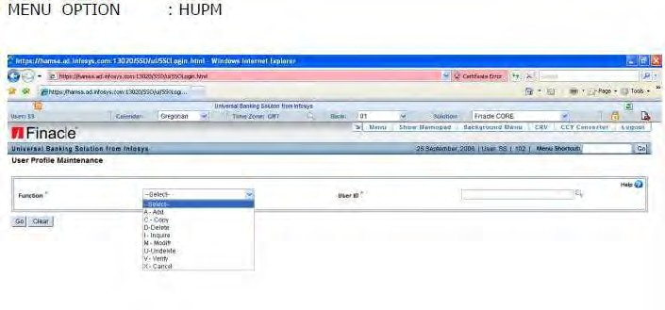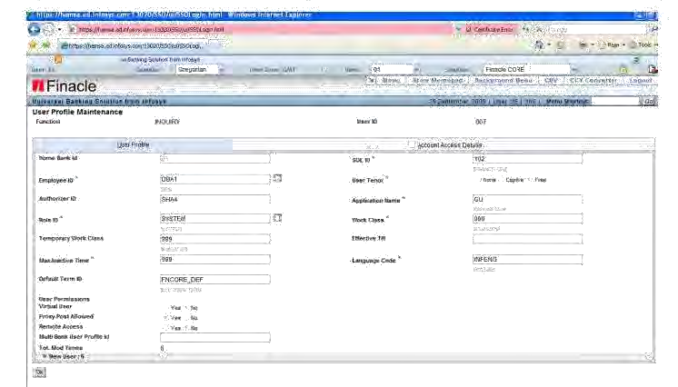

DELETING FROM FINACLE USER LOGIN - HSAC

If the user accidentally/ forcefully closes the Finacle active window or system throws an error then the same user cannot login to the Finacle Core again and will show the message:

“User already logged in”.

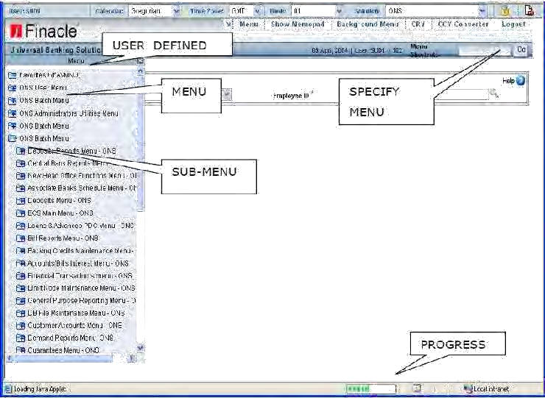Then another officer who has the access right can forcefully enable the login status by deleting the USER from the active list using the Menu HSAC.

PROGRESS INDICATOR

This is a small rectangle at the end that indicates the progress of the operation the

system is currently performing.

##### FAVOURITES

Left side of the user menu is for favourites list. User can have the list of frequently used menu options in the favourites. Copy the menu option that is frequently used and paste the same in the favourite's list.

**Use Ctrl+C for copying and Ctrl+V for pasting in the favourites list**.

|  |  |
| --- | --- |
| **KEY MAPPING** |  |
| **Actions** | F e a t u r e Hot Keys |
| Click (Maximum Usage) | Mouse |
| Go /OK/Ac c e p t | F4 |
| Cancel /Ba c k | F3 |
| Signature | F9 |
| Submit | F 1 0 |
| Maximized Windows | F 1 1 |
| Visit Particular Tab | Ctrl+Alt+ Under lined alphabet |

## LIST OF SCHEME TYPES IN FINACLE

SCHEME TYPE

|  |  |
| --- | --- |
| SBA | Saving Account |
| CAA | Current Account |
| TDA | Term Deposit Account |
| CCA | Cash Credit Account |
| ODA | Overdraft Account |
| LAA | Loan Account |
| OAB | Office Account Basic |
| OAP | Office Account Pointing |
| FBA | Foreign Bill Account |
| PCA | Packing Credit Account |
| HOC | Head Office |
| OSP | Office Account System Pointing |
| DDA | Demand Draft |
| OAD | Office Account Dummy |
| CLA | Commercial Lending |
| BIA | Bills Inland Customer related |
| TUA | Top up deposits Customer related |

## CUSTOMER RELATIONSHIP MANAGEMENT

**OVERVIEW**

When an individual starts a relationship with the bank by availing its products and or services, he is known as a CUSTOMER.

Finacle is a customer centric solution. All products and services offered in Finacle are built around the customer. The Customer Information File where all the information about the customer is stored. The information can be customer‟sbasic data, segmentation, products & services offered to customer, customer preferences, financial details, related parties, assets and liabilities, interests, hobbies and so on. The data relating to these should have access through various backend. So, instead of capturing the information in multiple back end systems, it is maintained at a common CIF database in Customer Relationship Management module and linkage is provided to all the required back end systems.

Every individual (retail) and business (corporate) customer bears a unique identity signified as CIF ID. This gives a global flavour to conduct business transactions across geographies, systems, channels, products, at all times. This ID is created for the customer in the bank's database. This CIF ID is subsequently used by the Bank to provide all types of products and services to the customer. On creation of the CIF ID, the customers can perform banking transactions such as depositing money, availing loan, credit or debit card or any other product of the bank. The CIF system helps the bank to know the details of the individuals with whom they maintain certain relationship. CIF creation is about capturing the details of the individual / corporates, doing the required validations and storing it in the Bank‟s database for future reference. The whole bundle of customer- related information thus captured is available in the CIF module of the CRM.

The customers, based on whether they are individuals or business are referred to as either Retail or Corporates.

CUSTOMERS are two types –

1. **Retail** - Theindividuals or persons who form parclientele.
2. **Corporate** - The corporates or the businesses that form another segment of theBank‟s clientele.

CIF ID: Customer Information File system, in FINACLE, stores all the customer related information, account information, preferences, segment, and profitability. Every individual (retail) and business (corporate) customer bears a unique identity signified as

CIF ID.

SECTION OBJECTIVE

At the end of the section, the user will conversant with:

* Opening a Retail CIF entity
* Opening a Corporate CIF entity
* Maintenance of Retail and Corporate CIF entity
* CIF Status maintenance –Blacklist, Negative List and Suspend status
* Relationship Manager Maintenance

TERMINOLOGY

The individuals or corporate whose information is stored in the data base are known as “**ENTITIES**. The entities could be of the following types –

**CIF** –Customer Information File

**Entity** - Customer/Contact/Prospect/Non customer

**Customer** –Any entity who has one or more accounts with the bank and who is a MainAccount Holder in any of these accounts

**Prospect** –Entity for whom the bank is trying to sell its products and services **Contact** –Related party of the customer (Introducer, Guarantor, Joint Holder, Letter ofAuthority holder etc.

**Non Customer** –Walk-in customer who requests for some bank services (Remittancerequest)

**Retail CIF** - Individual entities

* Customer
* Contact
* Prospect
* Non Customer

**Corporate CIF** - Corporate entities

* Customer
* Prospect
* Non Customer
* **Relationship Manager** –Single point of contact for the entity in the bank,Relationship manager will play the role of coordinator between bank and entity.
* **Household id**- A unique identifier (label) to identify the CIF entities of the

samefamily –Referred in Retail CIF

* **User**- Finacle CRM Application users Rep- Bank employees
* **DSA Reps**: Reps appointed by DSA for product marketing and service logging
* **Group**- Administrative and Business groups
* **GROUP ID -** The same corporate may have different corporate CIFs dependingupon its legal constitution. However, all these may belong to the same corporate group. So linkage of such corporate CIF is enabled through the Group ID. It is a unique ID generated by the system based on an inbuilt logic.
* **Preferred Locale**: CIF Entity preferred language code
* **QDE** –Quick Data Entry–Basic data capture required for A/c opening in Core
* **SQDE** –Super QDE–Minimal data capture required for A/c opening in Core
* **DDE** –Detail Data Entry–Capture of Complete data relating to CIF as part of CIFData repository maintenance
* **Suspension of Customer** –Disabling an entity for new a/c creation or any otherrelationship
* **Approval Process**- Workflow process attached for approval of CIF Creation/modification
* **Current Process Step**- The process step which is due for completion as part ofprocess handling.
* **De dup Check**-The check against the existing CIF records based on the parametersspecified for Duplicate check
* **Blacklist check**- The check against the blacklisted entities. Check against thedefaulters in the financial system
* **Negative List check**- The check against the Negative listed entities

**Retail CIF Creation**

**A Customer ID can be -**

1. Modified –Bank can modify the details of CIF.
2. Inquired –Bank can inquire about CIF.
3. Copied –Bank can create a CIF with help of copy option in case of Household ID.
4. Blacklisted –An entity being blacklisted by various credit agencies/other financial Institutions.
5. Negated –An entity being rated low/high risk by bank due to non- performance of existing A/C.
6. Suspended –Bank can disable CIF from creating any new relationship.
7. Dedup –It is required for checking the duplicate CIF entities in the system.
8. Transferred –Transfers the ownership and the new owner can further assign or transfer.
9. Assigned –Assignee gets the right only to carry out the activities on behalf of the owner.

Retail CIF module supports creation of customer, prospect, non-customer and contact. Itcaptures lots of entity‟s information; some of them mandatory. In case of retail customer CIF, data capture has been split into General,Demographic, Psychographic, Credit Card Detail and Trade Finance tabs.

There are two methods of capturing information for a CIF entity, one is Detail Data Entry (DDE) and another one is Quick Data Entry (QDE).

FUNCTIONS - CIF RETAIL

* **New Entity**: Helps create a contact, customer, prospect, and non-customer.
* **Entity Queue:** Enforces the verification and approval features of CRM to approveor, reject or, close a retail entity. This feature also helps assign and transfer entity records.
* **Edit Entity:** Helps modify existing records of a contact, customer, prospect, andnon-customer.
* **Operations:** Helps perform dedup check, blacklist check, negative check or, find asuspended entity

**CIF Retail -> New entity -> customer QDE**

Once the user clicks OK to proceed, the CIF approval process selection page pops up which is the setup we have done under the process definition. The user can select the appropriate process from the listing

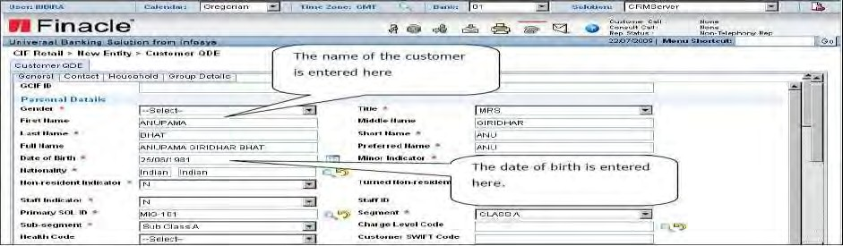

As shown above the fields with red asterisk/star are mandatorily to be filled by the user. The full name gets automatically filled with first character of customer first name, first character of the middle name and all the characters of last name.

1. **General Tab**
2. **Contact details tab**

To complete the CIF creation process user has to the screen, if any field is not entered by the user or in case of data entry mistake system will throw appropriate error messages.

Once the user clicks OK to proceed, the CIF approval process selection page pops up, The user has to click on the save process selection button to move ahead for further activity. Once it is done the CIF will move to the group tray for approval from where the authorised person can take it to the self-tray and approve.

Thefollowing are the CIF Retail menu options, se

**CRM -> FUNCTION -> CIF RETAIL -> New Entity -> Customer**

In **General tab**:

Basic information Contact

Identification Documents Details Currency

Core Interface

**In Demographic tab:**

General Details Qualification Employment Details

Income and Expense Details

**In Psychographic tab:**

Individual Profile or Preference Details

**In Other Bank and Credit Card tab:**

**Verification of Retail CIF**

To verify the CIF created as above, the user who will verify has to select the CIF from the entity queue. The entity queue can be viewed in the Group Tray. To verify the CIF, the entity has to be first moved from the Group Tray to the Self Tray of the approver. This is done by another user who will check.

CIF RETAIL-> ENTITY QUEUE

1. Tray Type –Business Centre Group
2. Entity Type –Customer
3. Group –General Banking
4. Select BusinessCentre.
5. Click on **Submit.**

A **Customer Details** list will appear. Right Click on it and select **Entity -> Get as Assignee.**

Now the Entity has been successfully moved to **Self**-Tray. Again go to –

CIF RETAIL-> ENTITY QUEUE

1. Tray Type –Self
2. Entity Type –Customer
3. Action –Submitted
4. For Approval, Click on **Submit.**

After moving it to Self-tray, the box on the extreme right is to be checked for the

**“CURRENTPROCESS STEP”**tobedisplayed.

**Super Quick Data Entry Retail CIF – SQDE**

The Customer SQDE screen is the simplest and easiest means of creating a customer ID in CRM. The difference from the QDE screen is that the entire data required for creating the CIF ID can be captured in a single tab. Hence there is no need to enter the identification details, contact details, household and group details through different tabs. Also, the user is not required to enter a currency as the default currency defined in CRM ADMIN will be considered as the Base Currency of the customer. However, if the user needs to capture multiple currencies or multiple addresses and other details of the customer, it has to be entered through the Edit Customer function subsequently.

**Corporate CIF QDE**

The Customer SQDE screen is the simplest and easiest means of creating a customer ID in CRM. The difference from the QDE screen is that the entire data required for creating the CIF ID can be captured in a single tab. Hence there is no need to enter the identification details, contact details and group details through separate tabs. Also, the user is not required to enter a currency as the default currency defined in CRM ADMIN will be considered as the Base Currency of the customer. However, if the user needs to capture multiple currencies or multiple addresses and other details of the customer, it

has to be entered through the Edit Customer function subsequently.

**CIF Corporate -> New entity -> Customer SQDE**

The Corporate Name and the Short Name has to be mandatorily captured by the user. The Corporate Name field has a limit of 100 characters. Short name is used for searching the customers in Finacle Core application. The incorporation date represents the date on which the entity represented by the corporate CIF has been formed.

VERIFICATION OF RETAIL / CORPORATE CIF

Once the entire data is captured either through QDE mode or SQDE mode AND WHEN THE PROCESS step is selected the CIF will move to group tray for verification purpose.

CIF RETAIL - > ENTITY QUEUE

The entity queue can be viewed in the Group Tray. To verify the CIF, the entity has to be first moved from the Group Tray to the Self Tray of the approver. On selecting the CIF, the user has to“GETENTITY” as assignee and thus the entity moves from the group to the self-tray. After moving it to the self-tray, the box on the extreme right is to be checked for the “CURRENT PROCESS STEP” to be displayed.

**Modification of CIF - CIF EDIT**

The data captured initially at the time of CIF creation may undergo change in the lifetime of the CIF. Details like address, contact details; group id etc. may be updated. In these scenarios the CIFEdit menu will come into picture for doing the necessary action. The navigation for both retail as well as corporate is similar in nature.

**Enabling CIF in Finacle Core**

Once the retail/ corporate CIF is verified in CRM before creating entities like accounts, etc. the CIF id has to be linked to Finacle Core Application. This is done using the menu option HCCFM- CIF Core Fields Maintenance in Finacle Core application. CIF core integration requires verification. And the verification is to be done using the same menu HCCFM by another user who has necessary verifying powers.

**Blacklisting / undo blacklisting**

Blacklisting is done for those customers of the bank against whom the court has passed the order as they are not credit worthy or have become insolvent. The menu used here is**Retail / Corporate**

**CIF- > Operations -> Blacklist /Undo Blacklisting**

###### Negation / undo Negation

Negation is done for those customers of the bank who are not maintaining their relationship properly in the same bank. People who have defaulted, cheque bounce cases on a regular basis can be treated as negative customers. The menu used here is Retail / Corporate CIF -**>Operations-**

**> Negate/Undo negate**

360 DEGREE VIEW

The 360 Degree view is the CRM business vantage point. It allows use of options that cover an all-round business-centric view of the CRM Business Objects. This option is used to view details of complete relationship details of the selected Retail / CorporateCIF entity. The relationship details include the master information of the CIF entity,accounts held in various back end system, opportunities and incidents logged for the selected entity.

## INVENTORY MANAGEMENT

All banks maintain inventory of various security and non-security items.

### TERMINOLOGY

□

**Inventory:** Inventory means stock of items that a bank holds. From the bankingperspective, inventory can be classified into **security and non-security items**.

□

**Security items** are Demand Drafts, Cheque books, Term deposit receipts,Travellers cheques & Gift cheques of different denominations etc., where tracking of each single unit of inventory is required.

□

**Non security items** are items like furniture, fixtures, stationary items other thansecurity items etc.

**Inventory Class:** In CBS software, each inventory item is identified by theinventory item code defined for it. The system allows defining of major classification of inventory item called as Inventory Class. Inventory Class code can be created using the **HRRCDM** menu. For e.g. Cheques, DD, FDR etc.

•

**Inventory Type:** Within the major inventory class, there may be a minor classification of inventory item called Inventory Type. For e.g. CA Cheques, SB Cheques etc. Can be created using **HIIM** menu.

•

**Location Class and Location Code**: The place where the inventory is located isidentified with Location Class, Location Class is a broader classification and Location Code is a sub-classification of a location where an inventory is held. Inventory items are moved from one location to another location. While LocationClass is defined in HRRCDM, the sub classifications of Location Class which are referred to here as Location Code is defined through HILCM menu option.

INVENTORY ITEM MAINTENANCE –HIIM

After defining the inventory class, the sub classification of inventory i.e., the various types of inventory under a particular Inventory Class are defined using the menu option HIIM.

INVENTORY MOVEMENT AUTHORISATION MAINTENANCE - HIMAUM

In Finacle, it is possible to define users as authorisers for movement of inventory for a

specific location. For a Location Class, you can specify up to a maximum of two authorisers. The menu option for defining the authorisers is HIMAUM.

INVENTORY LOCATION CODE MAINTENANCE –HILCM

While Location Class is defined in HRRCDM, the sub classifications of Location Class which are referred to here as Location Code is defined through HILCM menu option.

INVENTORY MOVEMENT- HIMC

Moving an inventory from one location to another requires following information:

Originating Location class Originating Location code To Target location class Target location code

The first movement of inventory shall happen to “DL/DL” (Double Lock) location. Oneofthe officers shall move the outstanding stock of security forms i.e. FD Receipts, demand draft, pay order, cheque books into the system in “Add” (A) mode.

The officer shall <Commit>(F10) to generate an inventory transaction id. He will note down the same.

The other official (designated vide HIMAUM menu) shall invoke HIMC (Verify) mode to verify the above inventory transaction.

**Inventory Movement Maintenance - HIMAUM**

After adding the new Inventory to a location it can be modified or cancelled before verification.

CANCELLATION

Cancellation of a movement is done using function „X‟ of HIMC menu option. It should be borne in mind that a cancellation of a movement is possible only before verification of the same. However, it is not mandatory that the user who initiated the movement has to cancel --- it can be cancelled by any other user too.

MODIFICATION

Modification can be done before verification and can be done by any user.

**Authorizer ID:**

Any inventory movement from one location to another has to be authorised by the designated users only, (Set up done through HIMAUM). However, if for any reason, the user who is designated for authorising a movement is not available, then the User id specified in „Authorizer ID‟ field of that designated User can authorise the movement. This type of authorising on behalf of another user is applicable only for the inventory movement.

INVENTORY MOVEMENT INQUIRY

Using HIMI menu option, the user can specify the available criteria and able to know the actual position /location of the inventory.

INVENTORY STOCK SPLIT / INQUIRY (ALL LOCATION) - HISIA

If the user wants to inquire or split the inventory on others locations then the menu option HISIA can be invoked. The screen interface and navigation will be similar to HISAI except that the user will be in a position to change the employee location code.

INVENTORY STOCK MERGE / INQUIRY- (OWN LOCATION) -HIMAI

The inventory merge or inquiry on own location can be done through HIMAI.

##### RELATED MENU OPTIONS

MENU OPTION DESCRIPTION

|  |  |
| --- | --- |
| **HIMAUM** | INVENTORY MOVEMENT AUTHORISATIONMAINTEANCE |
| **HIMAUI** | INVENTORY MOVEMENT AUTHORISATION INQUIRY |
| **HILCM** | INVENTORY LOCATION CODE MAINTENANCE |
| **HIIM** | INVENTORY ITEM MAINTENANCE |
| **HIMC** | INVENTORY MOVEMENT BETWEEN LOCATIONS |
| **HISAI** | INVENTORY INQUIRY & SPLIT–FOR THE LOGGED |
| EMPLOYEE IN ONLY |
| **HISIA** | INVENTORY INQUIRY, SPLIT - ALL LOCATIONS |
| **HIMAI** | INVENTORY INQUIRY AND MERGE – FOR THE EMPLOYEE |
| LOGGED IN LOCATION ONLY |
| **HIMIA** | INVENTORY INQUIRY AND MERGE –FOR ALL LOCATION |
| **HISR** | INVENTORY STATUS REPORT –FOR THE USER (EMPLOYEE) |
| LOGGED IN ONLY |
| **HISRA** | INVENTORY STATUS REPORT –ALL |
| **HIMI** | INVENTORY MOVEMENT INQUIRY |
| **HIMR** | INVENTORY MOVEMENT REPORT |
| **HIIA** | INVENTORY INQUIRY ALL |
| **HILCI** | INVENTORY LOCATION CODE INQUIRY |

#### Cheque book Maintenance

Bank customers use instruments for debiting the accounts for various reasons like withdrawing of fund, payment, transfer to other accounts etc. For this purpose bank needsto provide the valid instruments to customer and for which all the records are kept in Bank register. These negotiable instruments are in general term known as Cheques and are security items whose documentation and records are securely maintained.

#### Issue of Cheque Book:

* The issue of cheque book to customer has two levels.
* The entry of cheque book by maker that are to be issued and the verification of same need to be done.
* The cheque book instruments are kept under custody since these are security items.
* The enterer and verifier should not be same.
* At the time of verification of the issue, cheque book should be available with the issuing person i.e. custodian.
* It is possible to select any range of cheque leaves for issue.
* It is suggested that at the employee location, cheque books should be split as per the physical cheque book size
* It is possible to collect Cheque book issue service charges
* It is possible to transfer cheque book issued to a customer from one account to another account of same customer falls under a specific scheme type.

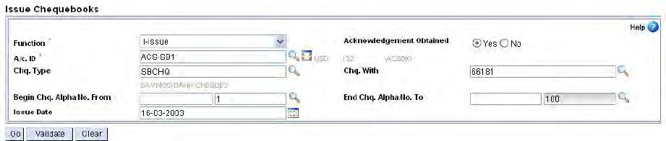**Cheque Issue Menu: HICHB Function-I(ISSUE)**

During the cheque book issue user need to put the A/C No. of customer and type of cheque leaves like SB, CA, CC or OD etc. , cheque available with and collect MICR charges or not.

After issuing of Cheque book, verification is done by Menu: **HICHB / HICHBA Function –V (Verify)**

#### Stop Payment:

**Menu Option: HSPP (**This Menu option is used to stop or revoke payment processing).

This facility is provided to stop a single cheque or multiple cheques in a series. Stop payment or revocation charges can be collected through event based charge collection at the time of verification process.

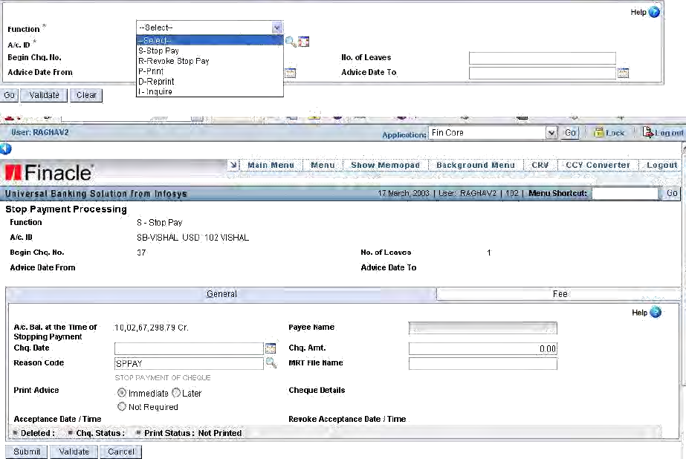

**Verification of Stop payment process, Menu: HSPPAU,Function: V**

The Payment which is stopped through SPP has to be authorized through HSPPAU menuoption. Stop payment charge details can be seen through the option „C‟. Stop payment charges are not modifiable.

Cancellation of Stop payment process can be done before verification by selecting X- Cancelfunction and after authorization stop payment can only be revoked.

**Cheque Book Maintenance Menu Option: HCHBM**

Through this menu option, maintenance activities like Caution, Destroying, revoking and acknowledgement of cheques can be done.

It is possible to explode the entry to enquire leaf details.

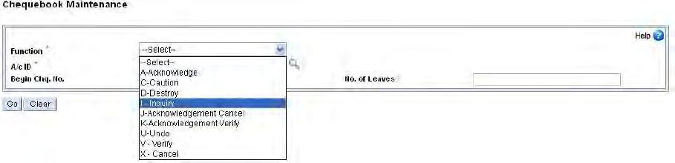

31

#### Updation of cheque status

**Menu: HUCS**

This menu option can be used to change the cheque status as Unused and Paid. Sometimes it happens that user enters the wrong cheque number and if is not actually paidor presented, system update the cheque status when actually that cheque is presented, system may not allow debit, as the system recordshows already paid.

Under this circumstances, if the user wants to change the paid status of the original chequeto different number and present cheque status option.

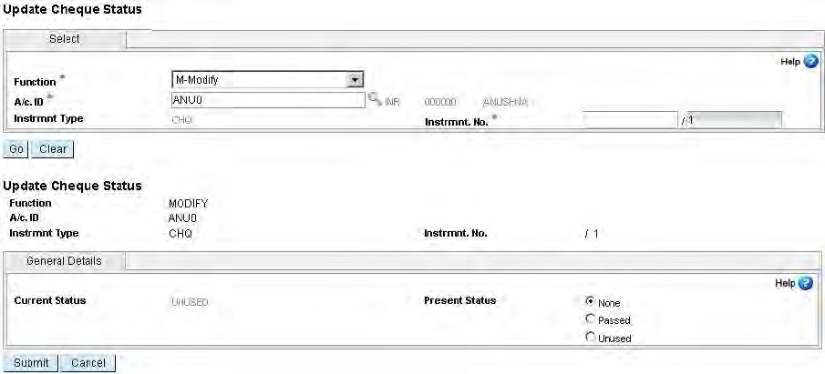

#### Transfer of cheque books Between Accounts

###### Menu: HXFCHBAC

Cheque books can be transferred between accounts of same customer only. Verification is done through same menu option or HXFCHACAU

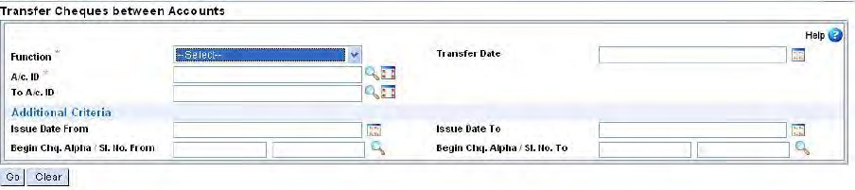

Cheque Book Issued Register Printing:

A report of all cheque books issued to customers can be generated by executing the menu option HCHBIR. The screen details are shown below:

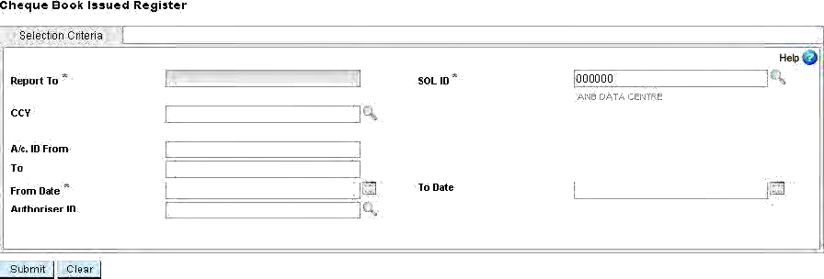

## TRANSACTION MAINTENANCE

#### Terminologies:

**Entered transaction:** Status given when a transaction is created with no effect of thetransaction any balance.

**Posted transaction:** Status given when the actual account balances get affected. It caneither increase (credit transaction) or decrease (debit transaction) the balance in the account. It does not affect the Sub GL balances. The person who posts the transaction must have necessary permission or access to carry out the process.

**Verified transaction:** Status given when another person ensures the correctness of thetransaction and also authorises it. The person who authorises the transaction must have the necessary permission or access to carry out the process.

**Deleted transaction:** Status of a transaction which is logically deleted. Deletedtransactions are available for inquiry in the Core Banking Solution at any point of time.

**Maker and Checker**

Maker and checker are nothing but two persons who are involved in the creation and posting of the transactions. Maker is the person who creates the transaction. Checker is the person who verifies the transaction. A transaction usually involves two or a maximum of three persons for a transaction to get completed.

A transaction can be modified by any number of persons. The Core Banking Solution keeps track of the last person who has modified the transaction. Once the modification is done by a person, the Core Banking Solution overwrites the information of the first person who has created the transaction. This is for the simple reason that the person who is modifying the transaction might be doing with the wrong intention. The Core Banking Solution does not keep track of person who has deletes the transaction also. Only the status of the transaction is updated to Deleted.

**Backdated transaction**

This is a transaction that is initiated on an account where transaction date which is less than BOD dates. At the end of day, the Core Banking Solution updates the Sub GL Balances for all the previous days. You must print all statutory reports as there is a change in the previous day's balances.

**Post-dated transaction**

This transaction occurs for an account where the transaction date is greater than the current date (Core Banking Solution date or BOD date). In this scenario you cannot process the transaction till the date of transaction matches with the BOD date.

**Value dated transaction**

This is a transaction with the transaction date as BOD date. All accounting entries are for BOD date, but the effective date of the transaction is less than BOD date or greater than BOD date. This type of transaction is identified for interest calculation. The effect of the transaction for interest calculation is based on the value date of the transaction. A transaction which has a value date which is less than BOD date is known as Back value dated transaction and a transaction which has a value date which is greater than the BOD date is known as Future value dated transaction.

**GL Date in a transaction**

When the branches work in different time zones, SOLs need not necessarily do the EOD / BOD operations to proceed with next day's transactions. Instead they can just change the GL date and go ahead with their next business date transactions.

**Inter SOL Transaction**

When the account involved in the transaction does not belong to the SOL which initiates the transaction, such a transaction is known as Inter SOL Transaction.

**Additional Details:**

Some times when a transaction is put to an account, going by nature of account and for processing of transactions, certain additional details are required. This will be captured as part of the entry of transaction itself. Without these details the posting of transaction does not go through. This additional information required for processing of the transaction is referred to as Additional details.

**Implicit Part Transaction:**

Implicit part transactions are system created transactions as a part of transaction creation process. Eg.Issue of DD. After accepting additional details, system creates charge transaction. This is implicit part tran. This type of transactions cannot be deleted. We need to delete the original transaction that in turn automatically marks implicit part tran as deleted.

TRANSACTION ID

Each batch of balanced transactions is identified by a unique number. Each batch of transaction has both debit and credit transactions to make it a balanced transaction. A batch has a minimum of one debit and one credit transaction. Similarly the other combinations are as follows:

1. One debit and multiple credits ,
2. One credit and multiple debits and
3. Multiple credits and multiple debits

There are two types of Transaction IDs. User typed transaction has a transaction ID which is recycled every day. System generated transaction has a transaction ID which is recycled once it reaches the maximum value. The Core Banking Solution automatically recycles the number once it reaches maximum.

**TRANSACTION MAINTENANCE –HTM(supports**

**multi-currency)**

All types of transactions to any type of account are put through the menu option HTM.

**(For creating a new transaction,select A from the drop down box and the rest of the options you can select as per the function you required.)**

**Transaction Type/Sub Type:** C/NP -Cash/Normal Payment Function: A**Add** Addition of a new transaction

Tran Type Sub type: C/NP -Cash/Normal Payment Click on Go button. The following screen will appear.

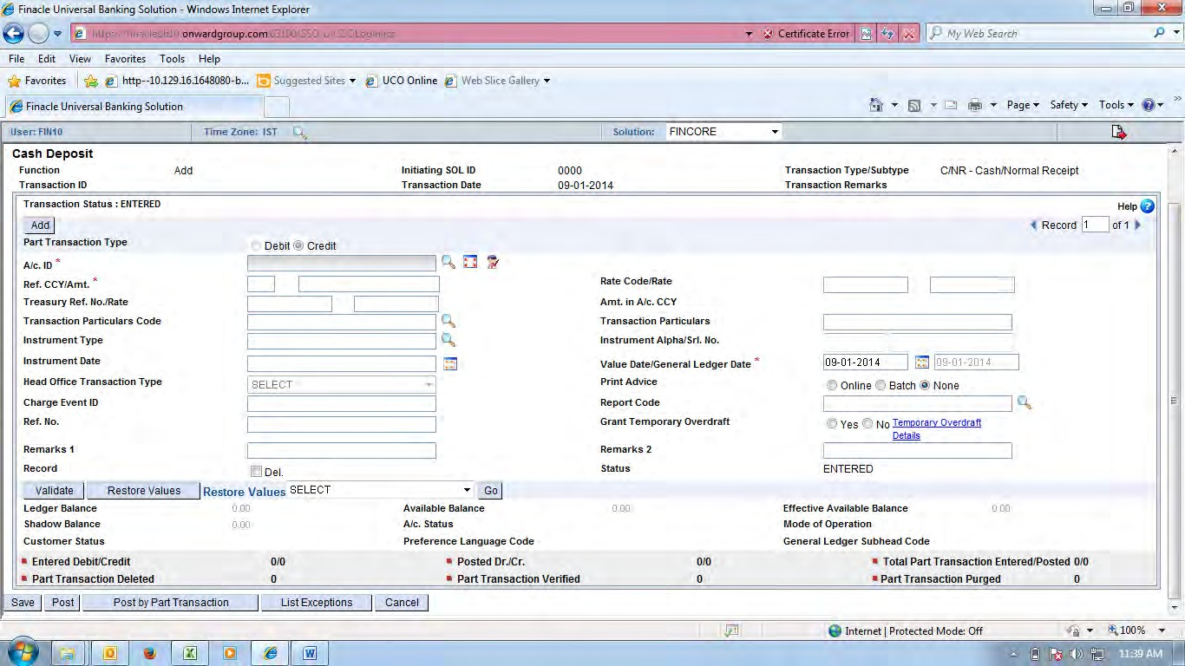

All mandatory and necessary fielddescriptionshave been provided according the above screen. Here red star marked fields are mandatory. Fill the value as per the field name.

**\***A/c ID: The number of the account you wish to debit or credit.

**\*Ref CCY / Amt**: Currency is displayed by system based on the account number entered. If this ischanged then rate code or rate becomes mandatory to arrive at the value in account currency.

**Rate Code / Rate:** When the rate code is selected through the search icon, the relevant rate willbe populated.

**Treasury Ref No. / Rate:** Type or select the Treasury Reference Number

Amt in A/c CCY: The amount in account currency must be displayed in case of multi-currency transaction.

**Tran Particulars Code**: The relevant code pertaining to nature of transaction can be selected.

**Tran Particulars**: Type the transaction particulars.

**Inst. Type:** This is valid in case of debit transaction.

**Instr. No:** The number of the instrument is input. Here both the alpha part and numerical partare entered. Alpha field is not mandatory.

**Instr. Date:** The date on which the instrument is drawn. This is validated for post-dated chequesand stale instruments based on the validity period set for each instrument type.

**Value Date / GL Date:** Type the value date of the transaction. System default populates the GLDate.

***If the transaction is related to HO then the following field will be required.***

**Head Office Tran Type:** This field is valid only in case the transactions are put to an accountwhich belongs to HOC scheme type. The valid values are

O –Originating transaction R –Responding transaction X –Reversal transaction

P –Parking Transaction

A - BAR Adjustment transaction

Grant TOD: If for a debit transaction for customer operative account, there are insufficient funds then by checking the box TOD can be granted.

**Status:** This is a display field. The following are the status a transaction can be associated with:E –Entered

P –Posted V –Verified D –Deleted

After entering the transactions in the add mode, the transactions can be saved and the tran id will be generated. If the user wants to enter more transactions then by visiting the next screen it can be done.

DELETION OF UNPOSTED TRANSACTION

MENU OPTION: HDTE

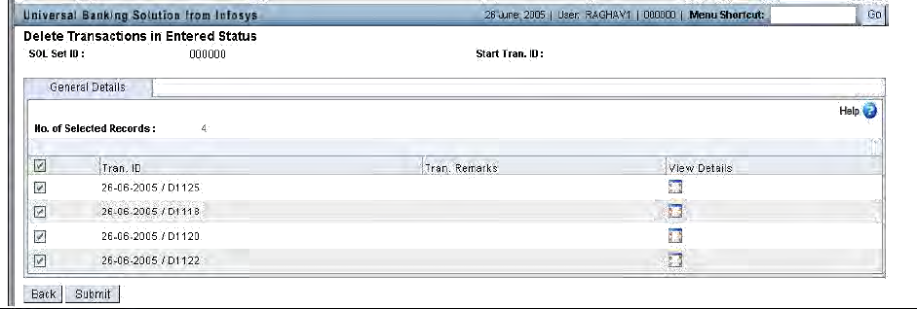

TRANSFER TRANSACTION –HXFER

The menu option for doing a transfer transaction between two or more accounts is through HXFER. On invoking the option the following screen is shown.

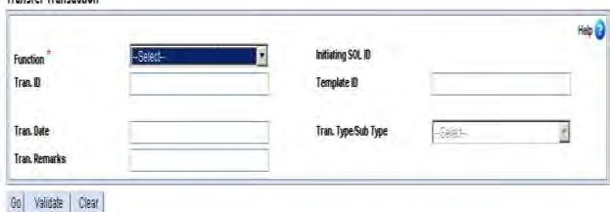

Function A-Add

Tran. Type/Sub type T-BI (Transfer-Bank Induced)

Click on Go and the screen will appear like HTM screen. The relevant Part Tran Type for debit or credit transaction is selected. All other details are similar to HTM as earlier mentioned

**FINANCIAL TRANSACTION REPORT –HFTR**

Reports based on selection criteria such as Account ID, Ref Number, Tran ID, Tran Type,Part Tran Type, Instrument Number, Instrument Type, Transaction amount low,Transaction amount high, GL Subhead, Value Dated, Account Status, Transaction Status and Enter User ID can be generated through the HFTR menu option.

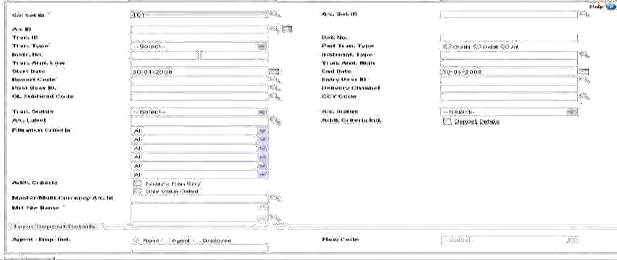

.

By providing the required criteria,click on submit and the result will be shown.

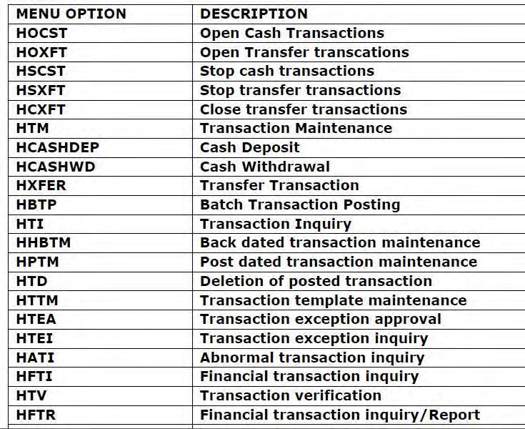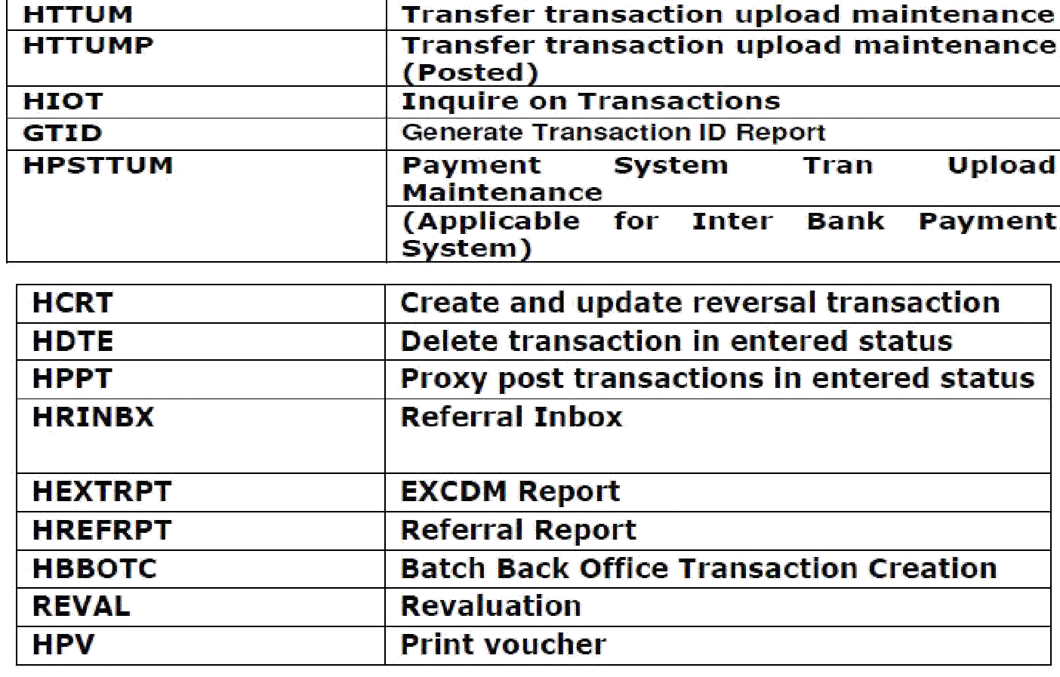

## SAVINGS BANK SCHEME

Finacle supports all the different Savings products presently offered to customer, namely SBGEN, SBSTF, SBCAL, and CALL2

**Opening an SB account Menu: HOAACSB**

* + Function: O
  + CIF ID: Put Customer ID
  + CCY: Select from the list which is displayed on clicking the searcher icon adjacent to the field.
  + Scheme Code: Put the scheme Code
  + Permanent A/C ID: Put the account number.
  + Click on <Go>

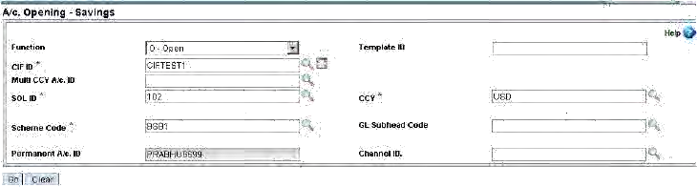

**General Details**

* A/C Name, A/C Short Name will populate automatically from CIF details. A/C Open Date: Default BOD Date. This Date can be modified.
* A/c Statement: None / Frequency as per Bank Business
* Mode of Operation: Select from list which is displayed on clicking the searcher icon adjacent to the field.
* Other details like Staff, Native Language Details etc. can be captured here.

**Interest Details**

* Interest Credit A/c : Original
* Interest Debit A/c : Original
* Interest Rate Code: Select from list which is displayed on clicking the searcher icon adjacent to the field.
* A/C Pegged: Select the appropriate choice for the field.

**Scheme Details**

* Chq allowed: Y/N
* Nomination: Y/N
* A/c Health Code: Select from the searcher

**Related Party Details**

According to the requirement of the Customer other Party (i.e. Nominee, Joint Holder etc.) details has to enter.

**Document Details**

The details of the document can be captured here. Click on <**Submit**>

*Notethe account number….*

**Menu: HOAACMSB**

Modification of Savings Account (Before Verification) can be done by same user who has created the account.

**Verification of Account**

The user who has created the account will not be able to verify the account. Verification will be done by another user.

**Menu: HOAACVSB**

* Function: Verify
* Temporary A/c Id: Enter the account Id created above
* Click on <Go>

The following Tabs have to visit.

* General Tab
* Interest Tab
* Scheme Tab
* Related Party Details
* Document details
* Click on <Submit>

The verification of the savings account will give you a permanent account number, which will be used for the transaction.

**Inquire on Balance of Account Menu: HACCBAL**

Put the Account Number or Account ID Click on <GO>

System will display the balance details of an account.

## CURRENT ACCOUNT

**Opening of CA account Menu: HOAACCA**

* + Function: O
  + CIF ID: Put Customer ID
  + CCY: Select from the list which is displayed on clicking the searcher icon adjacent to the field.
  + Scheme Code: Put the scheme Code
  + Permanent A/C ID: Put the account number.
  + Click on <Go>

**General Details**

A/C Name, A/C Short Name will populate automatically from CIF details. A/C Open Date: Default BOD Date. This Date can be modified.

A/c Statement: None / Frequency as per Bank Business

Mode of Operation: Select from list which is displayed on clicking the searcher icon adjacent to the field.

Other details like Native Language Details etc. can be captured here.

**Interest Details**

User should visit the page only, no need to put any data. Interest will not be applicable on current account.

**Scheme Details**

* Chq allowed: Y/N
* A/c Health Code: Select from the searcher

**Related Party Details**

According to the requirement of the Customer, other Party (i.e. Authorize Signatory, Joint Holder etc.) details have to be entered.

**Document Details**

The details of the document which are required for opening an account can be captured here. Click on <Submit>

Note the account number….

Modification of Current Account (Before Verification) can be done by same user who has created the account.

**Menu: HOAACMCA**

**Verification of Account**

The user who has created the account will not be able to verify the account. Verification will be done by another user.

**Menu: HOAACVCA**

* + Function: Verify
  + Temporary A/c Id: Enter the account Id created above
  + Click on <Go>

The following Tabs have to visit.

* + General Tab
  + Interest Tab
  + Scheme Tab
  + Related Party Details
  + Document details
  + Click on <Submit>

The verification of the savings account will give you a permanent account number, which will be used for the transaction.

## HANDLING VARIOUS TYPES OF OPERATIONS IN AN ACCOUNT

NOMINATION DETAILS ENTRY

The nomination details can be maintained and captured while opening or maintaining the account. In case of Saving, Term deposit and Recurring Deposit nominee details can be required.

Menu: **HOAACSB, HOAACTD**.

At the time of opening an A/C, in Scheme Details if Nomination is selected as „Yes”, Nomination Details Tab has to be visited. Capture all the details of the Nominee here only.

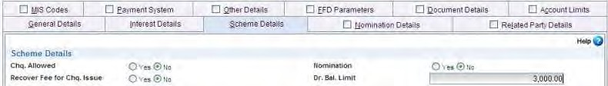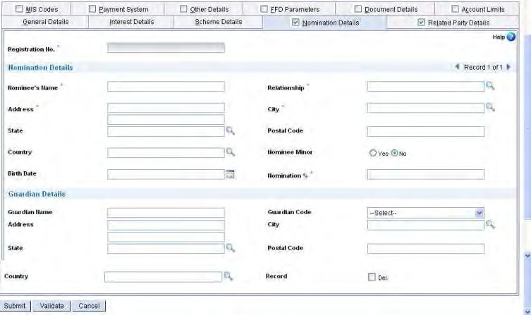

If the nominee is minor then “Guardian Details” should be entered.

RELATED PARTY DETAILS ENTRY

Power of attorney, Joint Holder, Letter of authority, Authorized signatory information etc. can be maintained and captured while opening or maintaining of an A/C.

Menu: **HOAACSB/CC/CA/LA/TD**

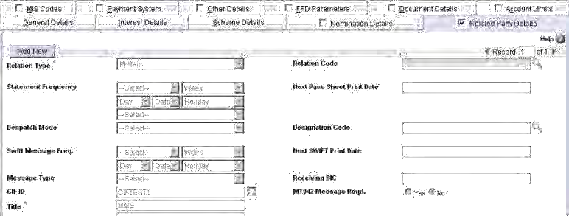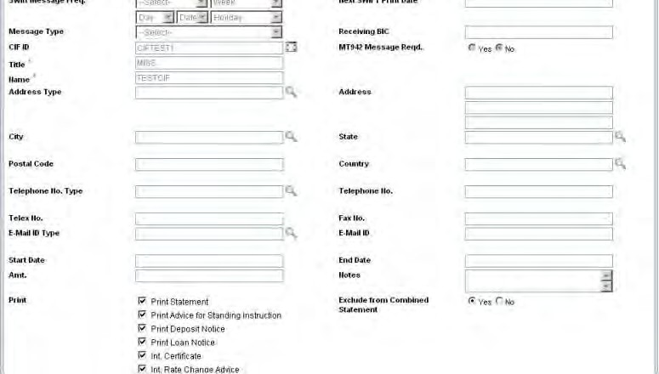

t

The first record in Related Party Details is populated from the CIF Id. All other joint holders for an account can be assigned here for specific business purposes. Relation type and Relation code of the joint holder to the a/c has to be entered here. It is to be noted that the joint holders need not have a CIF record.

CHANGE OF CUSTOMER ID FOR AN ACCOUNT

If the account is opened for a wrong customer, user can rectify it by changing the CIF (Customer ID).

MENU: **HCCA**

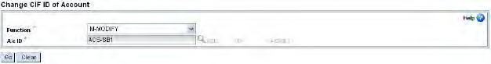

Clicking on **GO** the following screen will display.

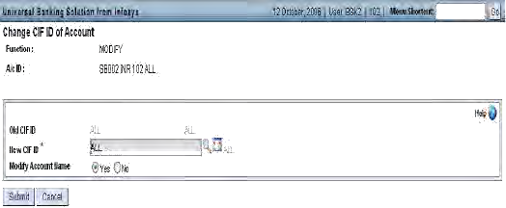

CHEQUE BOOK FACILITY ALLOWANCE

At the time of opening an A/C, in Scheme Details, CHEQUE BOOK facility is there. Cheque Book is given to SBA, CCA, CAA, ODA type of accounts.

MENU: **HACM**



ISSUE OF CHEQUE BOOK

If cheque book facility is given in the scheme to the account then user can issue cheque book to that account.

MENU: **HICHB**

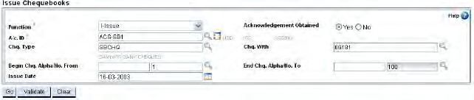

CHEQUE BOOK MAINTENANCE

The cheque book maintenance provides facility for Acknowledgement, Cautioning, Inquiring and Destroying cheques.

MENU: **HCHBM**

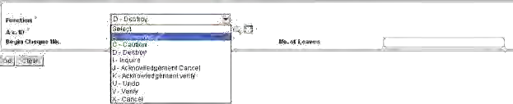

At time of closing an account if any unused cheques are present, they have to be destroyed first.

ACCOUNT NAME CHANGE

Account name can be changed at time of opening. MENU: **HOAACSB/CC/CA/OD/LA.**

If account name is entered wrongly while opening an account then it can be changed. MENU: **HAALM**

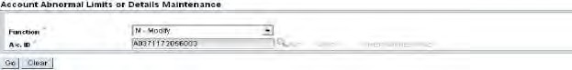

TRANSFER OF ACCOUNTS BETWEEN SCHEMES

Accounts can be transferred between scheme codes of the same scheme type and same currency code belonging to the same SOL. The accounts should falls under the scheme Type of SBA/CCA/CAA/ODA/TDA.

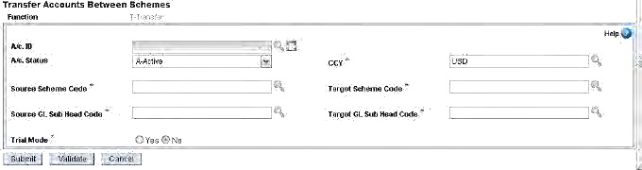

MENU: **HACXFRSC**

TRANSFER OF ACCOUNTS BETWEEN GLSUBHEADS

The accounts can be transferred between GL Sub Heads of the same scheme type and same currency code belonging to the same SOL.

MENU: **HTACBSH**

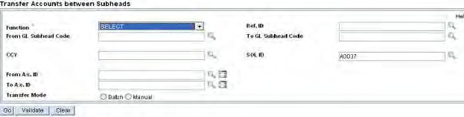

TRANSFER OF ACCOUNTS BETWEEN SOLS

Transfer of accounts across SOL is supported for only those accounts belonging to SBA/CCA/CAA/TDA/ODA/LAA/PCA type of schemes and currency should be same.

MENU: **HACXFSOL**

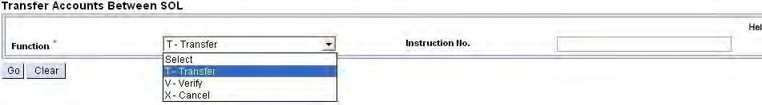

Clicking on GO the following screen will display.

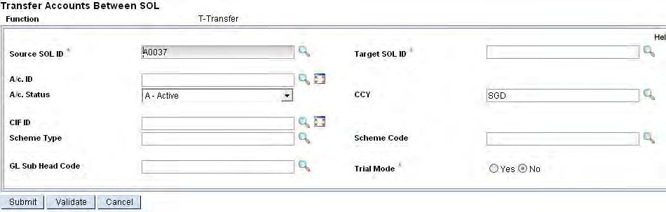

ACCOUNT LIMIT HISTORY MAINTENANCE

Any limit sanctioned to an account requires maintenance for increasing and decreasing in the sanctioned limit itself or monitoring drawing power because of drop in the value of security, bringing in more/additional security to get a higher sanctioned limit.

MENU: **HACLHM**

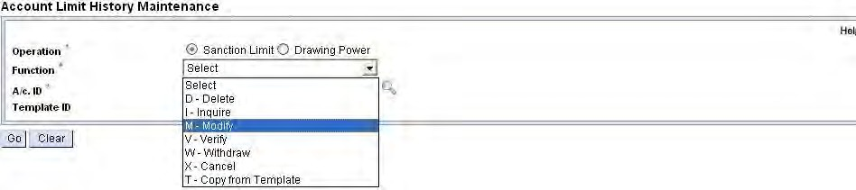

INTEREST RATE MAINTENANCE

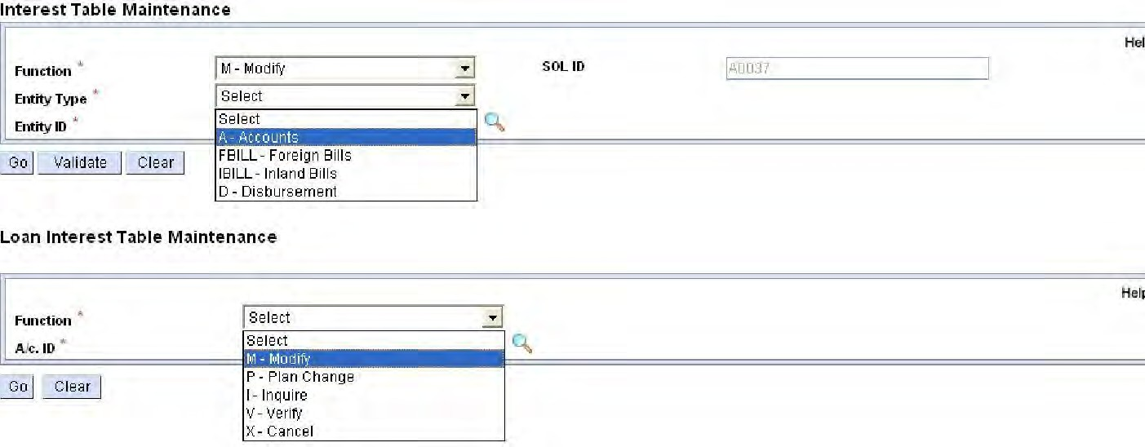Modify the existing rate of interest of an account. MENU: **HINTTM/HLINTTM**

Interest table code, Customer Preferential Int. (Cr) and (Dr), Minimum and Maximum Interest (Cr) and (Dr), Account Preferential Int. (Cr) and (Dr), Interest Pegged Flag, Start Date and End Date.

ACCOUNT FREEZE MAINTENANCE

The freeze status of an account can be maintained here. MENU: **HAFSM**

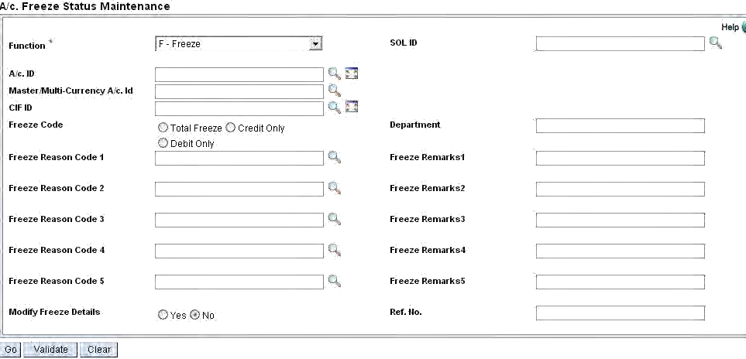

51

ACCOUNT CLOSURE CHARGES

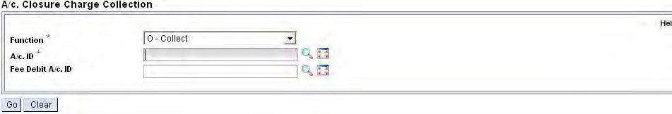Closure charges can be taken before closing of an account depending on schemes. MENU: **HCACC**

ACCOUNT CLOSURE

Close of an account.

MENU: **HCAAC**

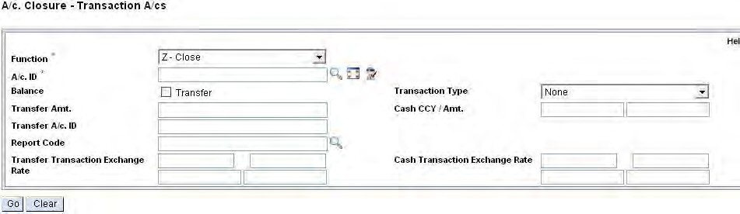

BATCH CLOSURE OF OPERATIVE ACCOUNT

Batch closure has been enabled to close operative accounts of scheme type SBA, CAA, ODA and CCA where balances are zero.

MENU: **BCLSOP**

## ACCOUNT LIEN MAINTENANCE

###### Illustration

Lien is nothing but linking of deposit type of account with an advance account for the purpose of security and freezing the amount for further transaction. Once a valid lien is placed on a bank account, it is frozen. The bank holds the money there for some period of time without giving any to the owner or to the lien holder. Also the bank will turn the money over to the lien holder when the time period expires. A lien will put a hold only on the money that is in the account at the time the lien is given to the bank. Deposits made after the lien has been filed may be given to the owner; these deposits are not subject to the lien.

Create lien on account and make lien related inquiry. The placing of lien manually is irrespective of balance in that account. The user cannot modify the system created liens.

MENU: **HALM**

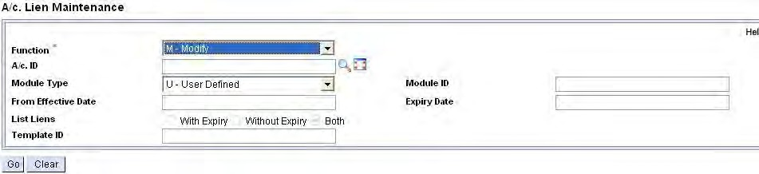

## OVERDRAFT ACCOUNT

1. **Opening an OD account: Menu Option HOAACOD**
   * CIF ID:
   * Scheme Code: Put the scheme Code
   * Click on <Go> General Details

A/c Statement: None / Frequency as per Bank Business Interest Details

* Interest Credit A/c : Original
* Interest Debit A/c : Original
* Next Interest Calculation( Cr): Cntrl. +X
* Next Interest Calculation ( Dr): Cntrl.+X
* Interest slab
* Tenor of Slab: 99 Scheme Details
* Sanction Limit: 2, 00,000.
* Max Allowed Limit: 20, 00,000.
* Expiry date: User has to put the expiry date
* A/c Health Code: Select from the searcher Accounts Limits
* Sanction date: Cntrl +X (Populate Current Date)
* Document Date: Cntrl +X (Populate Current Date)
* Sanction Level:
* Sanction Authority:
* Limit Reference No:
* Drawing Power Indicator: Derived Related Party Details Click on

<Submit>

*Note the account number….*

1. **Verification of ACCOUNT: Menu option: HOAACVOD**
   * Function: Verify
   * Temporary A/c Id: Enter the account Id created above
   * Click on <Go>
   * Interest Tab
   * Int. Slab Tab
   * Scheme Tab
   * Account Limit
   * Related Party Details
   * Document details
   * Click on <Submit>
2. **Inquire on Balance of Account: Menu option: HACCBAL**

Put the Account Number or Account ID ----

Click on <GO>

Sanction Limit should be ------

Drawing Power should be -----

Available Balance should be -----

Float Balance –-----

Funds in Clearing ----

## TERM DEPOSIT

Account Opening Term Deposit

**Menu: HOAACTD**

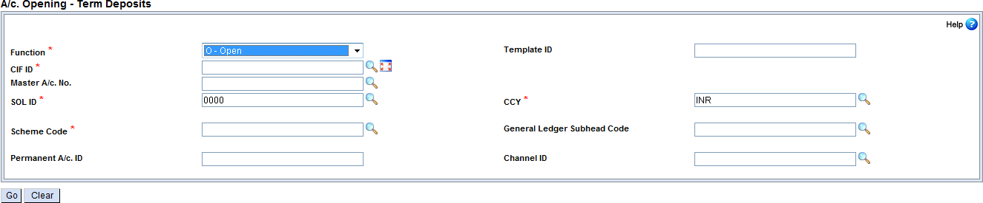

**Screen 1**

* Select Functionas “**O-Open**”
* Specify the Customer Information File (CIF ID) for which the term deposit account is to be opened- Use relevant CIF id
* Enter the **relevant scheme code**
* Click **Go**

**Screen 2 (visit the following tabs) General Tab**

* A/c open date: Value Date

**Interest and Tax Tab**

* Enter the Interest Credit Account –Use your own current account.

**Scheme Details Tab**

* Enter the Deposit / Instalment as R. 10000.
* Enter the Deposit Period as 12 months.
* Deselect the check box for Nomination.
* Enter the Repayment A/c Id.

**Flow Details Tab**

* Just click on the Flow Tab. Nothing need be altered.

**Renewal & Closure TAB**

* Select the option Auto Close.

**Related Party Tab**

* Just click on the Related Party Tab. Nothing need be altered.

**Transaction Details Tab**

* Select the Tran Creation During as “Opening.
* Select the Tran Type as “Transfer”
* Specify the Dr. A/c ID as the user‟s own SB account. (User to ensure availability of one SB account with sufficient balance to cater to deposit amount)
* Click SUBMIT

*NOTE: Above mentioned tabs are mandatory tabs which the user has to visit. Apart from the mandatory tabs there are non-mandatory tabs which can be visited and data captured as per requirements of the bank*

**Account Modification before verification through menu option - HOAACMTD**

After opening the account but before verification if the user wants to make any modification, the same can be done through the menu option **“HOAACMTD**”. Modification can be done by the same user whohas created the account or by any other user. **The user has to enter the accountnumber and click on <GO>. After modifications are done <SUBMIT> button is to be clicked.**

**Account Opening Verification - HOAACVTD**

During verification it is not possible to make any changes to data that are already captured. As part of verification, user is forced to view all the tabs for which data is entered during account creation.

* Invoke menu HOAACVTD.
* Function – V (Verify).
* Enter the TD Account Number.
* Click Go.
* During verification the user is forced to visit the following details which the user visited at the time of account creation:-
* Scheme Details
* General details
* Related party details
* Account Interest and tax details
* Nomination details (in case, nomination flag is Y at the account level)
* All other tabs for which data is entered during account creation

*Note: - If the user clicks on view audit button the screen will display all the tables affected.*

**HACMTD –Term Deposit Maintenance**

MODIFYING AFTER VERIFICATION (Example - Converting the account to a Joint Account)

Invoke menu **HACMTD**

* Select Function: M-Modify
* A/C ID: User to enter the TD account number opened.
* Select Related Party Details tab
* Click on Add New button
* Select Relation Type: J-Joint Holder
* Select CIF ID: User to enter the CIF id created.
* General details tab to be visited and Mode of operation as „Joint‟ to be selected.
* Submit button to be clicked.

The above operation is to be verified by another user by using the same menu option.

**Interest Application**

Interest application using **HACINT menu**is to be done for the deposit opened with back value date in order to proceed for renewal.

„From‟ A/c Id: Enter the term deposit a/c opened in previous step. Post Tran- Yes

Frequency based Interest Run: No See the report –**HPR**

**Term Deposit Account Renewal**

* Renew the Term Deposit account maturing today. Please see what transactions are created by system –**HTDREN**
* **Function –Renew**
* A/c Id: Enter the term deposit a/c opened in previous step
* Click “GO”
* Print Renewal Confirmation- Immediate
* Click Submit
* Get it verified by another user. –**HTDREN**
* Inquire renewal details using **HRELACI** (RELATED ACCOUNTS LOOKUP).

**Closure of Term Deposit Accounts**

Pre/Post-close a Term Deposit account for full amount.

* Use Term Deposit Closure (**HCAACTD)** menu option
* Function Z
* Enter Account Id
* Enter the amount of withdrawal.
* Click GO
* Visit the Closure Details Tab
* Give the tran type as Repayment Account Only.
* Clickon SUBMIT.
* You can see the transactions done by the system.

**Closure Verification – HCAACVTD**

The verification of closure of account is enabled through the menu option HCAACVTD for online closure of accounts. The closure transactions are created only during verificationprocess.

**Reports Menu**

1. ACCOUNT BALANCE DETAILS (HACDET)
2. GENERAL DEPOSIT DETAILS (HGDET)

Menu options HACDET AND HGDET are used to generate various account wise reports based on several selection parameters

Menu option HGDET can be used to generate the list of all TD accounts maturing next month.

1. FLOW AMOUNT WISE DISTRIBUTION OF DEPOSIT - HFDD
2. DISTRIBUTION OF DEPOSITS THROUGH HRDD/HSDD/HMDD. A consolidated report of scheme wise/ rate wise/maturity period wise can be generated using HRDD, HSDD & HMDD menu options.

**InquiriesMenu Menu: HRELACI**

1. RELATED ACCOUNTS LOOKUP FOR DEPOSITS
2. RENEWED ACCOUNT LOOKUP FOR DEPOSIT

The menu is helpful to know the links to the existing account. The account ID for which the renewed accounts has to be looked has to be entered and GO is pressed.

There is an explode button next to ID where the user can go and have further details.

**Deposit Modelling**

Invoke menu option **HDEPMOD** AND PRESS **<GO>**

Capture data in the following fields:

**Deposit Amount** – Enter Deposit Amount. **Deposit Period** – Enter Deposit period in months. **Interest rate**- Enter the rate of interest.

Press **<COMPUTE>** button

After capturing the data as above, system will automatically calculate the maturity value of the term deposit.

## STANDING INSTRUCTION

**OVERVIEW**

* + Standing Instructions (SI) is a facility provided by the banks to its account holders who want to make payments or remittances of a recurring nature like payment of insurance premiums, subscriptions, transfer of funds, instalments to recurring deposits or loan accounts and so on.
  + Customers may give standing instructions to the bank to make these payments and to make remittances on their behalf on specified dates, for specified amounts.
  + **CREATION OF A STANDING INSTRUCTION**

Standing instructions are entered into the system using menu **HSSIM** –Standing Instruction Maintenance.This menu option has two sets of information.

* + - **Header details** maintains and describe various information like whether SI is customerInduced or Bank Induced, CIF ID, SOL ID, execution details like SI frequency, execution time, Next execution date, End date, auto post or not, carry forward etc. and condition details.
    - **Instruction details** - This is a multi-record screen. The user will enter the details of thepart transaction here i.e., the account id which is used for creating the transaction, part transaction type, Memo pad is required to be created till the transaction is posted or not. The user has to ensure that the total amount of debit and credit indicated here matches with the currency and also the amount.

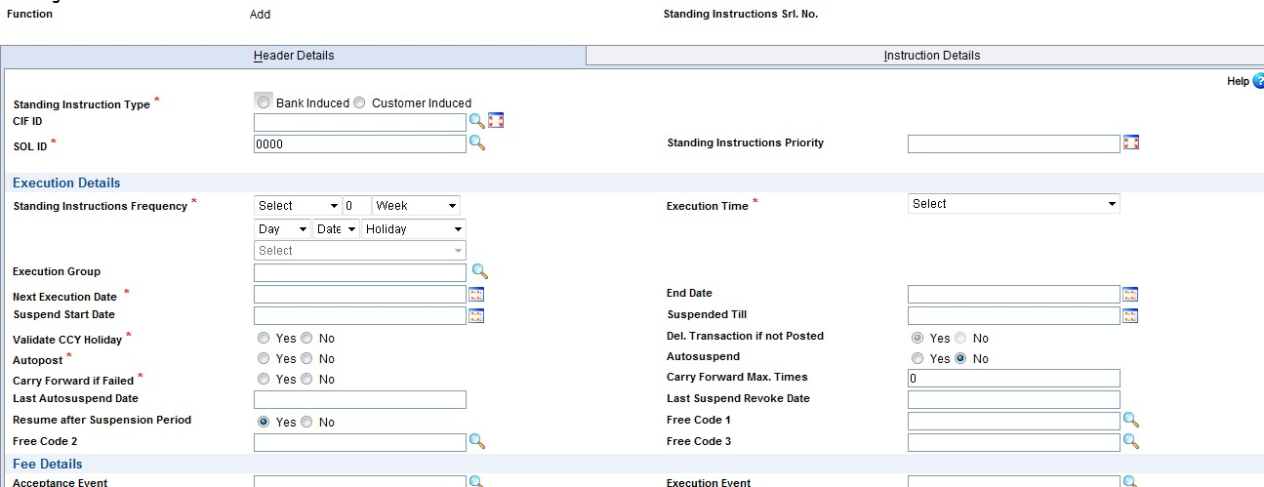

**SI EXECUTION in FINACLE –HSIE**

* + - All standing instructions that satisfy the criteria specified will be eligible for execution. Standing instructions marked for execution during ABH or CSOLOP will automatically be picked up for execution as a part of end of day process.
    - However, if execution time specified by user is “Any time during the day” or “Every Time”, then user has to invoke the SI execution menu HSIE.

**SI REGISTER PRINT–HSIRP**

* + - This option is used to generate a report on Standing Instructions.

This report shows SI Execution Success/Failure and SI Advices also have SI Priority Field

63

## POOL CONCEPT THROUGH HSWEEPS

It is possible that a customer has more than one account of the types like Savings Bank, Current account, Overdraft facility, Term deposit accounts or Loan accounts. There may be a situation that one of the SB accounts on which a cheque has been issued does not have enough funds for passing of the same but substantial amount is available in any of the other account. In such a situation the Bank may not return the cheque and would like to allow the debit to go through. In order to facilitate such a feature, SWEEPS helps the Bank.

The Bank can have a pool of accounts for each customer from where the amounts could be taken. The application provides a feature to pull the amounts available from various accounts, opened in different currencies, under different scheme types. The scheme types from where the pull can be done are SBA, CAA, CCA, ODA and TDA.

**FBA, PCA, BIA and LAA** even though belong to customer accounts **are not eligible** for thisfeature. Along with these scheme types OAB and OAP are also not considered. However unlike Single currency pools, TD accounts and operative accounts linked to FFD Accounts cannot be included in a multi-currency pool.

Finacle supports collection of charges for sweep operations. SWPC, SWPM and SWPR are the event types used for creation, modification and regularisation of sweeps.

It is also possible to generate a report using SRCDR menu option –sweeps regularisation charges detail report

**Disable auto-linking to pool(Y/N):**

Whenthisparameter is set to“Y‟, newaccounts under the scheme and for customers having existing pools will not be automatically addedto the existing pools during account opening verification. However, if the “Allow Sweeps” flag is set at scheme and customer levels, these accounts can be linked to the pool manually at a later stage.

**CREATION OF A POOL FOR A CUSTOMER –**MENU OPTION **HSWEEPS**

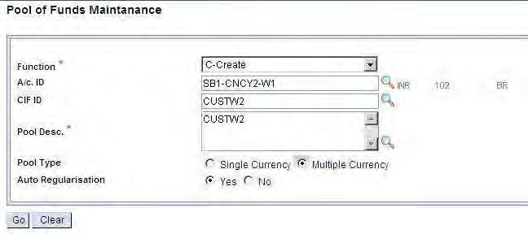

The functions available are C-Create / I-Inquire / M-Modify / R-Revoke Suspend / S- Suspend / X-Cancel / V-Verify.

If the user is creating a pool, he has to use fun pool description pool type, mode of regularisation. CIF ID field is not mandatory. Once the userindicates the account number, pooldescription, pool type, mode of regularisation and clicks on“Go”, the system picks up the primary customer ID the accounts which matches the relationship of the account indicated as under:

**Auto regularisation:** When the value is set to“M‟, then automatic regularization ofunregularized pool will be disabled and the user will have to make a manual fund transfer to the account in pool having deficit balance to bring it to a regularized state. However no manual interference is allowed for FFDs. However, the operative accounts linked to the FFDs can participate in the manual fund transfer.

Eg: If a pool has multiple operative accounts and one or more of these accounts have linked FFDs, then system behaviour for FFD-linked operative accounts and non-FFD-linked operative account will differ. For a non-FFD-linked account, no automatic regularization will take place.

However, for FFD-linked operative accounts, regularization funding from FFDs will take place automatically by the existing FFD regularization.

When the value of Mode of Sweep is set as “S‟for a pool, the System will trigger regularization by itself.

The option of modification of the Mode of Sweep is available

1. Modification from “S‟to “M‟: Modification of the Mode of Sweep from System to Manual is allowed only for a regularized pool. If the pool is in an un-regularized state, then this modification will not be allowed.
2. Modification from “M” to “S”: Modification of Mode of Sweep from Manual to System will be allowed without any restrictions. However, **this modification should always be done onlyafter due regularization of un-regularized pools by manually transferring funds from funding accounts to the deficit accounts.** System will display an information message statingthe same during such modification. However, there will be no system restrictions if an un- regularized pool is modified from Manual to System. The probable results of such a modification will be:

**Order:**

Once the system displays the eligible accounts for this pool, the user can indicate the order in which the sweeps should happen within the scheme type. This order is based on the ascending order of the account opening dates of the accounts in a pool for a given scheme type. There is no restriction that the user should enter the order in the same way. He can just go on giving whatever number he likes. But finally when the order is to be arrived, system will simply put it in ascending order within the scheme type.

**AccountNumber:**

System first displays the account. If the user wants to add some more, he can do so at the end. If the user picks up an account which does not match with the relationship, type of the account indicated in the function block, the exception set up at HSCFM would be raised. While selecting an account which does not match with the relationship type of the indicated account, if that customer ID is not enabled for sweeping, the user cannot select such accounts for the pool. If the account is already selected for one pool such accounts cannot be included in any other pool whether for the same customer or for a different customer. However this restriction is not applicable for TDA type of account. All Flexi Fixed Deposits (TDA) type of accounts can be linked to more than one pool also. If the user wants to use an account which is already in a different pool, first the account should be removed from the pool where it is included and then use it in the other pool. The accounts which are enabled for pool facility can only be used for SWEEP facility.

**Account Name**:

This is only a display field.

**Scheme:**

The scheme under which the account is opened.

**Contribution to Pool:**

Contribution to pool is to the extent of effective available amt.

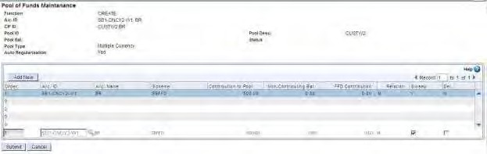

While creating a single currency pool, accounts of the customer having currency same as the pool currency are displayed on the detail page.If the pool type is selected as multi currency and the next record button is clicked, all the accounts of customer irrespective of the currency are displayed.

**Checks and Validations**

1. Single currency pool with the value of auto regularization flag as No cannot be created.
2. Multi-Currency Pool can be created with auto regularization flag as Yes or No.
3. TD accounts cannot be linked to a multi-currency pool.
4. Operative account having Flexi Fixed Type of deposit linked to it cannot be linked to a multi-currency pool.
5. Operative account having its Flexi Fixed Parameters set cannot be linked to a multi-currency pool.
6. By default, pool type is single currency and auto regularization flag as yes.

**RELATION TYPE:**

System displays the relationship of the account. The relationship could be Main account holder, Joint account holder etc. This is a display field and protected

**SWEEP:**

Here the user can decide whether the account has to be used for sweeping or not. Even if at the account level the flag is set as “N” that account will go and update the flag at account level also. At the account level the user cannot go and modifythe field values. It is a protected field at the account level.

Once the pool is created, the pool needs to be verified. Only after verification the pool will be effective. Once the pool is created, system will show the effective available balance for the account, which is being debited taking into the account the balances from all the accounts based on the indicator (available balance or book balance) set up at pool level. Other functions are modification. Cancellation is to be invoked before verification. It is also possible to suspend a pool. Suspension of the pool will result in not considering the accounts for sweeps. Revoking of suspension of the pool is also possible. Both suspension and revoking the suspension requires verification. Inquire is another function available for the menu.

If the user is invoking any of the above function for the pool, description field <list> is available. The user can list for a given CIF ID and select the pool that needs to be accessed. If the pool is suspended, then the status of the pool isshownas “Suspended” else the status would be “Active”.

**AVAILABLE BALANCE:**

The available balance will be calculated based on the following process:

* 1. System first identifies all the positive balance and negative balance accounts. Negative(Debit) balance accounts could be accounts belonging to ODA and CCA accounts where the balance are less than zero and still balances are available for withdrawal.
  2. Out of the positive balance accounts system goes by the order in which the scheme types are mentioned at HSCFM.
  3. System then looks at the order of the accounts in which sweep should happen within the scheme type based on the pool set up.
  4. System will now look at the parameter set up at scheme level to consider whether minimum balance should be taken into account or not.
  5. Finally, the debit balance accounts would be considered, Effective Available

Amount for Sweeps will display the Amount as zero where pool effective available amount is negative.

FUNCTIONALITY –PROCESS DURING DEBIT TRANSACTION

Once the system arrives at the effective available balance, a debit can be done to the account.

FUNCTIONALITY –PULL SWEEP PROCESS

The system tries to adjust the proceeds by pulling the amounts as explained in the availability of the amount process. This process happens as an end of day process. If the user wants to adjust the proceeds, he can invoke the menu **SWOPS** during the day also.

##### NOTE:

* In a pool it is possible to have accounts of only one currency
* User can maintain any number of pools for a single customer. If accounts are there in different currencies, the user can have different pools involving different currencies
* A frozen account is not allowed to be a part of a pool. Also freezing of an account, which is in a pool, is not allowed.
* The “Future Value DatedBalance” will not be considered duringanyoperations ofFFDand POOL (i.e. FFD Breaking, FFD Creation, POOL Contribution, etc.)

**HMPRPT**: A menu option to report unregularised manual pools. It chooses all the manual poolsand all the account in the pools and these details are the input for script PoolScript.scr. This script identifies the A/cs having Debit balance and reports them as Un-regularised Accounts. The output is used by the mprpt.mrt to generate the final report.

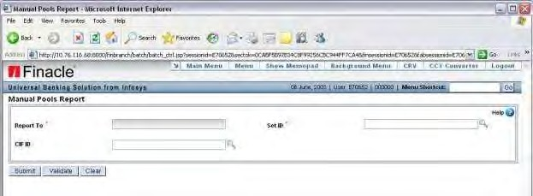

## LOAN

In a loan, initially the borrower receives or borrows an amount of money from lender, called principle and is obligated to pay back or repay an equal amount of money to thelender at a later time. Depending on nature of advances, loan types can be Secured, Unsecured, Demand, Term and Subsidized.

###### Rephasement of Loan

Many a times, the borrower/customer may not be able to adhere to the repayment schedule stipulated by the Bank for various reasons. This results in overdues in that account. After a thorough review of the account, considering the various issues associated with it, Bank may come out with a different repayment schedule to mitigate the hardships faced by the borrower/guarantor. This reconsideration of the repayment schedule is known as Rephasement of the Account.

AOD/AOS

AOD means acknowledgement of Debt. AOS means Acknowledgement of Security. Before legal proceedings are initiated against the borrower for recovery of the advance, the Banks take care to ensure that the securities and the documents obtained for the purpose of loan are in force. In order to ensure this at periodical intervals the Banks would be obtaining these two documents to keep the original documents/securities obtained in force.

**Prepayment**

Whenever the Bank makes advances, it expects the borrower to pay the same in pre- defined period that may be equal instalments or staggered instalments. It is possible that the borrower who takes the loan can make repayment of the loan amount much ahead of the schedule and close the account. In many cases, especially in case of long term loans like housing loan, the Banks does not want the customer to make early payment because of cash management and investment management. In those cases the Banks may even charge penalty for making early payment. Such early payment made in front of the schedule is known as pre-payment or unscheduled payment.

**Asset classification**

Each advance account in a Bank is an asset to the Bank. The Bank monitors the assets closely to ensure that it recovers the advance amount along with interest and related charges promptly. As a part of monitoring the accounts, accounts are classified into various categories depending upon the status of each account as to whether all the instalments are recovered, all the interest and various charges applied are recovered, whether the payment has come as per the schedule etc. If there is any discrepancy, depending upon the period for which dues are not recovered, the percentage of amount that could not be recovered etc., accounts are classified into various categories. As and

when the accounts goes from bad to worse conditions, more and more follow up will be required for recovery. This classification of accounts is known as Asset classification

**Asset provisioning**

As a step further to asset classification, Banks will have to keep a certain percentage of the outstanding in loan accounts wherever they feel difficulty in recovering. This amount which is kept from its income is known as provision amount for Bad and Doubtful debts. The Central Bank of the country would be defining norms and procedure for making such provisions depending upon the status of each account. This provision may vary from any percentage up to a maximum of 100 percent provision.

**Writing off**

The accounts which have been classified as worst asset and where 100 percent provision is done, will be written off from the books of accounts, if the Bank feels that there is nochances of recovering the amount at all. This will be done by adjusting the amount from the provision made. This process of making the adjustment from the provision amount is known as Charge off/Writing off. Banks continue to put efforts for recovering the amount subsequent to writing off also.

FLOWS

Flow is a code. Every Transaction either a Debit or a credit to a Loan account is associated with a flow code/ID. Based on the flow, the system has to do some internal storing of information, processes, validations etc. This is required to arrive at the Demand, Collection and Balance position of an account thus reflecting the overdue position of an account. This is also useful for classification of assets into performing and non-performing assets.

The flows are categorised into following categories:

C – Collection D – Demand

P – Disbursement T – Transfer

E – Equated Instalments

DISBURSEMENT:

Represents loan amount released to the account holder based on the sanction limit. Normally disbursement flows will happen while opening. There can be a single or multiple disbursements in a loan account. In case of multiple flows disbursement will happen subsequent to account opening. Disbursement flow is associated with debit transactions except in case of reversals of disbursement.

**DEMAND (also known as bill):**

Demand is made on the customer for repayment of the loan amount due. The demand can be Principal demand, Interest demand, Bank charges demand and Other charges

demand. Demands are raised periodically during the life cycle of the loan account. As and when an instalment becomes due, system automatically raises a demand for the principal amount. Whenever interest is applied/capitalised (debit to account) interest demand is raised. Whenever any other debits like payment of insurance, payment of tax etc. are done it can be a Bank charge demand or Other Demand.

COLLECTION:

This is a transaction for recovery of amount to a loan account. Collection flows can happen during the lifecycle of the loan account, when the customer makes a repayment. For collection flows, it is possible to specify the offset sequence (the sequence in which the demands raised are to be offset or adjusted (such as principal first, interest next, charges etc.)). It is also possible to specify that the collections should be set off in the chronological order in which the demands have been raised or in a specific way. It is also possible to adjust various demands in the loan account over riding the definition. Collection is associated with credit transactions to loan a/c.

TRANSFER:

A loan account can also go into credit balance in some cases. When the loan account goes to credit balance, it needs to be debited to transfer the credit balance. This debit cannot be treated as a disbursement, Interest or any other Charge. In such cases, the transaction will be Classified/Identified as Transfer “flow”. “Transferflow”ispossible onlyiftheliability of the account is nil and the interest calculation is up-to-date.

**Equated instalments:**

The repayment to a loan account could be done in equated instalments. The equated instalments can be monthly, quarterly or any other specified period. If the instalments are of equated in nature, then the amount repaid will be adjusted towards both principal and interest.

INTEREST TABLE CODE:

MENU OPTION –HITCM / HIVSM

Each limit node can have its own interest associated with it. Otherwise the interest applicable to the account would be applied. In case the Bank wants to calculate interest based on the limit node to which the account is linked, then user has to indicate the interest table code that needs to be used here. If both the account and the limit node have an interest table code attached, then system uses the limit node interest table code by overriding the interest table code associated with the account.

The following are the menu options to **OPEN** a Loan Account.

MENU–HOAACLA

* FUNCTION –O
* ACCOUNT TYPE –NORMAL
* CIF ID
* SOL ID
* CCY
* SCHEME CODE Click on **GO**.

In **General Tab** the following are mandatory….

* ACCOUNT NAME
* ACCOUNT SHORT NAME
* ACCOUNT OPENING DATE
* ACCOUNT STATEMENT
* STATEMENT FREQUENCY
* DESPATCH MODE
* NEXT PRINT DATE
* ECS ENABLED

In **A/C Interest** Tab the following are mandatory… In Repricing Details…

* REPRICING PLAN In Interest Details…
* COLLECT INT.
* COMPOUNDING REST IND.

In **Loan Details** Tab the following are mandatory...

* + LOAN TYPE
  + LOAN AMOUNT
  + LOAN PERIOD
  + REVIEW AUTHORITY
  + HOLD IN OPERATIVE A/C FOR AMOUNT
  + REPAYMENT METHOD
  + OPERATIVE A/C ID

In **LA Interest** Tab nothing to changed, just visit the Tab. In **Payment Plan** Tab the following are mandatory...

In **General** Details….

* + EQUATED INSTALMENT
  + EI FORMULA
  + NO. OF INSTALLMENT
  + INSTALLMENT START DATE
  + INTEREST START DATE
  + INSTALLMENT FREQUENCY
  + INTEREST FREQUENCY
  + In Payment Schedule Tab the following are mandatory...
  + INSTALLMENT ID
  + INSTALLMENT START DATE
  + INSTALLMENT FREQUENCY
  + NO. OF INSTALLMENT

Click on **Amortization Schedule**. System should display Amortization Schedule to the user.

In **Loan Fees** tab nothing to change. Just observe the information. In **Disbursement Schedule** the following are mandatory...

* + DISBURSEMENT DATE
  + DISBURSEMENT CCY
  + DISBURSEMENT AMOUNT
  + MODE OF PAYMENT
  + CREDIT A/C NUMBER (In case of Transfer)

In **Related Party** Details Tab…

Each Persons relationship with main A/C holder is captured here and any statement has to be sent to these persons etc. are also captured here. The following are mandatory...

* + RELATION TYPE
  + RELATION CODE
  + STATEMENT FREQUENCY
  + DESPATCH MODE
  + CIF ID or TITLE, NAME
  + ADDRESS TYPE
  + ADDRESS
  + CITY
  + STATE
  + POSTAL CODE
  + COUNTRY
  + TELEPHONE NO
  + EMAIL ID etc.

In **Account Limit** Tab the following are mandatory...

* + SANCTION LIMIT
  + LIMIT LEVEL INT.
  + SANCTION DATE
  + EXPIRY DATE
  + DOCUMENT DATE
  + SANCTION LEVEL
  + SANCTION AUTHORITY
  + LIMIT REF. NUMBER
  + DRAWING POWER IND.
  + A/C RECALLED FLAG

In **Document** Tab the following are mandatory...

* + DOCUMENT CODE
  + DUE DATE
  + SANCTION DETAILS

In **Post Dated Cheque** Tab the following are mandatory...

If the user has entered value “P” = Post Dated Cheques for “Repayment method” in “Scheme Details” , then the user can enter the details of the PDCs received by the Bank.

* + START INSTR. NO
  + NO. OF PDC
  + AMOUNT
  + MICR CODE or BANK CODE and BRANCH CODE
  + NEXT DATE
  + TYPE OF PDC
  + PDC PAYMENT TYPE
  + PROVIDER
  + CIF ID

In **Multi Source Instruction** Tab the following are mandatory...

* + INSTALLMENT TYPE
  + REPAY METHOD
  + AMT INDICATOR (AMT or PERCENT)
  + AMOUNT
  + PERCENT
  + A/C ID

Click on first **VALIDATE** then **SUBMIT.**

74

Loan General Inquiry

MENU –HLNGI

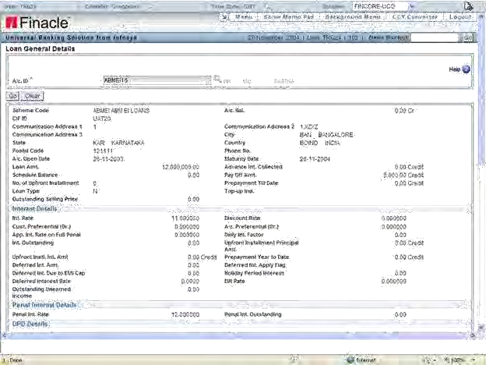

Loan Repayment Schedule

MENU –HLRPSI

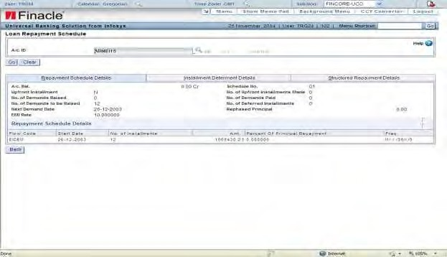

Inquiry of Interest

MENU –HLINTI

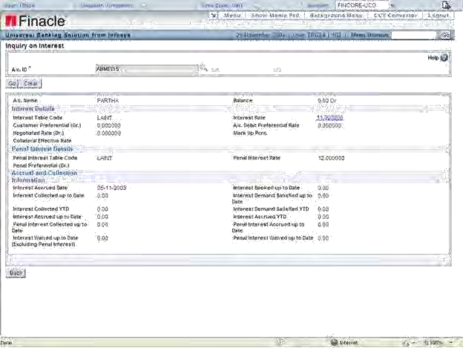

In **Loan Disbursement** Details the following are mandatory:

MENU –HLADISB

* + FUNCTION
  + VALUE DATE
  + A/C ID
  + REMARKS
  + TRANSACTION TYPE
  + DISBURSEMENT AMT
  + GROSS/NET DISBURSEMENT
  + FINAL DISBURSEMENT
  + Click on ACCEPT

**Loan Fee Assessment** Details will appear. Click on **GO.**

* + MODE OF DISBURSEMENT
  + AMOUNT (Loan CCY)
  + VALUE DTE
  + CREDIT A/C NO.
  + Click on ACCEPT.

**Loan Rebate Assessment** Details will appear. Click on **ACCEPT**.

System will take back to the transaction detail page. Click on **ACCEPT**.

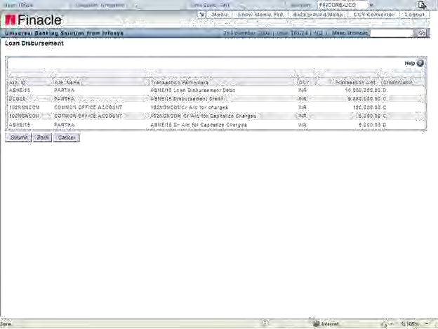

Click on **SUBMIT.**

Loan Inquiry

MENU –HLACLI

Loan **Disbursement Letter** Generation

MENU - HLADML

* + loan account id from
  + loan account id to
  + Disbursement Date Click on **SUBMIT.**

System will generate the loan disbursement letter. Invoke the menu to generate the report.

MENU - HPR

Click on **Print screen** to view the details Click on **CANCEL** to go back.

Loan Demand Generation Process

MENU –HLADGEN

* + REPORT TOA/C FROM
  + TO A/C ID
  + PRINT INTEREST DETAILS
  + NPA / A/Cs
  + DISABLED A/Cs
  + FORCE INTEREST RUN
  + OVERRIDE NPA INTEREST
  + TRIAL MODE Click on **SUBMIT.**

System will apply the interest and also will raise the principal demands. System will generate 5 reports namely –

* + INTEREST FAILURE REPORT
  + INTEREST DETAIL REPORT
  + DEMAND CREATION FAILURE REPORT
  + DEMAND CREATION SUCCESS REPORT
  + OFTI POST REPORT

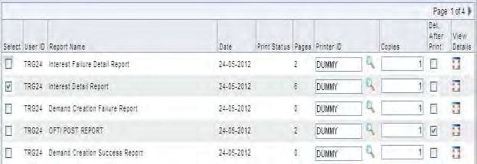

Print Debit/Credit Advice for Customer

MENU –HADVC

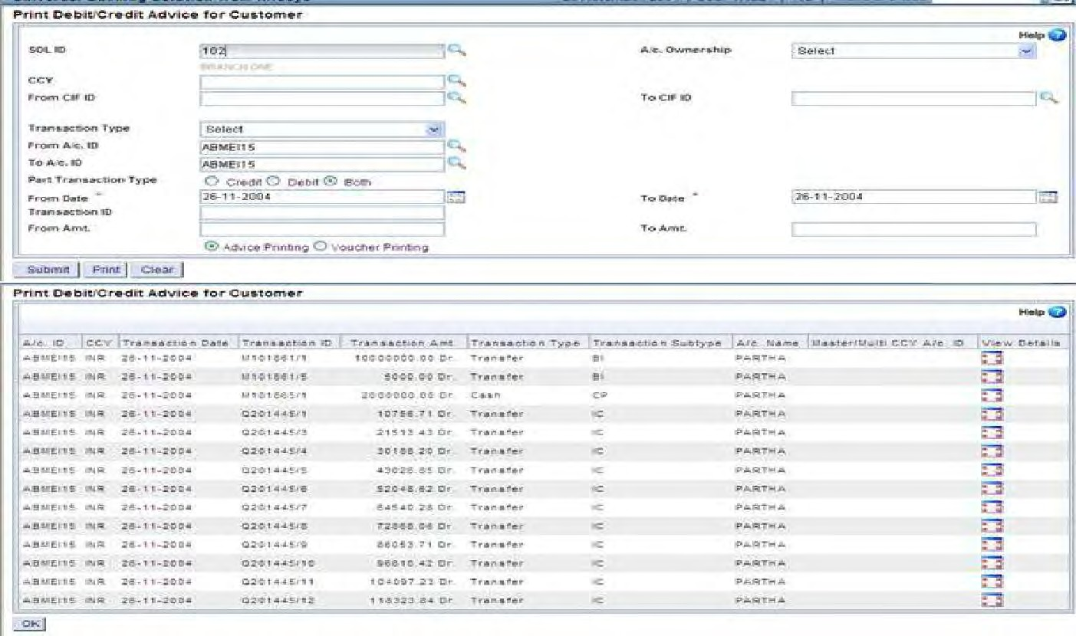

Loan Overdue Position Inquiry

MENU –HLAOPI

* + FROM A/C ID
  + TO A/C ID
  + AS OF DATE Click on **SUBMIT.**

System will display the non interest and interest demand details.

Click on **view details icon**. System will list frequency wise demand details. Click on **view details icon**. System will give the breakup of interest demand and principle demand for a given total demand.

Further click on **view details icon**. System will take the user to a new screen where it will display the demand id, demand date, demand effective date, demand overdue date for the demand which you have selected.

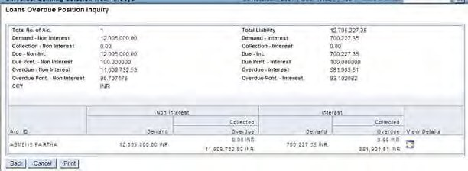

Repayment Process

MENU –HLASPAY

* + PAYMENT TYPE
  + TRANSACTION TYPE Click on **GO**
  + LOAN A/C ID
  + CREDIT AMT Click on **ACCEPT**

System will take the user to the demand adjustment screen.

* + Inquire on the following below details
  + Principal adjustment amount and principal outstanding amount.
  + Interest adjustment amount and interest outstanding amount
  + Total adjustment and total outstanding amount
  + Take the help of the mentor to under this behaviour of the system. Click on **SUMMARY** details to view the details.

Click on **BACK** to go back to previous screen.

Loan unscheduled payment

MENU –HLAUPAY

* + PAYMENT TYPE
  + TRANSACTION TYPE
  + Click on GO
  + LOAN A/C ID
  + CREDIT AMT Click on **ACCEPT**

Click on **SUBMIT**. Transaction ID will generate has to verify through same menu option.

Loan Payment History Inquiry

MENU –HLPAYH

* A/C ID Click on Go.

**Loan Demand Satisfaction Process**

There should be enough balance in operativeAccount for the system to carry out the recovery.

**MENU –HLADSP** REPORT TO DEMAND

TYPE FROM

A/C ID TO A/C ID RECOVERY

MODE Click on

**SUBMIT.**

Invoke MENU - **HPR** to display the report.

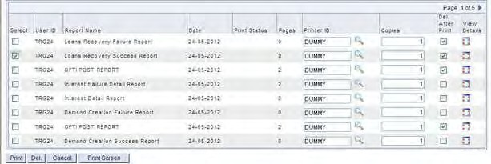

Loan Payoff Process

MENU –HPAYOFF

* + A/C ID
  + TRANSACTION TYPE Click on **GO**
  + PAYOFF FEES

Click on **CREATE TRANSACTION**

80

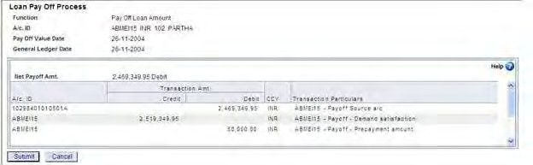

Click on **SUBMIT**. System will give the message Payoff Done Successfully. Verification will be done through same menu option.

Batch Closure of Loan A/Cs

MENU –HCLSLAA

* + REPORT TO
  + FROM A/C ID
  + TO A/C ID

Click on **SUBMIT.** Batch Program Successfully invoked will appear.

**Close Loan Account MENU - CAACLA**

* + FUNCTION
  + A/C ID Click on **GO**

Put CLOSURE REMARKS

Click on **SUBMIT.**

## COLLATERAL MAINTENANCE

**Collateral code Creation: (collateral master Maintenance)**

Menu option **HCMM**

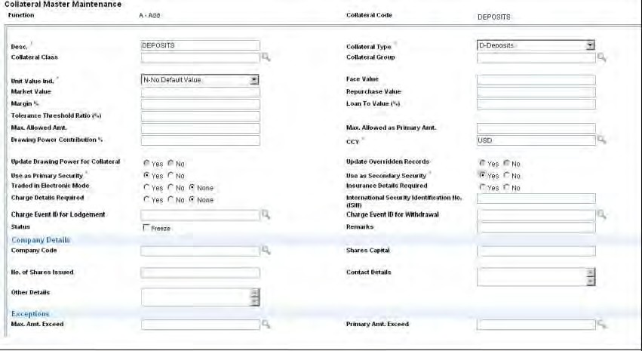

Function:ADD, Collateral Code: user defined--- Click on <Go>

**Description**:

Collateral Type: Immovable Type

Unit Value Indicator: F-face value, M-Market Value, N-No default Value

CCY: INR

Use as Primary Securities: Yes Use as Secondary Securities: No Loan To Value:

Click on <Submit>

**Verify Collateral code Creation:**

**Menu Option: HCMM**

Function: Verify, Collateral Code:

Click on <Go> Then Click on <Submit>

**Collateral Register Maintenance (*Linking of Collateral code with Collateraltype) --***

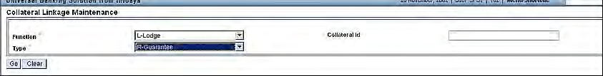**Creation of Collateral Link ID Menu option: HCLM**

**Function**: Lodge

Type: I Immovable Property Click on <Go>

**General**

Collateral Code: Created above Ceiling Limit:

**Particular**

Nature of Charge:

Derive Value from:

*Property doc number*: Put PD number

Address: Put the address of the issuing organization Click on <Submit>

Note Collateral ID…

**Verify the Collateral Linkage Menu option: HCLM**

Function: Verify Collateral ID

Type: Immovable Property

General Particular

Click on <Submit>

**Linking of Collateral ID with the Limit Node and Account ID: Menu Option: HSCLM**

The user willbeusing“L–Link”tolinkthecollateralswithanaccount or with a Limit Node. The other valid functions available here are Unlink, Inquiry, Modify, Verify and Cancel.

**Linkage Types:** The security can be linked to either an account / Limit node with Option/ linkage type as A/c - Account or to a limit node with type as Limit Node.

**Collateral Id:** Enter the collateral Id number which was received during the lodging ofthe collateral using HCLM.

After entering the apportioned Value in the respective field, and upon submitting the record, the user would get the message Collateral Id Linked successfully to the entity, **Function Verify the Collateral Linkage**

**Menu Option: HSCLM**

L: Link

Linkage Type: A/c Id:

Collateral Id: created above in step 3 Accept

Apportioned Value: 200000 (User defined) Click on <Submit>

Function: Verify

Linkage Type: A/c Id: Collateral Id:

Accept

Click on <Submit>

**Customer Collateral Inquiries Menu Option: HCOLINI**

Customer Collateral Details CIF ID:

Click on <Go>

LIMIT NODE INQUIRY OPTIONS CUSTOMER LIMIT DETAILS

Customer limits can be inquired with the help of CRV menu option –HCULMTI.

LIMIT NODE DETAILS

Limit node details can be inquired with the help of CRV menu option –HLNDI. Enter the CIF ID and the limit node.

LIMIT TREE DETAILS

Customer limit tree details can be inquired with the help of CRV menu option – HLMTREEI.

LIMIT TREE LOOKUP

The menu option LTL can be used to inquire into various limit nodes and their details. On specifying the selection criteria, the system displays details such as node id, description and limit sanctioned at the node level and liability.

**Menu option: HLTL**

The user can indicate any criteria and inquire for the information pertaining to the criteria. In the above menu option, the user can inquire and see the details of how exactly a parent limit ID is utilised. This menu option gives the tree structure on the various limits that are linked to other Limits. Option has been provided to the user to

<explode> from a record to see further details of a particular Limit ID.

**COLLATERAL REGISTER LOOKUP, MENU OPTION: HCLL**

This option allows the user to inquire on the various accounts/limit nodes linked for a particular Security. The user will be able to get a consolidated view of security wise exposure of the Bank. The user has to invoke a menu SRL to have a look at the information.

COLLATERAL REGISTER MODULE REPORTS

MENU OPTION: HCLMRPTS

You can generate various reports over charges, security details and insurance details using the HCLMRPTS menu option.

# COMMERCIAL LOAN

OVERVIEW

Lending is one of the main activities of the Bank. Through lending activity, Bank earns major income that is referred to as Interest. Banks also earn by way of charges collected for various activities that they carry out in relation to loans.

When Banks finance the activities of corporate houses, the loans are called Corporate Loans. Depending upon the type of the product, quantum of loan amount, the nature, handling and behaviour of the advances differ. Processing of the advance also differ.

Banks some time appoint individuals or an organisation to promote its product. In turn they will be compensated with different types of commission, incentive etc. for having brought in business to the Bank. These individuals or organisation is known as Direct Selling Agents.

TERMINOLOGY EXPLAINED

**Draw Down:** The process of the customer drawing the amount of the loan sanctioned. Inother words, it is the bank disbursing the loan sanctioned.

**Crystallisation:** Conversion of overdue liability denominated in a Foreign Currency intohome currency or to a designated third currency

**Draw down notice:** The notice given by the customer indicating that he wants money tobe disbursed to him as per the schedule

**Annualised Percentage Rate (APR):** The APR is the relative cost of credit expressedin percentage terms on the basis of one year.

Banks quote rates of interest in different ways. In addition to interest, banks also levy certain other charges. Often the customer does not get a clear picture about the total cost he is incurring on his loan account in a year. This clarity is all the more important when he is trying to compare his cost of borrowing from different banks.

Therefore the customer would like to know his total cost taking into account all his interest costs and other charges per year, as a percentage vis-à-vis his loan amount. This would easily be able to compare cost of borrowing from different banks. This single rate quoted for total cost is called the **Annualised Percentage Rate**.

DELINQUENCY CYCLE

Any loan sanctioned will have a repayment schedule and the borrower has to adhere to the repayment schedule. It is a common thing that the instalment does not get paid on due date and the Banks wants to follow it up. Apart from just following it for recovery purposes they also want some statistical data on what was the due date for an instalment and when it actually got paid/recovered, Depending upon how many days of delay was there; the account would be passing through various cycles. This updation is done with respect to each of the instalments.

Delinquency details means, the time buckets under which overdue instalments will be classified. That means for how many days each of the instalment was pending and into how many cycles it moved before it was paid. This information is required to know how the customer has repaid his instalments. The user can decide the period of each cycle.

When dues in a loan account are not recovered on due dates, the account is said to be delinquent. In some countries, the words „Out of Order‟ or „Overdue‟ accounts are also used for delinquent accounts. Accounts becoming delinquent have a lot of significance forbanks because they will have to pay more attention to these accounts to see that dues are recovered. The longer an account remains delinquent, the more the concern for the bank. To monitor this, banks resort to what are called delinquency cycles. Each delinquency cycle corresponds to a certain number of days that the account remained delinquent. Finacle supports creation of up to 15 Delinquency Cycles. The concept of delinquency cycles works on the way bank defines it at scheme level. For example the bank may define at scheme level that all the accounts that are delinquent for a period of 15 days must be categorised under Cycle 1, all the accounts that are delinquent for a period of 45 days must be categorised under Cycle 2, all the accounts that are delinquent for a period of 90 days must be categorised under Cycle 3 etc.. Based onthislogicbanks categorise accounts into various Delinquency Cycles. Suppose an account was delinquent for 60 days. It would have been categorised in Cycle 3, by the system. If he clears all the dues on the 60th day, his account is no more a delinquent account. In this case, the categorisation is removed. Thus an account can be a delinquent account at one point in time and can be a good account subsequently.

HCLGSPM –LOAN FEE /CHARGE DETAILS

For Commercial loan SCHEME Details and Scheme Names are created through Menu

HCLGSPM.

**Amortisation credit account placeholder**: When charges/fees collected up front forthe entire tenor of the loan account and In case the Bank does not want to recognise the entire amount as income at the time of collection, they can place these credits to this account. As and when it is accrued and due, respective amounts can be recognised as the real income to the credit of P&L account.

**Amortisation debit account placeholder**: Just as in the case of upfront collection of various charges/fees, the Banks also may have to pay to its Agent some commission upfront. In case the period does not coincide with the payment of commission or it is paid upfront which is due over the tenor of the loan account, such debits can be placed to this account and as and when it becomes due the P&L account could be charged.

GENERAL USER ACTIVITIES

Set up summarized:

HRRCDM

Account Type codes should be maintained through HRRCDM.

HSCFM

Account type priority sequence and the collection flow id for customer wise appropriation should be set.

HLAFM

Here, the flow id sequence for the collection flow id set in HSCFM should be maintained.

HOAACCL

“Repay.Method‟ shouldbesetasN-NOBATCHRECOVERYforall accounts.

OPENING OF ACCOUNT –HOAACCL

The account is opened by invoking menu HOAACCL. An account is opened with reference to customer ID for a particular SOL in a particular currency under a particular product and linked to a specific GL Sub head. User can select the function „Open or Copyfrom Template‟. If copy from template is selected then Template Id, created through HFTMPLC would be mandatory.

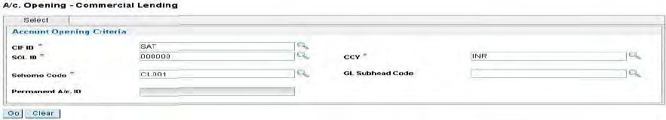

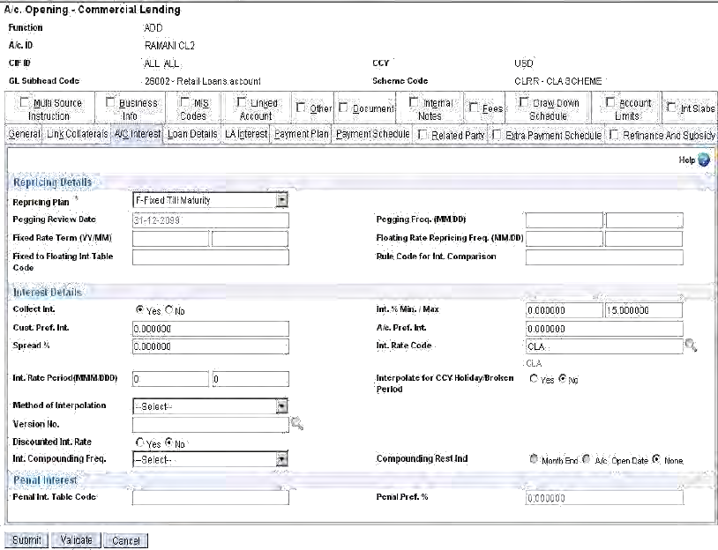

Verification of the account should be done using menu option **HOAACVLA.**

To enter the details the user should visit and fill up the following mandatory tabs:

1) General details 2) A/c Interest 3) Loan Interest 4) Loan Details 5) Payment Plan 6) Payment Schedule 7)Draw Down Schedule 8) Document 9) Related party 10) Fees 11) Others.

**Note:**

1. If the Product is of draw-down interest met down interest method is supported only for non-EI type of loan accounts.

ACCOUNT MAINTENANCE –HACMCL

For any further maintenance of the account the user has to invoke HACMCL menu option. It is possible to change many of the information except Interest, Restructuring/Rephasement, Name change, Short name change for which there are separate menu options available.

DRAW DOWN

In commercial Loan Disbursement is termed as Draw Down. This is actually a transaction creation process. Disbursement will happen based on the draw down schedule in comparison with the notice recorded in the system. The menu option for draw down is**HCLDRDN.**

If advance interest is to be collected, it would be done up to the date mentioned in the draw down schedule. An advice can also be sent for the draw down based on the flag ticked. On accept from the screen the user would be taken to the charge screen. All the charges that are deductible would be shown. The user can select the ones he would like to collect and <Accept> to proceed further.

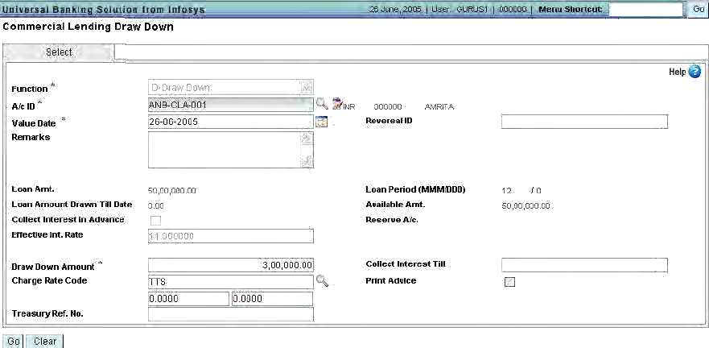

DRAW DOWN MAINTENANCE - HCLDSM

In case the draw down schedule is not maintained as a part of the account opening, the same can be done using the menu option –HCLDSM

This menu is used to do any modifications and also to add additional records even if there are no previous records. Any modification that is done requires verification by another user. The verification has to be done using the same menu option.

This menu option can be used for carrying out following functions:

M –Modification, C –Cancellation of drawn down, X –Cancel of modification done, V – Verification of modifications done, I –Inquiry

DRAW DOWN NOTICE MAINTENANCE - HCLDN

Customers are required to give notice of draw down. As a part of the account opening, draw down schedule would have been drawn. But in order to actually draw the money the customer is required to give notice. This is again dependent on whether such a notice is required or not which is set up at the time of defining the product including the exceptions associated with it. In case it is required the user can invoke menu HCLDN to record receipt of the notice.

DRAW DOWN LEVEL INTEREST CALCULATION

In case of commercial lending, it is possible to have different rate of interest for each of the draw down. When the interest is calculated, system will use the interest rate attached to each of the draw down. In this case System will apply interest to the extent of amount drawn against each of such draw down.

Draw down level interest is applicable only for Non EI type of account and the interest should be pegged for such accounts Once the roll over is initiated, all draw down will be merged and account level interest would be applied on all the drawn down done. This will be applicable till the next roll over. In order to use the feature, during account opening the flag should be ticked/set to “Y” for “Draw Down level interest” field.

FEE ASSESSMENT, COLLECTION AND REFUND - HLAFACR

This process is applicable for all the fees/charges that are defined as either recoverable or Deductible. In order to Assess, Assess and Recover or Recover assessed charges, the user has to invoke the menu HLAFACR which provides all the functionalities. The same menu also provides for refunding of the waived charges.

INTEREST PROCESS ACCRUAL

Accrual of interest is the first step in interest calculation process. As mentioned in the interest manual accrual is only a report and no financial transactions are created. For CLA type of accounts, interest accrual is done with the help of menu CLACCR.

INTEREST BOOKING

Interest booking is a process involving two different office accounts –Interest receivable and the P&L (Interest income account) and financial transactions are created by the system along with the report. In case of advance interest is collected and then system does amortisation. The menu option for interest booking is CLBOOK.

INTEREST CALCULATION

Interest calculation is done with a menu option LADGEN which is used. This is the

same menu option which is used for interest calculation of all loan accounts

**Note:**

* 1. This menu option cannot be used for adhoc interest calculation. ACINT menu option should be used for adhoc interest calculation
  2. Accrual and booking for retail loan & deposits are to be done using ACACCR and ACBOOK menu option.
  3. The system will not generate automatically the principal and interest demand. User has to set up a batch job –LADGEN
  4. In case of non EI accounts, if interest and principal demands are to be generated on the same day, if interest demand generation fails for any reason, system will raise principal demand. But in case of EI accounts if any of the process fails –principal demand generation or interest demand generation –entire process fails
  5. Interest frequency in General Details of ACM is not used and those fields are protected for loan accounts. The details captured in Repayment Details are used in case of loan accounts
  6. Demand generation report will show EI amount and Interest demand amount in addition to principal amount if the account is EI account (scheme wise and currency wise)
  7. Failure Report for Principal and Interest demand generation is also available.
  8. Interest calculation report similar to ACINT option of SB/CA/CC/OD A/cs
  9. In case of rephasement of account, user has to invoke LADGEN in “Force” mode.
  10. In “Force” mode user has to enter the “Value Date”.
  11. If the due of the account is extended for the immediate next instalment to be raised, then while raising the demand, the demand overdue is populated as the date extended to by the user during extension.
  12. Interest re-calculation should be initiated if the Penal interest on principal demand overdue flag is set to “YES” and the demand overdue date is extended for the particular demand.
  13. No validation has been put for the overdue date. The user needs to consciously change the same.

Any holiday is there subsequent to the interest calculation date indicated; system takes care of calculating interest based on the value set at frequency – “N” – Next day or “P” – Previous day.

AMORTISATION OF VARIOUS FEES/CHARGES AND ADVANCE INTEREST COLLECTION

The loan module provides feature to collect various charges and fees. These fees and charges can be collected upfront during disbursement. But the charges, which are

collected upfront, would be for the entire loan period. As such, the Banks may not want to recognise the entire collections as an income and would like to recognise only when it is accrued and becomes due. In order to achieve this, the upfront-collected charges/fees can be amortised as and when required. Amortisation of the fees and charges are to be done by invoking the menu **HLACAM**. In order to amortise the charges, the set up should have been done at scheme level/product level whether a charge can be amortised or not. Only such charges can be amortised by invoking this menu option

Amortisation can be done in two ways –Straight line method and Proportionate to interest method.

If any of the charges at the account level is modified, next amortisation process will take care of necessary adjustments

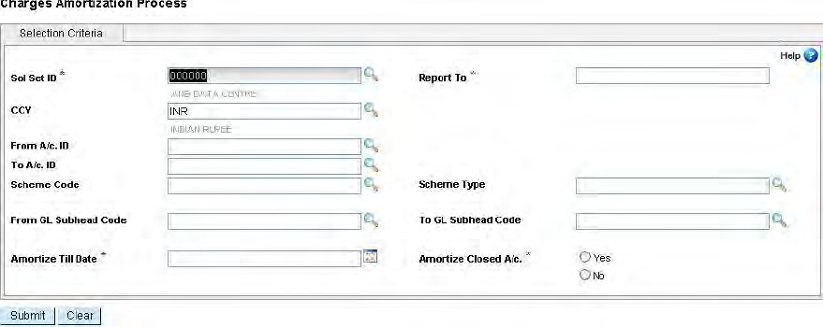

SCHEDULED PAYMENT - HCLSPAY

Schedule payment means, payment made towards the amounts which have become due. While accepting payment, Bank has the choice of apportioning the amount received to various demands that are pending as per the pre-defined terms or on line adjustments. The menu option to accept the scheduled payment is HCLSPAY.

SCREEN DETAILS

Criteria Page: This screen will capture the following details Function Code S- Payment/V-Verify/X-Cancel –Drop down

CIF ID –Pick list, Tran type –Always Transfer. Disabled radio button Type of appropriation –„S‟-System / ‟M‟–Manual –Radio button

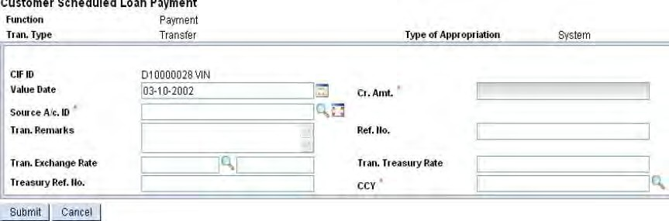

**Details Page**: This screen will capture the other details for payment.Source A/c Id Value date Credit amount. Ref No. –For OAP type of account Tran Exchange rate, Tran Treasury rate, Treasury ref no, CCY Code

**Account Details Page:** This screen will display the following detailsSol Id

* A/c Id
* Currency code
* A/c Type
* Demand Type/ Subtype
* Outstanding amt.
* Appropriation Amt.
* Amt. After Appropriation

UNSCHEDULED PAYMENT - HCLUPAY

This is nothing but pre-payment to the account. Pre-payment attracts charges depending upon the set up done. The menu option for un scheduled payment is HCLUPAY.

**Note:**

* Facility to enter maximum amount that can be accepted as prepayment apart from the existing minimum amount for prepayment
* Prepayment amount not to exceed XXX number of instalments. The total sum of prepayment so far made should not exceed the indicated number of instalments.
* The prepayment will be adjusted to the liability from last interest applied date by first in first out FIFO method in case of multiple draw downs.
* The interest calculated will be collected from the customer during the event of prepayment
* The adjustment for this interest collected amount will be done on next interest calculation for the account.
* If prepayment value date is less than last interest applied date, then interest collection during prepayment is not allowed.

▪

* Prepayment with interest calculation YES cannot be done prior to last prepayment date

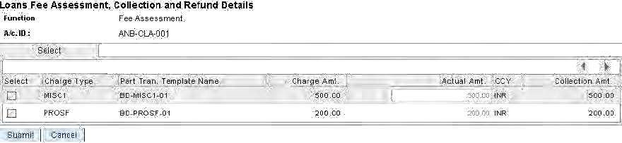

PAYOFF –SETTLEMENT OF LOAN ACCOUNT

Just like the loan payment processing that can handle schedule payments, unscheduled payment, maturity processing and reversal of transactions, for pay off an account before the maturity date, a separate menu is available. Using this menu option, the user can close the account. The menu is HPAYOFF. Using this menu option the user can close the account or do an inquiry on the closed account. Inquire can be for a future date also.

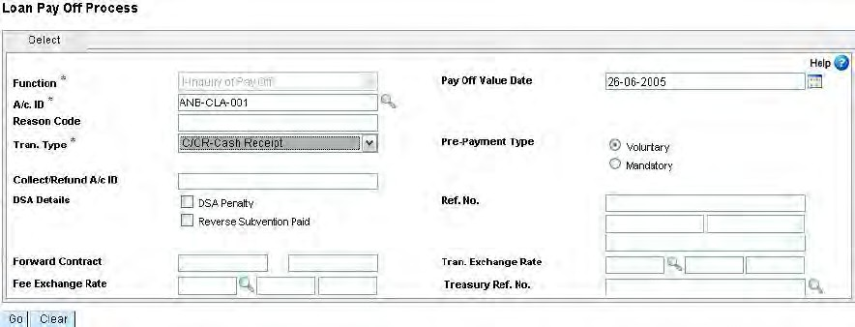

System also shows all pending charges which are not assessed, assessed but not recovered. User can do assessment and arrive at the closure amount including charges.

User can select unassessed charges if he wants to collect that also by selecting the record. Modification is permitted if allowed.

After indicating these values and <ACCEPT>, user is taken to dummy field of “Pending fee”. From here <explode> facility is available which gives the details of the fees which need to be recovered. Prepayment fee, if any, is set up, system calculates and shows the prepayment fee. From here also <explode> feature is available to see the details. Systemdisplays all the relevant data pertaining to this account. System also calculates the pending interest that needs to be collected.

REPAYMENT SCHEDULE REPORT

User can generate repayment schedule for the accounts opened by giving criteria for giving it to the borrower/customer. The menu option is HLARSH and interface is as under:

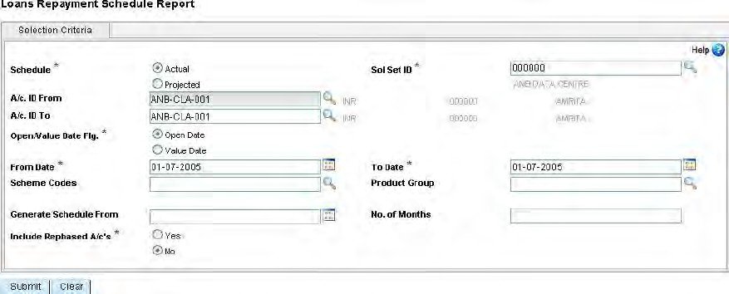

PAYOFF –SETTLEMENT OF LOAN ACCOUNT

The menu is HPAYOFF. Using this menu option the user can close the account or do an inquiry on the closed account. Inquire can be for a future date also

The functions available are “P”–pay off (close the account) and “I”–inquire onthepayoff accounts. There is also provision to do “Reversal” of the pay off.

The Payoff parameters are:

1. Apply Pay off fees
2. Payoff Not Accepted Before (MM/DD)
3. No Payoff fees After (MM/DD)
4. Payoff Interest Till date
5. Payoff Notice Flag
6. Payoff Minimum Notice(MM/DD)
7. Payoff Notice Valid (MM/DD)

The above parameters are taken for processing and validation during HPAYOFF process. During scheme creation, the value for the field payoff int. till date flag should be set to“User Defined Date” for enabling the project. During PAYOFF, the user will be able to enter the user defined months and days field so that payoff amount will be calculated with interest calc. date as:

Int. calc. date = value date + user defined months + user defined days Thisenhancement is available for both PAYOFF mode and INQUIRY mode. **PAY-OFF and INQUIRE**

Inquire about closure can be done as on date or even for a future date.

System also shows all pending charges which are not assessed, assessed but not recovered.User can do assessment and arrive at the closure amount including charges.

The user can give the Fee Waived Amt. This amount will not be considered for the transaction but the same will be displayed in the Payoff Inquiry Report.

User can select un-assessed charges if he wants to collect that also by selecting the record. Modification is permitted if allowed. After indicating these values and

<ACCEPT>, user istaken to dummy field of “Pending fee”. From here <explode>facility is available which gives the details of the fees which need to be recovered. System also calculates the pendinginterest that needs to be collected. An <accept> from here will take the user to the option block from where the following functions are possible:

There is also a feature to take a print out of the displayed information and given to customer. In that case, user has to click “Print system displays information of creating the report which can be seen in the back ground.

If the option is for closure of the account, user has to select the function “Pay off If the user invokes this process then the payoff value date cannot be greater than BOD

Date. However it can less than BOD date for a back value dated closure.

On clicking the <Go>button; system displays all the uncollected charges which are pending. The user can <select> the charges which he wants to collect. If he does not select, it means he is not collecting the charge at all. This is the last occasion for him to collect the charges. On <submit> system displays information on what is the total

amount that needs to be collecting indicating all the values.

* Principal outstanding
* Interest outstanding
* Pending fees
* Interest since last application
* Prepayment charges
* Pending Bank fees
* Amount in loan payment account
* Deferred interest outstanding

The user can waive interest if he wants by mentioning how much he wants to waive.

On ensuring the correctness of the information user can click on <Create transaction> system displays the transaction it is going to create. User can verify for the correctness of the transaction and finally submit the process

On submit the system displays completion of the process successfully

LOAN ACCOUNT RECALL

Loan account recall is functionality in Finacle in which one can recall a loan given to customer. Then the sanction limit gets withdrawn and the customer has to pay the entire principal outstanding to the bank immediately.

The penal interest for a loan account is handled separately for a loan account for the recall period. Now the recall would be handled from a menu, HLARECAL. Also if an account is recalled, the outstanding principal amount will be raised as a demand. Then the penal interest calculation will be handled normally as any other case, but off course depending on the penal interest parameters.

The menu, HLARECAL, also handles the reversal of recall also. In reversal of the recall, the outstanding amount which got raised during the recall will be reverted back to the previous stage. But if any payments happened on the loan after the recall, it will not be possible to do the reversal of the recall.

This menu would raise a principal demand for the remaining outstanding principal (not raised portion only). Hence, in combination with the existing principal demands, entire loan principal amount becomes overdue immediately.

After the recall of the account, the system would calculate the penal interest based on the penal parameters only. If an account is recalled, and customer is trying to reschedule the account, then the recalled flag will be changed to no. The reversal of recall will not be allowed if any payments are done in between.

WRITING OFF/CHARGE OFF

Charge off of an account means writing off the account. This amount is written off by appropriating the loan account outstanding to the debit of P&L account. Charging off of an account is the last stage of the account. Accounts can be marked as past due with the help of menu **HMAPD**. The menu option for charging off a loan account is **HCOLA** and the interface is as under:

The user has to select the account which needs to be written off. System supports writing of partial amount in the loan account. If the user has selected partial write off, then he has to enter the amount that needs to be written off. Else system assumes that the entire amount in the loan is being written off.

**Note:**

Whether the account is written off partially or in full, the system adjusts the entire amount which is lying in interest suspense account. This is one by debiting the interest suspense account and crediting the loan account. This is the portion of interest which is derecognised by marking account as past due.

The system displays the transaction that is going to be created as a part of this process. If the information is OK user can <Submit> to continue process.

Successful completion of the process is indicated as under:

History for Charge Off is enabled for both Retail Loan (LAA) and Commercial Loan (CLA). For each charge-off / reversal system will store tran-id, charge-off / reversal date, charge-off / reversal amount, reason code, charge-off type and mode of operation (charge-off / reversal). System enables reversal for each charge-off transaction.

VERIFICATION OF CHARGE OFF:

The charge off process requires verification. Transaction is actually created as a part of verification. User will be invoking the same menu option –HCOLA –for verification.

REVERSAL OF CHARGE OFF

If for any reason the user has done charge off of a wrong account, it is possible to reverse the process. The user will be invoking the same menu option for reversal of the charge off process.

RECOVERY/ REVERSAL AFTER CHARGE OFF

Once an account is written off/ charged off, Banks will not inform the customer that his accountis written off. In many cases Banks are able to recover the amount even after

writing off. In such cases, the recovered amount goes directly to the credit of income account as earlier expenditure account would have been debited to make provision and write off. Banks also wants to know how much of such amounts were recovered during the year. In Finacle it is possible to know the recoveries done on such written off accounts.

* Total amount of principal written off
* Total amount of interest written off
* Total amount of pending fee at the time of written off
* Total amount of charges pending at the time of written off

Apart from this, there is also a provision to accrue interest on a written off account. If any such accrual has been done, then system shows accrued interest subsequent to written off date or last interest calculated date.

Such recoveries can be by way of cash or even to the debit of an account. The Recoveries in the written off account is done through a separate menu option HRACO.

System by default adjusts the recoveries in the account to Principal. But the user has the option to modify the details and can indicate what is being recovered on the account. Based on the information provided to the system, system creates appropriate transactions to the respective accounts.

Following are the transaction that are created :

**Principal recovery**

* DebitCash/customer account Credit Loan account
* Debit Charge off account Credit Recovery loss line

**Interest recovery/Accrued Interest recovery**

* Debit Cash/Customer account
* Credit Interest income account

**Recovery of charges/other charges**

* Debit Cash/Customer account
* Credit Income account (Depending upon the Charge set up)

## 20. GUIDE TO SYNDICATED LOANS

1. INTRODUCTION

A Syndicated loan is one that is provided by a group of lenders and is structured, arranged and administrated by one or several commercial bank or investment banks known as arranger.

Borrowing by way of a loan facility can provide a borrower with a flexible and efficient source of funding. If a borrower requires a large or sophisticated facility or multiple types of facility this is commonly provided by a group of lenders known as a syndicate under a syndicated loan agreement. A syndicated loan agreement simplifies the borrowing process as the borrower uses one agreement covering the whole group of banks

1. TYPES OF FACILITY COMMONLY SYNDICATED

Two types of loan facility are commonly syndicated: term loan facilities and revolving loan facilities.

* 1. **Term Loan Facility:** Under a term loan facility the lenders provide a specifiedcapital sum over a set period of time, known as the "term". Typically, the borrower is allowed a short period after executing the loan (“commitment" period), during which time it can draw loans up to a specified maximum facility limit. Repayment may be in instalments (facility is commonly described as "amortizing") or there may be one payment at the end of the facility (facility is commonly described as "bullet" repayment terms). Once a term loan has been repaid by the borrower, it cannot be re- drawn.
  2. **Revolving Loan Facility**: A revolving loan facility provides a borrower with amaximum aggregate amount of capital, available over a specified period of time. However, unlike a term loan, the revolving loan facility allows the borrower to drawdown, repay and re-draw loans advanced to it of the available capital during the term of the facility. Each loan is borrowed for a set period of time, after which time it is technically repayable. Repayment of a revolving loan is achieved either by scheduled reductions in the total amount of the facility over time, or by all outstanding loans being repaid on the date of termination.

A revolving loan facility is a particularly flexible financing tool as it may be drawn by a borrower by way of straight forward loans, but it is also possible to incorporate different

types of financial accommodation within it - for example, it is possible to incorporate a letter of credit facility or overdraft facility within the terms of a revolving credit facility.

* 1. **General**: Syndicated loan agreements may contain only a term or revolving facility orthey can contain a combination of. There can be one borrower or a group of borrowers with provision allowing for the accession of new borrowers The facility may include a guarantor or guarantors and again provisions may be incorporated allowing for additional guarantors to accede to the agreement.

2. PARTIES TO A SYNDICATED LOAN

The syndication process is initiated by the borrower, who appoints a lender through the grant of a mandate to act as the Arranger (also often called a Mandated Lead Arranger) on the deal. There is often more than one Arranger on any transaction. The Arranger is responsible for advising the borrower as to the type of facilities it requires and then negotiating the broad terms of those facilities. By the very nature of this appointment, it is likely that the Arranger will be a lender with which the borrower already has an established relationship, although it does not have to be. Arrangers appointed by the Borrower to act as Book runner also starts to put together a syndicate of banks to provide that facility.

Syndication is often done in stages, with an initial group of lenders agreeing to provide a share of the facility. This group of lenders is often referred to as Co-Arranger. The Co- Arrangers then find more lenders to participate in the facility, who agree to take a share of the Co- Arrangers' commitment.

**Agent**:To facilitate the process of administering the loan on a daily basis, one bank fromthe syndicate is appointed as Agent. The Agent who is appointed acts as the agent of the lenders not of the borrower and has a number of important functions:

**Point of Contact**: (maintaining contact with the borrower and representing the views ofthe syndicate)

**Monitor:**(monitoring the compliance of the borrower with certain terms of the facility)

**Paying Agent**: (the borrower makes all payments of interest and repayments ofprincipal and any other payments required under the Loan Agreement to the Agent. The Agent passes these monies back to the banks to whom they are due. Similarly the banks advance funds to the borrower through the Agent)

The terms of a syndicated loan agreement empower the Agent to undertake the roles described above in return for a fee. Any decisions of a material nature (for example, the granting of a waiver) must usually be taken by a majority, if not by the whole syndicate.

If the syndicated loan is to be secured, a lender from the syndicate is usually appointed to act as Security Trustee to hold the security on trust for the benefit of all the lenders. The duties imposed upon the Security Trustee are typically more extensive than those of an agent.

In large syndicates, it is sometimes decided that some decision making power should be delegated to the majority from time to time (often referred to as the 'majority lenders' or 'instructing group'). This group usually consists of members of the syndicate at the relevant time that holds a specified larger percentage of the total commitments under the facility. By delegating some of the decision-making, the mechanics of the loan are able to work more effectively than if each and every member of the syndicate had to be consulted and subsequently reach unanimous agreement on every request from the borrower.

## LIMIT NODES

**Security can be attached to an account and SRM through Limit Node.**

* 1. **Concept –** Limit node maintenance allows the user to maintain the limitsand control the drawing power at account level, limit level etc. Limit nodes can be linked to accounts, bank guarantees, documentary credits etc. Branch

user can restrict the limit at limit node level also.

* 1. **Purpose** –To monitor party‟s total exposurehead like fund, non-fund etc.
  2. **Limit Node** can be one or multiple. If there is more than one limit nodethen the parent child concept comes into picture. Where there is more than one limit under cap then limit nodes should be multiple to control exposure at various levels.

1. Create a Master Limit Node: Menu option: **MLM**
   1. Function: Add
   2. Master Limit node:
   3. Go
   4. Max Extension period: 12
   5. Click on <Submit>
2. Verify Master Limit Node
   1. Function: Verify
   2. Master Limit Node:
   3. Click on <Go>
   4. Click on <Submit>
3. **Create a Limit Suffix Reference code: Menu option: HRRCDM**

Limit Suffix Reference: Function:

Add

Ref Code: Click on <Go> Description

Click on <Submit>

1. **Create a Limit node: Menu option HLNM**

Function: Add

Limit Id (user defined / created above through HRRCDM) Click on

<Go>

Description CCY:

INR

Limit Type: CIF----

Approval Limit: 100000

Drawing Power Indicator: EQUAL Limit Approval Date: Cntrl + X Limit Expiry Date: 26-11-2012 Master Limit Node:

Product Code:

Visit Limit Categories Tab Click on

<Submit>

1. Verify the Limit Node: Menu option: HLNM
   1. Function Verify
   2. Limit Id:
   3. Click on <G0>
   4. Validate
   5. Visit Limit Categories Tab
   6. Click on <Submit>

Now, Go to **Menu option HLTL** (Limit tree Lookup) and give limit id and see the details

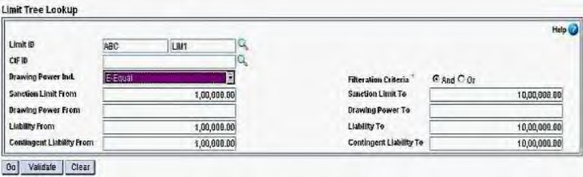

The user can indicate any criteria and inquire for the information pertaining to the criteria. On indicating the criteria and click on <go> the system display the following information as under;

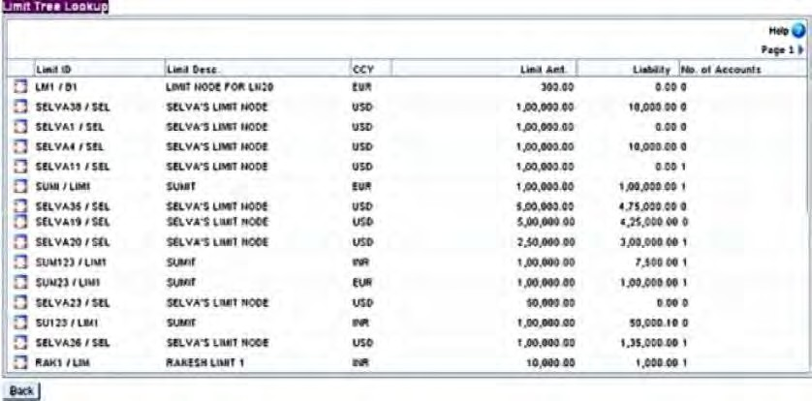

In the above menu option, the user can inquire and see the details of how exactly a

parent limit ID is utilised. This menu option gives the tree structure on the various limits that are linked to other Limits. Option has been provided to the user to <explode> from a record to see further details of a particular Limit ID.

**Limit Node Detail:**

**Creation of limit Node -** Invoke Menu Option–**LNM (Limit Node Maintenance) Creation of Parent Limit Node Function –A (Add)**

* + 1. Limit ID –This has two parts viz. Limit Prefix and Limit Suffix. Limit prefix is entered as a part of creating the limit id. It is always advisable that the customer id be used as limit prefix so that it is more beneficial from the point of usage (if Customer ID –15071959 then 15071959/TOT). Limit Suffix is the code available in the system for individual type of limit nodes which should be very carefully given. Limit ID –Suffix part, to be selected from drop down list. The system will come to the data block.
    2. Description –Free text. Generally Company‟s limit type. E.g. SEM IMPEX –Party Total Exp.
    3. Currency –HKD,SGD or INR (once the currency given and limit node is verified, the same cannot be modified through LNM, so be careful while specifying currency)
    4. Customer ID –15071959
    5. Parent Limit ID –While creating parent limit id, it will be blank for total exposure.
    6. Sanction Limit –Enter the sanction limit.
    7. Drawing Power Ind –D (Derived from Security- HCLM) as the case may

be. In Parent it should be „E‟ (Equal

* + 1. Drawing Power % - In case of parent limit id, leave it blank
    2. DP/Margin retained –leave it blank
    3. Limit Sanct/exp date –Enter Sanction date and in exp date field enter date of expiry. In case of Parent enter highest date among the exposure.
    4. Sanction Level Code –Select the code by pressing searcher. Head Office/ Regional Office
    5. Sanct. Auth. Code –Select the code by pressing searcher.
    6. Single Trans – N. If this is Y, then once the DP is utilized up to the

sanctioned limit, then customer will not be able to re-utilize it again even if he has remitted the earlier amount used. “Y‟should be in case of Loan(Fixed)

* + 1. Remarks –Free Text.
    2. User Maintained Liab. –The user can block part of the amount available in the limit by entering a value in this field. The amount available will be reduced by this value. The DP will be reduced by this value.
    3. Press SUBMIT (F10) to commit.
    4. Verification of Limit Node Menu Option **LNM,** 1. Function –V (Verify) put Limit id (suffix and prefix) Press F4. The system will display Limit Node Details. If everything acceptable, **Press Commit (F10).** The limit node id is verified.

**Creation of child Limit Node**

* + - 1. After creation of parent limit node, child limit node can be created which can be attached to the parent limit node on one side to check exposure and to HCLM on the other side to derive DP.
      2. Invoke Menu option –**LNM,** Function –A (Add) put Limit Node ID. Preferably cust_id (15011959/CCHST) should be prefix and appropriate Suffix should be selected by pressing searcher. The cursor will appear in the data block.
      3. Enter description, Currency, Customer id (D10052577) as explained above.
      4. Parent Limit Node –Should be the parent Limit ID allotted above which act as the parent limit node.
      5. Fill the remaining fields as explained in paragraph A.
      6. After filling all the details, **press F10 to commit.**
      7. Verify Limit Node
      8. Now, invoke menu option HLTL **(Limit Tree Lookup)** and observe that under parent limit node child is added to the just one level below of it.

**Attach Security to this Parent Limit**

**ID**.a. Menu Option **HCLM**

1. Function –A (Add) Linkage Type –N (Limit Node)
2. Node Id –Here put node id to which the HCLM is to be

attached. That means to which node DP is to be allowed.

1. Enter the details as explained at 2.b

NOTE:-

A.1 If the Security/Collateral is directly attached to Account then the Account will be opened first and then HCLM shall be created.

B.1 If Limit Node is to be attached to Account then first Limit nodes should be created then HCLM should be created and then account should be opened/attached

Once step A.1 is done then that HCLM cannot be attached through Limit Node and if Limit node is at all desired to be created then HCLM attached to the account shall be deleted first and then Limit node be created and rest of the process should be followed.

LIMIT NODE DETAILS INQUIRY

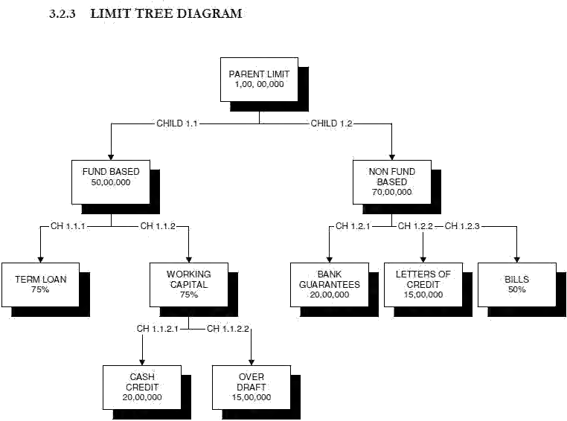**MENU OPTION: HLIMNDI**

In this menu option, the user can get information about the accounts that are linked to a particular limit node. Going by the above inquiry of LTL, HLIMNDI menu option displays following information for the limits selected Option

Option has been provided to the user to <explode> from a record in view details to see further details of a particular entity ID.

## TEMPORARY OVERDRAFTS

Temporary Overdraft (TOD) is aimed at providing business customers with flexible temporary overdraft to meet the short and urgent financial needs of the business.

Finacle 10x has the following features/provision to sanction and maintain temporary Overdrafts, which is outlined below.

* Facility to create TOD
* Sanction of TOD in advance to be made available for a future required date
* Sanction of TOD for a specific period (with number of days for which it is valid)
* Classification of TOD as Adhoc, Single and Running
* Classification of TOD as clean and secured.
* Sanction of TOD for a specific transaction (instant overdrafts)

- Provision to set up TOD creation by the system for specific batch jobs (interest application & demand satisfaction, standing instructions, drop in limits, reduction in limits, debit against flow deposits etc)

* Indicate specific rate of interest (normal & penal) at TOD level
* Provision to create TOD at the time of entry of inward clearing
* To maintain track of number of TODs allowed for the customer/account
* Report/Inquiry facility of TODs based on various selection criteria

**Terminology Explained**

TOD: TOD means Temporary Over Draft. A TOD is a limit/facility granted by the bank to its customers to draw in excess of available balance in their operative accounts, for a short period which is generally not backed by a formal sanction. In order to tide over the financial crisis period/delay in getting formal sanctions and meet immediate working capital requirements, the bank either gives clean or secured overdrafts to them.

Secured overdrafts: Secured overdrafts are those that are generally backed by

securities like government bonds, NSCs, life insurance policies, and banks own term deposits & shares and debentures of limited companies (in case of overdraft accounts) or by stocks-in trade (in case of cash credit accounts), Clean TOD: Clean TODs are granted without any security and are generally for a very short period (normally between 7 days to 15 days).

Single TOD: –A TOD granted for a specific purpose and for use only once. Once the TOD is used, it is not available again, even if the funds are replenished.

Ex. A TOD granted for Rs.1, 00,000.00 as a single TOD on 01.01.1998 and is valid up to 10.01.1998. The customer utilises it on 01.01.1998. On 05.01.1998 he remits a sum of Rs.50, 000/- to the account. The user cannot reuse the amount of Rs.50, 000/- remitted by him even though the TOD is valid up to 10.01.1998. It only allows him to avail the balance Rs.50, 000/- on or before 10.01.1998.

GRANTING OF TOD

Granting of TOD is done through HACTODM menu option. It is also possible to grant TOD for a future date.

HACTODM:

The user has to always go in the “M” –Modifymodefor creatingthe TOD. The Account ID for which the TOD is being granted is to be entered and then click on <GO>. The user has to click on „ADD NEW REC‟. The user has to enter thefollowing fields:

Grant Date –Effective date of TOD. The date from which the TOD is available for use by the account. This date can be BOD date or can be future dated.

Advance amount –The amount of TOD that is being granted now. Interest: One of the radio Buttons, i.e., A/C Level or TOD Level must be selected.

Account Level Interest –If A/C Level Int is selected, system will calculate the interest as per the setup maintained at account level.

TOD Level Interest –If TOD Level Int is selected, system will calculate the interest as per the setup maintained at TOD level.

TOD level int flag –The system puts a default value based on the set up done at Schemelevel –TOD Reference Details. If the value is “Y” for thisfield, the user will be able to indicate the Normal and Penal interest.

In order to have this feature of TOD level interest, the cust option TOD_LEVEL_INT_ALLOWED should be set to “1” and „Collect Interest Flag‟ value as

„Y‟ in HGSPM.

The user can select either the Account Level Interest or TOD Level Interest and Press the<Accept>button.

Expiry date –Date of expiry of the TOD (i.e., the date after which TOD amount is not available even if it is not utilised).

Penalty Date –Date from which penal rate of interest should be applied

Advance type –Type of TOD. There are three types of TOD that can be granted. Adhoc, Running, Single (For details refer earlier explanation)

Advance category –Whether secured or unsecured (For details refer earlier explanation)

Normal interest rate –If TOD level flag is “Y” this field table code is indicated at scheme level –TOD reference details, system populates the

normal interest rate set for that code. This is a modifiable field.

Effective Normal Interest-This field will be populated with rate as 0 if "TOD Level Int Flag" is "N". If "TOD Level Int Flag" is "Y" then this field is sum of Normal Interest, Account Preferential Interest and Customer Preferential Interest. But Preferential Interests will be included only if the "Apply TOD Pref. Interest" flag in SRGPM setup for the scheme of the account for which TOD is generated is set as "Y". This field is not enterable/modifiable.

Penal interest rate – This is populated by default, if interest table code is specified at scheme level. It is enterable/modifiable field Permitted by –This is mandatory field and user_id of the person who has permitted the TOD has to be entered Remarks –System populates the value set at scheme level. User can modify this during run time.

Event: This is a display field. The system displays the appropriate value based on the Type of TOD. The following are the valid event types

TODIN Instant TOD Granted From Transaction Maint Menu TODCL Instant TOD Granted from Clearing Menu

TODTM Auto TOD granted from Transaction Maint menu TODSI Instant TOD granted for Standing Instruction TODIC TOD Granted during Interest Calculation debit TODDL TOD Granted during Drop in Limit

TODMN TOD granted Manually

TODBH TOD granted by system for transaction created in batch TODLP TOD granted using LAPAY option (Setup should be of IN type)

VERIFICATION OF TOD GRANTED

Verification of the TOD granted depends upon the bank set up. If the bank does not want verification of TODs granted, then the same can be achieved through file type maintenance at table level. When user has a set-upwhich requires verification, done using the menu option HACTODM with function “V‟. The same user who created the TOD cannot verify the record.

**Menu-HACTODM**

After entering “V‟ and account number in function block, the user can click on the link below the Grant Date to verify the details entered:

If the details are correct, the user can click on the Cancel button to come back to the screen and then click the <Submit> button to verify the record.

INSTANT SANCTION OF TOD

A temporary overdraft (TOD) can be sanctioned instantly at the time of entering the transaction. This facility is available only if the user has defined a record for TOD Ref Type IN in HGSPM.

The user after entry of the transaction through HTM should check Grant TOD box (HTM sub option). “N”

**Menu –HTM /HCASHWD / HXFER/HICTMO/HLASPAY**

## CLEARING

Banks receive instruments such as cheques, drafts, and pay cheques issued by customers. These instruments are exchanged at the Clearing House. The process of settlement of these instruments is known as Clearing.

Inward clearing is a process whereby the Bank receives various types of negotiable instruments that are drawn on it by its customers and parts the resultant proceeds to the presenter of the instruments.

In case of Outward clearing, the Bank gets the proceeds since it acts as a collecting agent on behalf of its customers who have tendered the instruments for credit of their accounts.

Each bank or branch receives the list of cleared instruments payable to account holders. The process of lodging this information and regularizing the credit is called outward clearing. Both inward and outward clearing instruments are specified in zones to facilitate processing.

A zone is opened for each meeting that takes place for exchange of instruments between banks in a Clearing House. Each zone is associated with a zone code and the date on which the meeting takes place. Thus a zone code identifies a particular days clearing meeting.

##### OUTWARD CLEARING PROCESSES

OPENING OF ZONE

Opening of a zone can be done through HOZO menu option or using function (O) of HMCLZOH and then click on <submit> button

An outward clearing zone can be opened for processing for a given day as well for the days greater than the BOD date.

The following are the functions of the HMCLZOH menu option:

* + Open an Outward Clearing Zone
  + Suspend a Zone
  + Revoke Suspension
  + Copy Zone Details
  + Transfer Sets
  + Delete zone
  + Modify zone

##### LODGING OF INSTRUMENTS

**Lodging of Outward Clearing Instruments –HOCTM**

The user has the following options for entry of instruments

* one credit and multiple instruments
* one credit and one instrument
* Multiple credit and one instrument

NOTE: Entry of multiple instruments and multiple credits in one set is not permitted. Enter the zone date & code & click on “Go”

VERIFICATION OF INSTRUMENTS LODGED

The verification of instruments that are lodged through **HOCTM** can be done through **HOCTM** itself or using the **HOCIV** menu option. The **HOCTM** menu option facilitatesthe verification set by set whereas the HOCIV menu option facilitates bulk verification. You can also use batch verification. This can be done by using the **HOCTV** menu option. Here you have to just indicate the zone code, zone date and the set numbers to be verified. The details of the instruments lodged are not displayed. This is a Blind verification which can be done only after suspension of the zone.

MASS VERIFICATION OF LODGED INSTRUMENTS

The mass verification of lodged instruments can be done using the HOCTV menu option. However, using this menu option you can view all the instruments lodged but not verified. At one stroke all such instruments can be verified. The following screens details should be entered.

Zone Date Code: Select or type the zone date and the zone code for which sets are to be verified.

Start Set No.: Type the range of set numbers starting from which the sets are to be selected for verification.

End Set No.: Type the end set number must match with the last set number specified for that zone.

SUSPENSION OF ZONE

A zone has to be suspended once all the instruments are lodged and verified for further processing on the zone. The zone is suspended to avoid any further entry/lodging of instruments. i.e., after suspending a zone, no instruments can be lodged, modified, etc. Verification can be done even after zone is suspended. A zone has to be suspended to ensure that no more changes are done to the

RELEASE TO SHADOW BALANCE

This process creates transactions for the zone.

If the field - shadow balance flag is enabled, the transactions are created for crediting the customer‟s account directly. However the balances will be in un_clear_balance and

will be shownas “Fundsin clearing”. Bank/branch can restrict using thebalance for withdrawal by the customer.

##### REGULARISATION ZONE WISE

This process will move all the balances which are in unclear balance (Funds in Clearing) to clear balance and will be available to the customer for withdrawal without any restrictions. This happens when at the zone level, Shadow bal is enabled. If the Shadow Bal flag is unchecked, then this process will debit the intermediary account (credited during the release to shadow balances) and credit the customer‟s accounts with clear balance.

Regularization of zone in this scenario is done by invoking HMCLZOH menu option with function “G”orbyinvoking HRZFSBO menuoption. The regularization in this case happens based on each zone for which the process is initiated. If there are any instruments which are marked for pending then, regularization to that extent will not happen i.e., the zone would have been partially regularized. The user has to revoke the instruments which are marked for pending and then initiate the process again for complete regularization of the zone.

**Note**: If there are no instruments which are marked for pending, then the zone is closedautomatically as a part of the regularization process itself.

REPORT GENERATION

**HPCLSO** –PRINTING OF CLEARING SCHEDULE

This menu is used to generate a statement of Bank/Branch wise instruments, summary statement or both. The report can also be taken in file format by indicating the MRT file name. The report can be generated for a SOL or a SOL set id for any given date and zone.

**HPWO** –PRINT WASTE

This menu is used to generate a report for outward clearing instrument details for any given zone and date for a SOL or SOL set id. The screen interface is as under:

REVOKE SUSPENSION

MENU: HMCLZOH –function (V)

The zone is suspended to avoid any further entry/lodging of instruments and is used just

before further processes on the zone. If the branch wants to lodge some instruments in a suspended zone, it should revoke the suspension. Suspension of zone is also done during the end of day to avoid unauthorized entry of instruments. Next day in order to enable the users to lodge instruments, the suspension has to be revoked and is done using the above option.

MARK PENDING

MENU: HMARKPEN

In the normal course, any inward clearing instruments received at the branch have to be returned in the next day‟s outward clearing or same day depending upon the practice prevailing at the centre. Sometimes, the Bank may not be able to adhere to this practice. In such circumstances, the Bank informs the presenting branch about the delay in return of instruments and requests them not to part with the money.

In such a situation, the presenting Bank before initiating regularisation of the instruments, will mark the instrument as due for return and regularise the other instruments. Apart from this, if any of the Bank/Branch is not participating in the clearing then also those instruments should not be regularised and need to be marked as pending. This type of marking the instrument as due for return is known as marking the cheque as pending and can be done using the above option. Once the instrument is marked as pending, regularisation process will not regularise the amount of such instruments.

REVOKE PENDING

MENU: HREVPEND

The instruments which are marked pending can be revoked, if required by using the above menu option. This is generally used when the user has wrongly marked an instrument as pending. The instruments marked as pending should also be revoked so that the partially regularized zone can be regularized fully.

* + HIOCLS –INQUIRY ON OUTWARD CLEARING SETS
  + HACSBIO –INQUIRY ON SHADOW BALANCE OF AN ACCOUNT
  + HOPQ - INQUIRY ON THE OUTWARD CLEARING PART TRANS
  + HOIQ –INQUIRY ON THE OUTWARD CLEARING INSTRUMENTS
  + ACCOUNT BALANCE INQUIRY –“HACCBAL”

An inquiry into the components of available balance for any account is available through any of the above menu options.

**Funds in clearing:** This is the sum of un clear balance and Funds in clearing.

**Float balance:** This is sum of all instruments lodged for BOD date zones

### INWARD CLEARING PROCESS

OPENING OF ZONES –HMICZ –FUNCTION (O), HOICZ OR HOICZSET

Similar to outward clearing, opening of a zone is the first step in inward clearing process. The user has to open the zone to enable entry of instruments for the zone. At the time of opening the zone, the user has to indicate the BAR number,BAR date, BAR amount and number of instruments. As a part of opening the zone, system populates all the values defined for that zone defined in HICZCM and if the user wants to make any changes to the default populated values, he can do so.

The changes could be with regard to Rate code and Rate if it is a multi-currency zone, change in account numbers, charge event Ids for charge calculations etc. A zone could be opened for a particular service outlet or for a number of service outlets. If it is to be

done for a group/number of service outlets, a separate group should have been defined using HSSTM option. Opening of zones for multiple service outlets could be done by invoking HOICZSET menu option for the earlier defined set id. The following is the screen interface for HMICZ menu.

**Menu HMICZ –General details Screen 1**

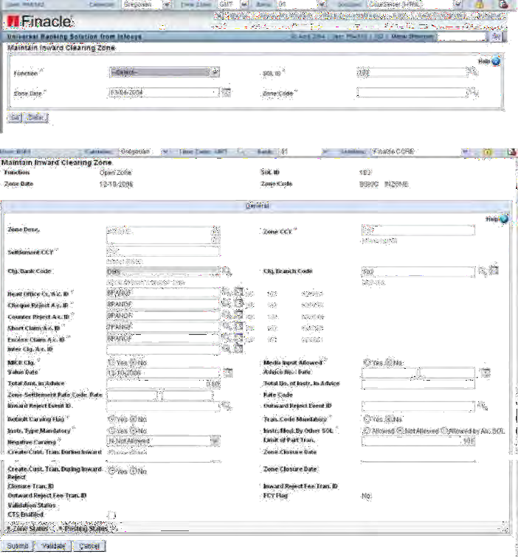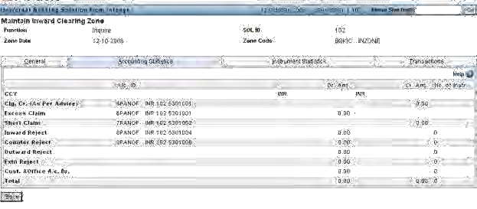

The screen which is displayed for HOICZSET is as under

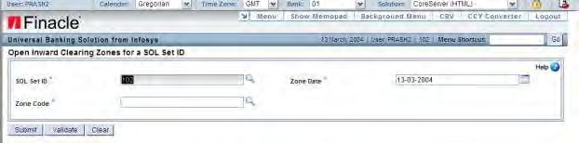

##### LODGING OF INSTRUMENTS –HICTMO

After opening of the zone is done, the user can start entry of instruments for the zone. The following are the features that are available as a part of entry of the instrument.

* Display of available balance for the account
* Facility to carve the amount or not
* Display ofcarved amount basedonthe above indicator
* Provision to mark the cheque as rejected –inward, outwardand counter.
* In case of outward rejects provision for listing of records if there are multiple records with same Instrument number.
* Entry of additional details forDD/Bankers cheque.
* Population of payee‟s name in case of Banker‟s cheque, DD drawn by a branch within the data centre or details of issue of DD has come through IBR module
* Provision to grant instant TOD at instrument level. This can be done only if “CL” type of TOD is specified at the scheme level of the account.
* Display of deficit amount for the account.
* Provision to carve the required amount for passing the instrument at the time of entry itself. This can be donebysetting value “Y” for field “Carve”.
* Provision for negative carving based on zone level flag.
* Provision to enter the report code and reference number if it is set as mandatory at scheme level.
* Provision to view exceptions that are encountered.
* Provision to change the rate and rate code at the time of entry in case of a multi- currency zone.
* Provision to change the charges calculated for rejection of cheques for inward and outward rejects.
* Provision to mark the instrument as
  + Listed but not received
  + Received but not listed
* 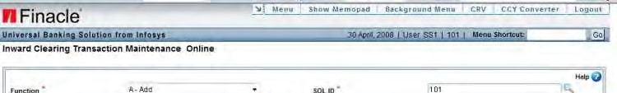Indicate the claim amount in respect of each instrument if there is any difference

121

On clicking „Go‟, the user is taken to the following screen wherein he enters the details of the inward clearing instrument:

Clicking <Down arrow> key will commit the record. For entering the details of the issue

bank code and branch code in case of Demand d and “Branch code” in the HICTMO screen.

Before going to the next record, system validates for all errors and forces the user to enter the mandatory information. User can see all the exceptions by clicking on Show Exceptions tab.

If the carved flag is set to “Y” the carved a reject, the user will be forced to enter the rejection details. If the currency is different andrate is not entered it will force the user to enter rate and if there is any rate corresponding to that rate code, system displays the same, otherwise the user has to enter the rate also. Additional details screen can be visited for marking the instrument as listed, received, to enter claim amount if there is any difference. This screen can also be used to indicate the rate code and rates if it is a multi-currency zone for conversion of amounts.

If the user has not enabled the negative carving field at zone template level, system will not allow the user to use the feature during entry of instruments, if the available amt in the account is lesser than the cheque amount.

In case the instrument is marked as rejected, carving flag should be set to “N”. In case of inward reject, the user has to enter the details of presenting bank and branch code or sortcode. Also, the user has to enter the reject reason code.

The user can modify the charges by visiting the charges screen

If there is any difference between the listed amount and instrument amount, the listed

amount should be indicated in the “claim amount” field. The difference between the actual instrument amount entered in HICTMO screen and this value will either be reflected eitheras a short claim or an excess claim.

This is also true in case of “listed” and “received” field values.

GRANTING INSTANT TOD FROM HICTMO

Facility is provided to grant instant TOD from HICTMO at each instrument level. This can be done provided the type of TOD is “CL” –Granting of Instant Clearing TOD at the scheme level of the account. The actual granting of TOD is done only when the part tran related to the instrument is posted.

In order to grant the instant TOD, the user has to enter the value “Y” for the field “TOD” in HICTMO screen and <explode>. On <explode> the user will be shown the following screeninterface for entering the details of instant TOD.

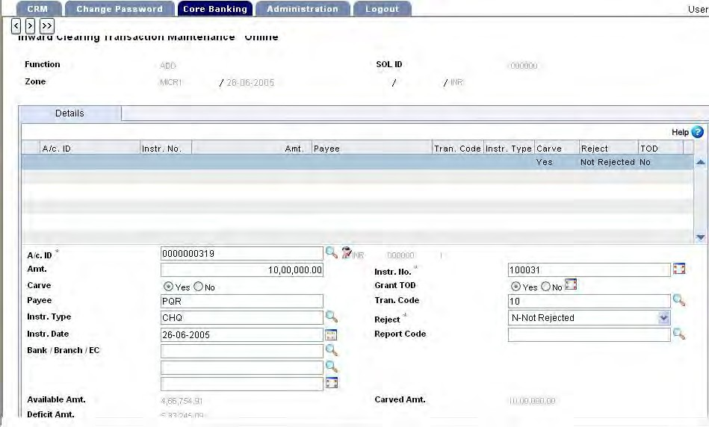

Between the time of granting instant TOD and initiating the posting process, if any credit has come to the account as a result of which TOD is not required for passing the cheque,then the system will not create any TOD record even though the user has ticked “Grant TOD” in HICTMO.

On clicking „Submit‟, the user is taken to the following screen:

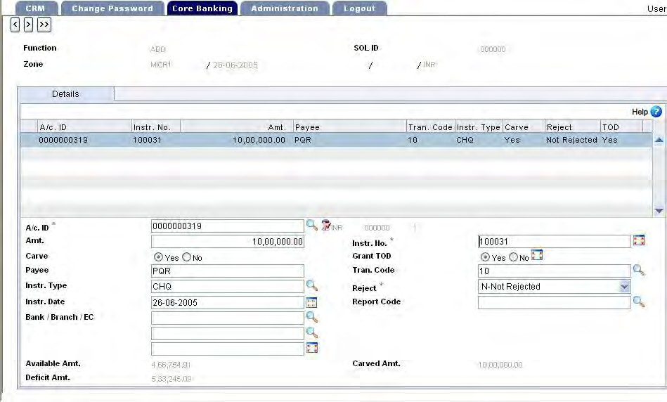

The user can click on „Submit‟ button to accept the instrument. As mentioned earlier

<arrow down> key will commit the previous record, and before committing system does all scheme level, account level validations and displays a message “exceptions encountered” if any. At this stage, if the user wants to know what the exceptions are, he can do so by clicking on “Show Exceptions” which will display alltheexceptions it has encountered in respect of the account.

##### INWARD RETURN /REJECTION OF CHEQUES

If the user wants to reject an instrument entered as a part of the entry itself, then it

canbe done so by entering a value “I”– inward reject or “O” – outward reject, “C” – counter reject. Once the value is entered for reject, the user has to enter the rejection details.

If the reject type is outward, system will list all instruments lodged in outward clearing which are not regularised and have the instrument number which is equal to the one entered in inward clearing. The user can select the appropriate record for marking it as rejected.

If the reject type is inward, user has to enter the collecting bank/branch details with the reason for rejection. The rejection screen can be invoked by clicking on the help button and the screen which is brought up by the system is as under. The user has to enter the presenting sort code or presenting bank & branch

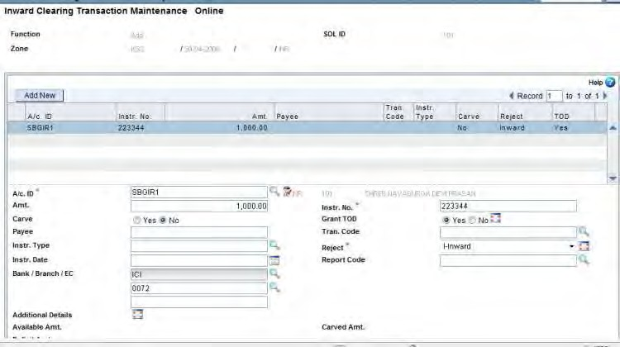

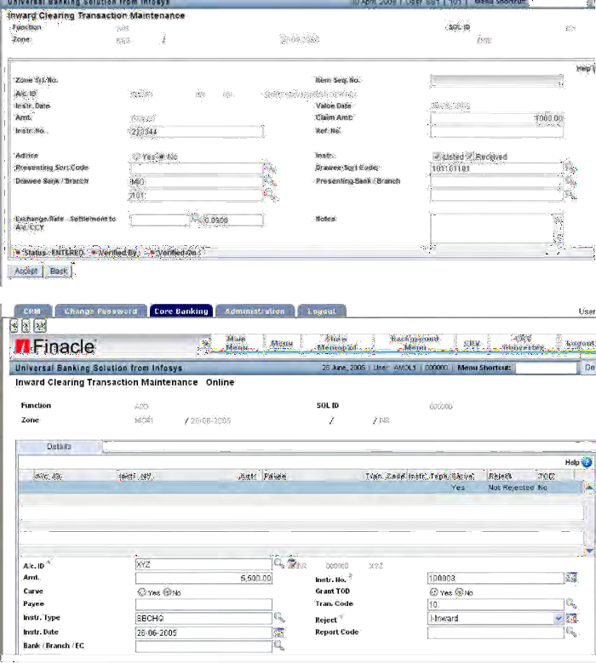

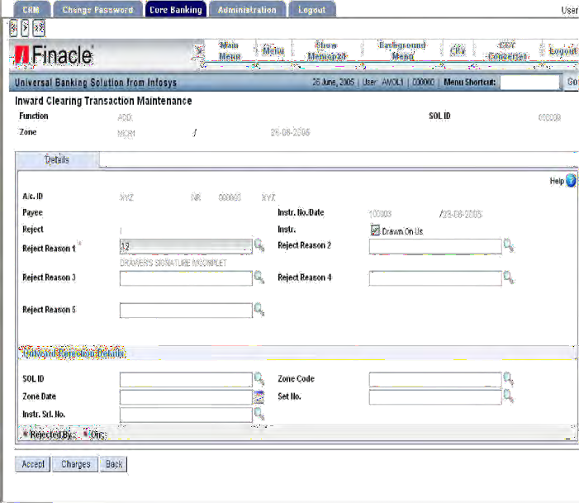

The user has to enter the reject reason code.

##### ENQUIRY OF REJECTED CHEQUES

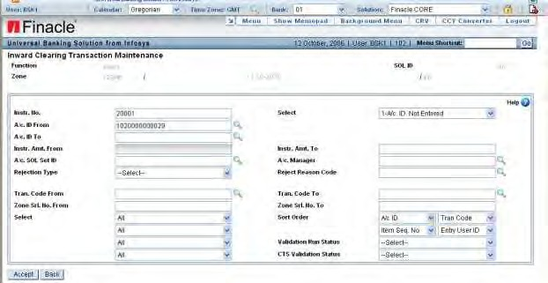The field Reject reason codes helps in filtering the rejected instrument from the inward cheques on the basis of specific codes and displaying them.

Screen for display of outward clearing instruments if multiple records are there for same number. The user can select the appropriate records from the list displayed.

In case of outward and inward rejects, if any charges have to be collected, the system will collect it based on the charge event ID Specified at zone level.

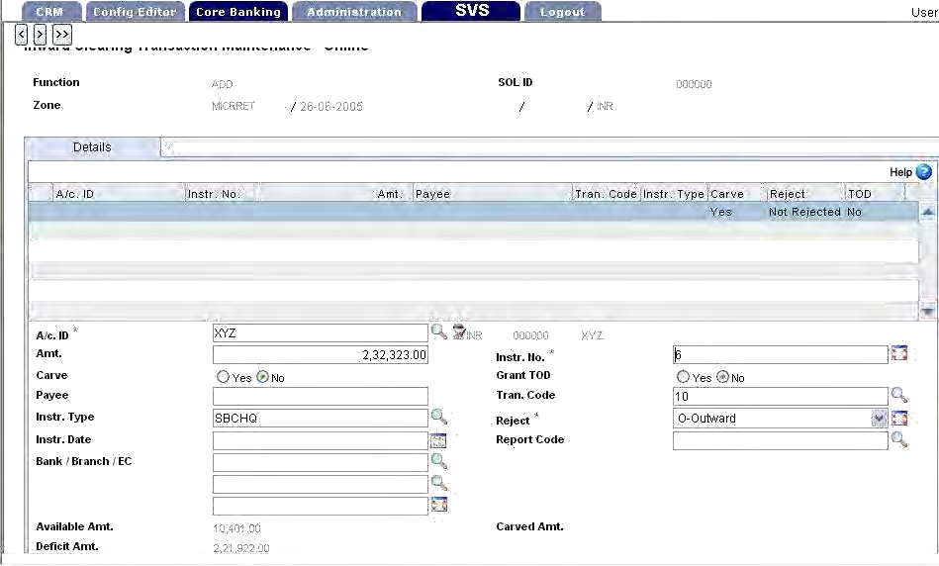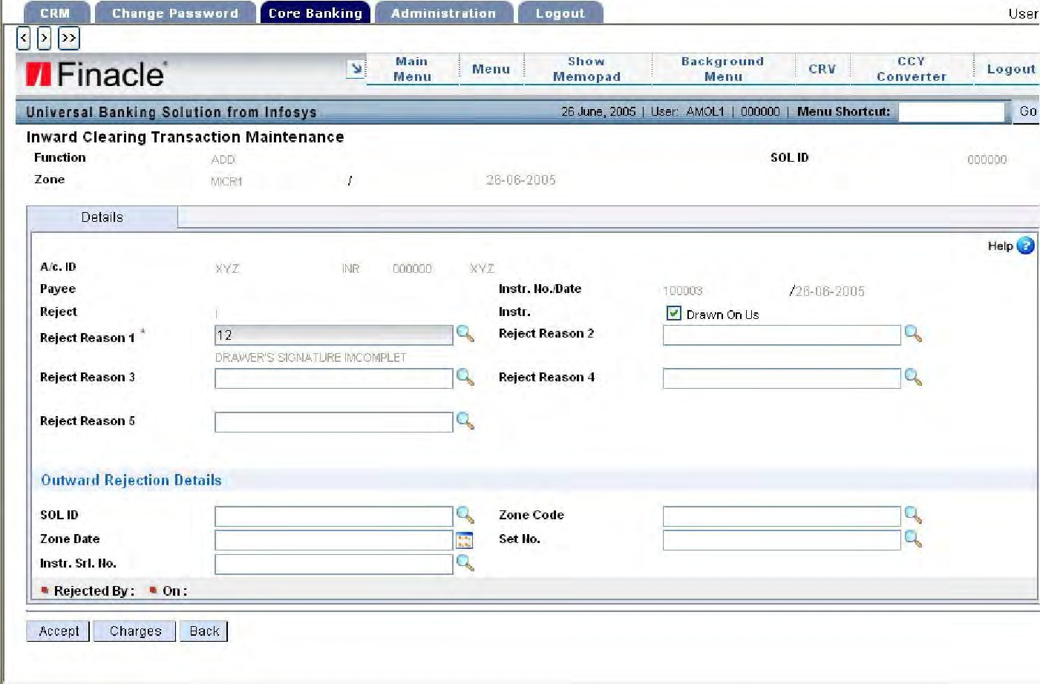

If the user wants to make any changes the user can invoke the following screen by clicking on “Charges‟buttonand modify the charges, if required. The following is the screen displayed for charge modifications.

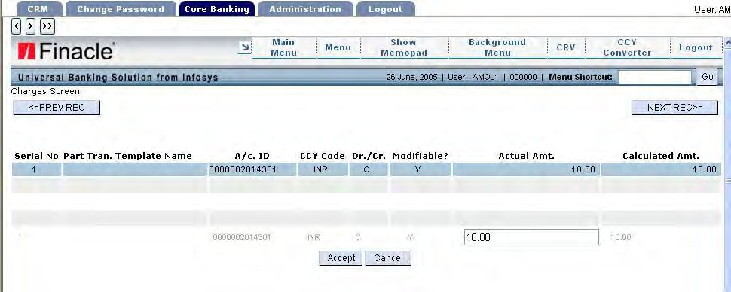

The user can modify the charges or accept the same. The transactions for the rejection charges will be created as a part of closure process of the zone. In case of inward rejects, the system will create dummy transactions to the customer‟s account to show that an instrument had been received in clearing and was rejected. This is based on the value setup at HICZCM level for the field “Route Reject tran through A/c.” If the flag is checked, system will create one debit and one credit transaction to the customer account.

VERIFICATION OF INSTRUMENTS LODGED THROUGH HICTMO

The user has to invoke the HICTMO menu for verification of the instruments lodged for a zone. The user will use function (V) for verifying the records and furnish the other particulars like zone code and zone date. If he does not indicate any criteria all the records will be selected. The same user cannot verify the records. The screen interface is given as under:

On clicking‟GO”,the user is taken to the following screen:

129

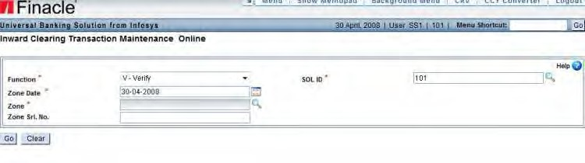

130

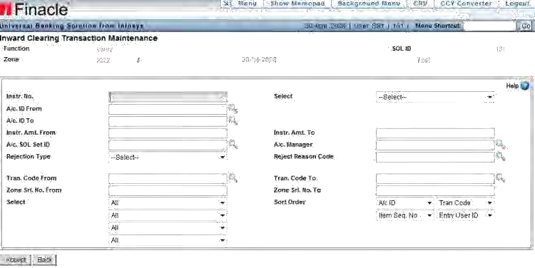

Here the user can give various selection criteria or just accept which will list out all the instruments entered. The screen interface is given below:

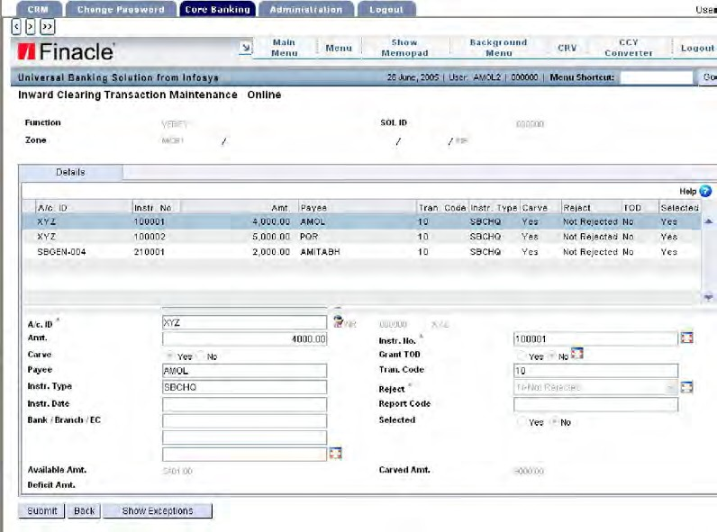

If the user does not want to verify some of the records, he has to go and deselect the records from verifying. The verifier can view all the details associated with the records like additional details, charges calculated, rejected details etc. before verification.

##### SUSPENSION OF ZONE –HMICZ

After all the records are entered, verified the zone has to be suspended for further processing of the records of the zone. It is done by invoking the menu HMICZ with function as (S). The screen is similar to the one.

##### VALIDATION RUN –HMICZ

This is a process which is required to be done before initiating the process of posting the zone. This process generates a report which indicates all the possible errors/exceptions the system is going to encounter when trying to the create transactions and post the same. Based on this report, the user can take appropriate actions/decisions to overcome the errors/exceptions without which the transactions cannot be posted. Such transactions will be in entered status only and the user has to initiate the Transaction Maintenance screen and post it separately. The validation run can be initiated any number of times. But the system will not do one more validation if there is no change in the earlier status of the Instrument. A second validation will be done only when there are some changes done to the records after the first validation is done. The validation can be done based on criteria selection. The user has to invoke HMICZ in Validation mode (Function (V)) from where the User will be taken to the following screen for criteria selection.

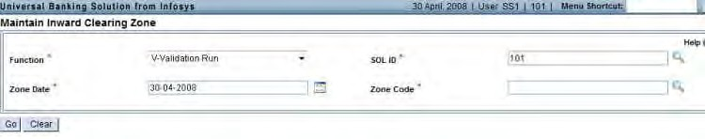

From the above screen the user is taken to print parameter screen. A report is generated for the validations done and user can either print it online or from the

background based on the values indicated in print parameter screen. The user can indicate the MRT file name to get the report the way he has defined.

HMICZ (T) –PRINTING OF VALIDATION REPORT

A separate function for printing of validation report has been provided to enable the user to take report whenever he wants. This can be done by invoking the menu HMICZ withfunction “T”. This report can be taken any number of times. Generation of this report does not carve the amount as done in validation process.

##### POST RUN OF THE ZONE –HMICZ

When all the above processes are over, the user can initiate posting of the zone. This process creates transactions and posts the same. Posting of transaction depends on the availability of funds, exceptions encountered etc. This process also generates a report of the transactions posted, failed etc. The user can open the file and view the details. The file will be available in the background menu. Post run can also be initiated any number of times. After initiating the post run, again the zone could be re-opened (via revoke suspension) for modification, verification and validation etc. and again re- initiate post run of the zone.Modification of instruments is allowed only where the transaction is in entered status. Any modification at this juncture will delete the originally created part transaction and creates a new part transaction for the modified record.

In order to invoke posting, HMICZ menu should be invoked with function (P).

##### CLOSURE OF ZONE –HMICZ

This is the final step in the inward clearing processes. The zone has to be closed to ensure that no further operation is initiated on that zone. This can be done by invoking the HMICZ menu with function (Z). End of day operation validates the status of inward clearingzones. System would raise the exception “Unclosed inward clearing zone exists” if it is attached/linked at HSCFM level.

In case if the number of transaction per tran id is set, transactions during posting would be created for the intermediary account specified at zone level for crediting the proceeds. The closure of zone process reverses the transaction put for the intermediary account and credit the clearing credit account. If any charge is to be collected for

rejections done, those transactions are also created as a part of closure of zone activity.

##### REVOKE SUSPENSION –HMICZ

When the zone is suspended, the user cannot add any records/instruments. In order to enable the user to enter instruments subsequently, suspension of zone should be revoked. This is done by invoking HMICZ menu with function (R).

UNLOCK ZONE

If for any reason during the inward clearing processes, the system results in a fatal error,the process gets terminated abnormally and the zone gets “locked”. I will not be able to carry out any further processes. In such a situation, the user has to

invoke the menu HUNIZ and unlock the zone

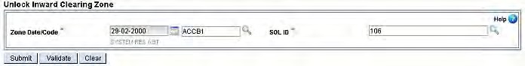

REPORTS

The following reports are available for inward clearing HPICW –PRINTING OF INWARD CLEARING WASTE The report can be generated for a SOL, SOL set id.

HPICS –PRINTING OF INWARD CLEARING SCHEDULE

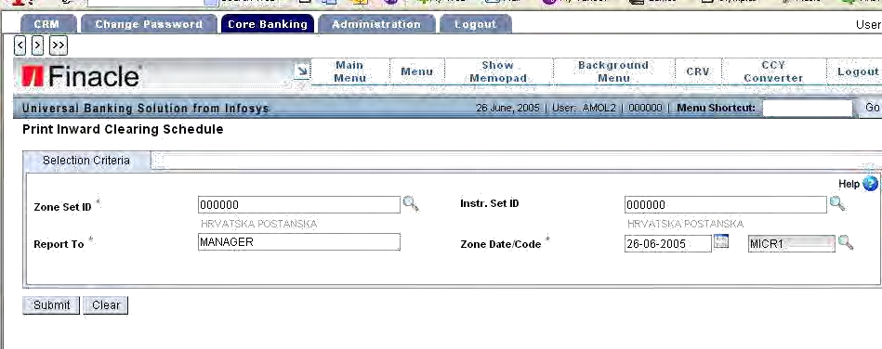

With the instrument set id a report can be generated for instruments lodged for accounts belonging to a particular SOL

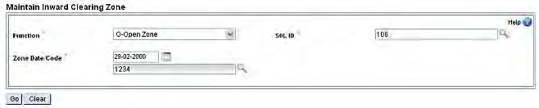

HREJREP –PRINTING OF ADVICE AND SCHEDULE OF REJECTED INSTRUMENTS& HPRR25 - REPORT OF REJECTED CHEQUES

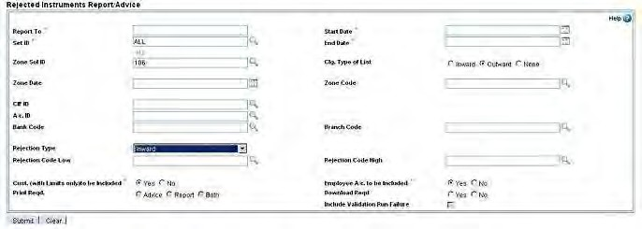

This menu helps in generation of a report or an advice to the customer in respect of instruments rejected for both inward, outward clearing.

INQUIRIES MENU: HMICZ

The user can invoke the above menu option to inquire the details of a specific zone. Inquiry is possible on General details, Transaction details and Statistical details. All these inquiriescan be done through sub option –G, T, and S. G - General details of the zone. This has information on two screens

LOAN PAYMENTS BY CLEARING:

Finacle is enabled for lodging clearing instruments for credit to Loan accounts.The following validations are required for lodging an instrument for a loan account:

* + The part Tran creation should be Instrument wise (the relevant field in HCLZCM set as "I". This is necessary, for rejection of instruments, (where there are multiple instruments in a set) to go through correctly.
  + Instrument lodging for a Loan account will not be allowed if the loan account status is not complete or if the account is charged off. The checks mentioned in pts 1 and 2 will also hold good during the upload of outward clearing instruments.
  + When the transaction is created for crediting the loan account, either during release or regularisation, the collection flow id will be chosen appropriately from the flow ids set up in HGSPM. For normal loans the collection flow id will be the one set in Default Collection Flow ID and for past due loans the flow id is the one set for the parameter Past Due Collection Flow ID.
  + The credit to the loan account will (either through instrument wise or zone wise) adjust the demands due.
  + The value date of credit will be as per zone value date or instrument value date.
  + The loan statement (HLAPSP) will print clearing credits and the reversal transaction due to bounced clearing cheques (only when the shadow balance flg = YES)
  + Outward clearing return for a loan account will go and reverse the credit posted during release to shadow balance.
  + Payments made through clearing cheques will offset demands raised to loan account only. It will not offset interest demands where interest is routed through loan interest account. For such cases loan payment account will have to be used.
  + Cheque return charges need to be handled manually as per the laid down norms.

## DEMAND DRAFT

OVERVIEW

Demand Draft is a mode of remittance. In this mode of remittance, the instrument is drawn on another bank or branch.Similarly, banker‟s cheque, cashiers cheque, manager‟scheque or pay order (referred to by various names) are other such instruments through which money is transferred from one person to another person. However, in case of a demand draft the instrument is drawn on the issuing branch itself. That means the payment is made by the branch which issues the instrument. Banks offer services such as demand draft, banker‟s cheque, cashiers cheque, manager‟s cheque and pay order, against a service charge which is one of the major sources of income to banks. Apart from issue and payment of drafts, activities such as cancellation, rectification, re-validation, reversal and noting caution, also form part of the DD handling process. Automatic charge calculation, calculation of special charges for special customers also form an integral part of this business requirement. However, in case of a pay order it is not necessary to reconcile as it is issued and paid by the same branch and entries are matched automatically during the payment process.

SECTION OBJECTIVE

* Issue of draft/bankers cheque
* Payment of draft/bankers cheque
* Marking draft/bankers cheque as lost
* Marking of non-payment of drafts
* Issue of duplicate draft/bankers cheque
* Cancellation of draft/bankers cheque
* Marking drafts as paid
* Reversal/Rectification entries
* Status Maintenance
* Inquiries –issue, payment etc.
* Printing and re-printing of drafts
* Reports –registers, schedules, daily statement etc.

TERMINOLOGY REVALIDATION OF DRAFTS

A draft is valid for specific period from the date of issue. Thereafter it has to be revalidated by the issuing branch at the request of the purchaser.

PAYMENT OF BANK DRAFTS

When a draft is presented for payment, the draft is paid after marking off the relative advice and after entering in the draft paid register. In case the advice is not received, the draft will be entered in Draft Ex-Advice Register

CANCELLATION OF A DRAFT

If the purchaser does not want to utilise the DD, he can cancel the same, by surrendering the original DD to the issuing branch.

ISSUE OF A DUPLICATE DRAFT

When a draft is reported lost by the purchaser, the drawee branch is advised to exercise caution in case the draft is presented for payment. After receipt of the non-payment advice, a duplicate draft will be issued against an indemnity executed by the purchaser.

CHARGE EVENT ID

In case of demand drafts following events have been identified for charge set up: DDI –Draft issue

DDD –Issue of duplicate demand draft DDC – Cancellation of demand draft DDP –Payment of demand draft

ISSUE OF DRAFT/BANKER CHEQUE –MASS ISSUE

Issue of draft / banker‟s cheque are done by using a menu option **HDDMI.**

**Value Date**:The user can issue a value dated DD. This value date will be only used fortransaction creation; however issue date will be following existing logic.Value date will be default populated with BOD, and it has been set as mandatory input for add operation. In other mode, this date is not modifiable.

**DD A/c id**: appropriate DD a/c no based on the DD type must be selected by the user. i.e.,if the bank is using different DD a/cs for banker‟s cheques, DDs on branches within the same Data Centre and others, the respective a/c opened for issue of these DDs should be selected by the user.Upon clicking “Go”, the screen will appear.

This shows the details of the first DD taken. Upon clickingthekeyon the right side, the application will take you to the next record which will be in running serialNumber.

**DD Amt**: DD amount has to be entered. The actual amount of the DD in Home currencywhen a cross currency DD is issued.

**Drawn on**: DD drawn on bank and branch is entered.

**Payee**: The payee name has to be entered.

Upon pressing‟Submit” key, thetranidisgenerated.

The above interface is a multi-record screen. The following functions are possible in the above option

* + A - Issue by ADD function
  + D- Delete
  + M - Modification
  + P - Posting
  + R - Printing of DD.
  + I –Inquire

Note:

* + if the user wants to issue mass drafts by using a cheque proper set up should have been done at scheme level and HSCFM level
  + All the drafts issued should belong to same currency
  + Multiple DD issued is on behalf of only one purchaser
  + In order to change the charges user has to click on “Fee‟and modifydetails in theamount column.
  + It is possible to debit two different operative accounts for DD amount and DD commission separately.

Click **Edit fee** or Fee Details to modify fee details for any or all the records. The Fee for DD Issue screen is displayed

Click **ACCEPT** the view the details of the DD

Click Additional Details icon next to the Advice Mode

**Note: Demand drafts can also be issued / paid through HTM menu option by visiting the additional details.**

PAYMENT OF DRAFTS/BANKER CHEQUES IN MASS –HDDMP

When the user wants to make payment of drafts in mass, the user has to invoke menu HDDMP. After typing the normal transaction details, if a duplicate record is found, then

a pop-up screen appears listing multiple records corresponding to that DD number.

By selecting the appropriate record, the user will be taken to the additional details screen where he has to enter the additional details.

The following are the points which the user has to note while making the mass payment.

* + - All drafts should be paid to debit of only one account
    - Credit account can also be only one account
    - This is a multiple record screen and user has to use <arrow down> key to enter additional record
    - There will be a consolidated credit for the credit account
    - The same menu is used to pay multi-currency draft also

The following are the operations that a user can perform by invoking the above menu

* + - A –Add records for payment of draft/banker cheque
    - D- Delete
    - P –Posting of transaction
    - M –Modify
    - I –Inquire

PAYMENT OF FOREX DEMAND DRAFTS IN MASS –HPFDDM

The HPFDDM menu option gives user a feature to have multiple rates for the same remittance transaction. This is applicable while paying DD in a currency different than that of the purchaser. The menu option HPFDDM is capable of storing the board/contract rate details for the DD to be paid if the payment currency is not the same as the DD currency. The screen is changed accordingly. Usage of multiple rates/tiered rates are not possible with HDDMP menu option.

CANCELLATION OF DEMAND DRAFT –HDDC

A draft/banker cheque after issue can either be paid in the normal course or the purchaser has a right to ask for cancellation of the same by producing the instrument and ask for refund of money.

The customer can cancel the demand draft by giving a value date. Value date is default populated with BOD Date however the user can change the date. During posting operation this date will not be modifiable.

The menu is HDDC.

CANCELLATION OF FOREX DEMAND DRAFTS –HCFDDS

The cancellation can be done at the issuing branch or at any other branch. The bank can collect/modify charges at the time of cancellation.

DD‟s which are issued through the HDDMI menu option involving only one exchange rate and in the same currency can also be cancelled through the HCFDDS menu option.

The menu is–Forex“HCFDDS”cancellation.

RECTIFICATION OF TRANSACTION –HDDR

Some Banks have the concept of rectification of DD entries. If by mistake a Draft has been issued for either a higher amount or lower amount, one more rectification entry will be passed to set right the situation.

ISSUE OF DUPLICATE DEMAND DRAFT

The normal process of issue of a duplicate draft is as under:

* + Mark the draft issued as LOST
  + Get confirmation from payee branch and as draft is NOT PAID (not applicable in case of centralized environment)
  + Issue duplicate draft

MARK THE DRAFT AS LOST

In order to mark the draft as LOST the user has to invoke the menu **HDDLOST.**

MARKING THE DRAFT AS NOT PAID

The user has to invoke **“HDDNPADV”**menu option for marking the Demand Draft as not paid.

DD STATUS MAINTENANCE (HDDSM)

A separate maintenance menu has been provided to maintain the status of drafts. The user can carry out following functions:

* 1. DD, M-MODIFY, I-INQUIRE, L-LIST, V-VERIFY, X-CANCEL, D- DELETE, U-UNDELETE.

This maintenance menu is required for the following reasons:

* + - to maintain data relating to the drafts/bankers cheque issued prior to computerization on which subsequent events can happen
    - at the payee branch to maintain the status of Draft reported lost, stopped payment of draft, issue of duplicate draft etc.
    - To verify the status at the time of issue of duplicate draft –If a draft is already marked as paid, issue of duplicate should be controlled
    - to verify the status at the time of issue of cancelling draft –If a draft is already marked as paid, cancellation of draft should be controlled
    - To revalidate a draft if it has become stale.
    - The system automatically updates the status of draft depending upon the event that is happening on the draft/instrument.

TRANSFER OF BALANCE FROM DRAFT ACCOUNT TO HO ACCOUNT: HDDT

Banks have a practice of transferring the outstanding balances in drafts account at periodical intervals to HO account for reconciliation purposes as on any given date.

By this process the balance in draft account

PRINTING OF DRAFTS

* + - PRINTING OF A SINGLE DD - HDDPRNT
    - PRINTING OF ALL UNPRINTED DRAFTS- HDDPALL
    - BATCH PRINTING OF DRAFT: HDDBP

REPRINTING OF DRAFTS: HDDREPRNT

Reprinting of drafts can be done only when the original printing is already done. The user will not be able to select a record for reprinting which is not already printed. Reprinting is also required to print the draft after duplicate is issued.

DD MODIFICATION: HDDMOD

Modification of draft after issue or payment can be done in respect of the following fields

a) DD issue branch code and b) Payee name

The modifications can be done even after the transaction is posted and also after EOD/BOD. This means modification is allowed even in respect of old records also.

REPORTS

PRINT DEMAND DRAFT REPORT: **HDDPRPT**

HDDPRPT menu option is used to print the demand draft report. User can give criteria

like issue set ID, print SET ID, from date and TO date and generate the report.

GENERATE BANKERS CHEQUE RECON REPORT: HBCREPRT

This menu Option is used to print a bank and branch-wise list of DDs or bankers cheques that are reconciled or un-reconciled by the bank based on the criteria selected.

DEMAND DRAFT MODULE

HDDMI Mass issue of DD

HDDMP Mass payment of DD HDDPRNT Printing of single DD

HPFDDM Payment of forex demand drafts in mass HDDPALL Printing of all unprinted DD

HDDBP DD batch printing HDDREPRNT Reprinting of DD HDDC DD cancellation

HDDD Issue of duplicate draft

HCFDDS Cancellation of forex demand drafts HDDLOST Marking of DD as LOST HDDNPADV Marking DD as not paid

HDDADV Marking DD as paid

HDDPADV Marking receipt of advice in case of ex-advice payment HDDR Rectification of DD

HDDII Specific DD issue inquiry

HDDIP Specific DD paid inquiry HDDIC DD credit inquiry

HDDID DD debit inquiry

HDDIR DD issue register

HBCREPORT Banker cheque reconciliation report HDDP Printing of various DD reports

HDDT Transfer from DD account HDDMOD Modification of DD HDDSM DD Status Maintenance

HDDPRPT To print Demand Draft Report HBCREPRT Generate Bankers cheque recon report HDDXFR DD TRANSFER TO HEAD OFFICE

## BILLS

**Introduction**

Collection of bill and cheque is one of the many services that banks offer to their customers. This service is specially designed for the benefit of the trading and business communities. It is necessary that collection are handled expeditiously, as delay in collection hurts the customer considerably as he cannot utilise the proceeds in time.

**Types of Bills**

The bills are broadly classified as:

* Demand Bill
* Usance Bill

**Demand Bill** –A demand bill is one on which payment should be made immediatelyafter the bill is presented and amount is demanded. The documents are delivered against payment.

**Usance Bill** –A usance bill is one on which payment should be made within a specifiedperiod of time after date/sight/acceptance.

**Demand Bill** –can be further classified on the basis whether the document of value ordocuments of title to goods are attached with it or not.

1. **Clean Demand Bill** –A clean demand bill is one with which documents of valueor documents of title to goods are not attached.
2. **Documentary Demand Bill** –A documentary demand bill is one with whichdocuments of value or documents of title to goods are attached.

**Usance Bills** can be classified as -

1. **Clean Usance Bill** –A clean usance bill is one with which documents of value ordocuments of title to goods are not attached.
2. **Documentary Usance Bill** –A documentary usance bill is one with whichdocuments of value or documents of title to goods are attached.

**Documentary Usance Bill** is further classified as-

1. **Documents Against Acceptance** –D/A bill is one where documents are to bedelivered against Acceptance.
2. **Documents Against Payment** –D/P bill is one where documents are to bedelivered to drawee against payment although the usance bill has been accepted earlier.

NOTE

A usance documentary bill should be treated as DA or DP as per the instructions of the drawer. If no specific instructions have been received, the bills should be treated as DP.

BILL PURCHASE ACCOUNT

The advance is referred to as „Bill Purchase Advance‟. The banks debit the Bill Purchase account during purchase / negotiation of the bill. The bill purchase accounts are openedunder scheme type FBA.

NOSTRO & VOSTRO ACCOUNTS

When Bank„A‟ opens an account with Bank „B‟ (which is located in another country), then that account is called (from A‟s point of view) a NOSTRO account. The same account will be called a VOSTRO account (from B‟s point of view). The account will be generally in B Bank's country currency (In case of ACU countries, the Bank, through situated in one of ACU countries may hold NOSTRO in USD a/c). This can be set up through HCBAM option in Finacle.

BUYER / SELLER LIMITS

Using HCCFM menu option, one can maintain information related to a customer. Use this option to maintain specific general information about the customer. You can view the customer list and monitor customer-related details.

**Inward or Outward Bill**

Based on Inland/Foreign Indicator in criteria screen, either Export/Import Indicator or Inward/Outward Indicator will be shown.

IMPORT & EXPORT BILL

In export bills, documents go out of the bank and proceeds come into the bank. So the bill is referred to as Export Bill. In import bills, documents come into the bank and proceeds go out of the bank. So the bill is referred to as Import bill.

Similarly in case of domestic bills, the bill is referred to as Inland /outward Bill.

**EXPORT BILL**

*Menu option* ***MEOB***is be used to issue and maintain**export bills**.

**Function Code:** It allows the user to select a specific operation. The following operationsare possible

G –Lodge C- Copy

T –Transfer I –Inquire M – Modify V - Verify

X –Cancel

P –Purchase A –Accept

R –Realize

K –Delink/Crystallization N –Dishonour

U –Interest Run

W –Process Message

E–Amend Bill (erstwhile Extend Due Date #) S –Co- Acceptance

Z –Close Bill

Y –Unclose Bill Q-Protest

F-Free delivery

LODGING OF A BILL:

In order to **lodge** a bill through MEOB menu option following tabs need to be visited mandatorily –

* General Details
* Party Details
* Tenor Details

The Notional Due Date is arrived at based on the bill usance, grace period and normal transit period as stated earlier. The user will not be able to modify the Notional Due date, but will be able to modify the due date. If the due date arrived at is not based on

any of thebase dates available in „Due Dt Ind‟ field, then user should use „O‟ variable to set any other due date / notional due date for the bill.

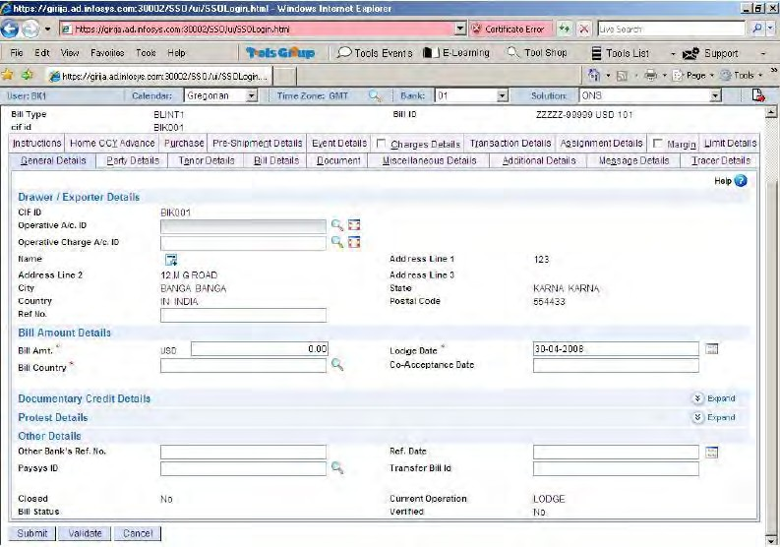

PURCHASE OF BILL

Purchase is allowed only for export. The BP account can be in any Currency. Exchange rate applied, for purchase, can be at the spot market rates or forward booked rates.

Based on the converted amount, margin specified, commission table codes etc. the default transactions are displayed to the user. The details can be changed for most of the fields. However the user is not allowed to modify the BP part tran account id, amount and part tran type or the interest collected amount etc. Interest will be calculated based on the

MBIC set up for the period from the Date of purchase up to the„Notional Due Date Following are the criteria fields for Purchase

Menu option: **MEOB** (Maintain export and Outward Bill)

Following are the criteria fields for Purchase

**Function Code:**

Mandatory Field. It should be selected as P -Purchase.

**Sol Id**:

Mandatory Field. It allows the user to enter a specific sol id.

**Bill Id**:

Mandatory Field. Bill Id of a Bill lodged.

On entering the required criteria and on click of GO Purchase details screen will be displayed and on top a panel consisting of twenty three different tabs is displayed.

In order to lodge a bill through MEOB menu option following tabs need to be visited mandatorily –

•Purchase Details

•Event Details

•Transaction Details

DELINK OR CRYSTALLIZATION OF THE BILL

Delinking / crystallisation is the process of converting the bill liability from one currency to another. Generally the liability is converted to Home currency by the bank, if the bill is not paid on the due date to cover themselves of exchange fluctuation.

TRANSFER FROM COLLECTION TO PURCHASE TYPE

It is possible that in the normal business scenario, a bill that is sent on collection may be required to be purchased subsequently, on receipt of acceptance. This can be achieved through MEOB menu option, withfunction code as „T‟ (transfer).However, theuser has to ensure that the tenor of the register to which the bill is being transferred is of the sametenor.

**Note**: The contingent entries in the collection will be reversed by the system upon transferof a bill from collection to purchase in full.

**IMPORT BILLS**

The processes for lodging and performing other operations in Import bill are the same as that of Export bills.

***Menu option MIIB* (maintain Import and Inland Bills) is**used to issue andmaintain **import bills**.

G –Lodge C- Copy

I –Inquire M-Modify V- Verify X –Cancel A –Accept

R –Realize

K –Delink/Crystallization N –Dishonour

U –Interest Run

W –Process Message

E–Amend Bill (erstwhile Extend Due Date #) S –Co- Acceptance

Z –Close Bill

Y –Unclose Bill Q-Protest

F-Free delivery

Following are the criteria fields for Issue

**Function Code:**

Mandatory Field. It allows the user to select a specific operation.

**Sol Id**:

Mandatory Field. It allows the user to enter a specific sol id (default populated)

**Bill Id**:

Mandatory Field. Bill Id is unique identification for current Bill being lodged. In case of system generated Bill type, the bill Id field is non mandatory.

**Bill Type**:

Mandatory Field. It helps the user in identifying whether it is an **Import CCY:**

Mandatory Field. It allows the user to enter a specific currency.

**CIF Id**:

Mandatory Field. Bill Id is unique identification for customer/party.

LODGE

In order to **lodge** a bill through MIIB menu option following tabs need to be visited mandatorily –

General Details Party Details Tenor details

MENU OPTIONS FOR FOREIGN BILLS

**Business Process Supported Menu Option**

|  |  |
| --- | --- |
| **Description** | **Menu Option** |
| Calculate and Collect interest | HBICN |
| Calculate Interest | HIBIBOOK |
| Collect Charges | APCHCOLL |
| Generate R Returns | HRRETURN |
| Generate ENC Statement | HFBENC |
| Generate Foreign Bills Covering Schedule | HFBCS |
| Generate Export Register Report | HFBER |
| Generate Foreign Bills Delinked Statement | HFBDLNK |
| Generate List of Pending and Dishonoured Bills | HFBPADB |
| Print Transaction Advice | HFB |
| Print Multi-tenor Bill | HMTBP |
| Generate Interest Collected or Paid on Bill Report | HBINTRPT |
| Generate Report on Batch Interest Collection on Bills | HBIODIC |
| Generate Foreign Bills Containing Discrepancies Report | HFBDISCR |
| Generate Foreign Bills Advance Interest Calculated Report | HFBAIC |
| Print Foreign Bills Balancing Register | HFBBR |
| Generate Exports Claim Report | HFBERC |
| Print Import Bills Register | HFBIR |
| Generate Overdue Import Bills Statement | HFBOIB |
| Generate Report on Bills Negotiated under Reserve | HFBRPR |
| Generate Bill Collection or Negotiation Statement | HFBSNC |
| Generate Purchase or Sale Report | HFXPSRG |
| Generate Forex Turnover Report | HFXTR |
| Generate Report on Charges Collected on Overdue Export Bills | HXOSCHRG |
| Generate Export Orders Report | HEXPRPT |
| Generate Presentation Memo of Foreign Bill | HPMEMO |
| Generate Report on Interest Collected on Foreign Bills | HFBICS |
| Inquire on Inward Bills | HIMPBILI |
| Generate Party wise Liability Register | HPLR |
| Inquire on Outward Bills | HEXPBILI |
| Generate R Return5 Report | HRRET5 |

GENERATE R RETURNS (HRRETURN)

R returns are statutory returns in India, and are submitted to the Reserve Bank of India every fortnight. This basically is the list of transactions, which has affected the NOSTRO account of the Bank. It is possible that every transaction, which the bank handles, need not affect the NOSTRO immediately.

In case of bills purchased, the NOSTRO gets credited only on the due date. So, the transactions can be broadly divided into two categories – those affecting the NOSTRO (cash transactions) and those, which do not affect NOSTRO (suspense transactions). Suspense transactions are reversed to cash when the NOSTRO actually gets affected. The report has to be prepared currency-wise.

## SWIFT

SWIFT - THE SOCIETY FOR WORLDWIDE INTERBANK FINANCIAL TELECOMMUNICATIONS

Started in Brussels (Belgium) in 1973 with the mission of creating a communication link and a common Language for international financial transactions. The organization defined the rules of trade, like what message to be used for which purpose, what should be the content of each message, and the Terminologies to be used in each message.

**Foreign REMITTANCES (THROUGH SWIFT)**

OUTWARD PAYMENT ORDER

--- ISSUE MENU - HPORDM

FUNCTION –ADD, PAYMENT PRODUCT:

CUSTOMER TYPE.THEN CLICK ON **GO.**

In **PAYMENT ORDER TAB** the following fields are mandatory:

***Remittance Details***

1. Debit A/C.
2. Requested Execution Date.
3. Remittance CCY/Amt.
4. TOD.
5. Debit Value Date.
6. Debit Execution date.
7. Charging A/C.
8. FX Rate.

***Payment Details***

1. Credit Execution Date.
2. Credit Value Date.

***Beneficiary Customer***

1. Address Type.
2. Name.
3. Address Line 1/2/3
4. Country.

***Account With Institution***

1. Address Type.
2. Bank Code.

152

1. Branch Code.

***Credit Details***

1. Method of Payment Derivation.
2. Method of Payment. (Then click on Fetch Button, Nostro Bank details are auto populated)
3. FX Rate.

***Charge Details***

1. Charge Option. (Click on View Charge Button) NOW VERIFY WITH SAME MENU.

VIEW PAYMENT ORDER MESSAGE MENU –HSMI

In **Payment Messages Inquiry** the following fields are mandatory.

1. PAYSYS ID.
2. IN / OUT INDICATOR.
3. SENDER REF.

Click on SUBMIT.

SEE THE TRANSACTION DETAILS AND STATUS.

TRANSFER PAYMENT ORDER MESSAGE MENU –HTRSWIFT

1. PUT PAYSYS ID: **SWIFT**
2. MESSAGE TYPE
3. TRANSFER MESSAGES Click on SUBMIT.

NOW VIEW TRANSFER MESSAGE MENU –HPR

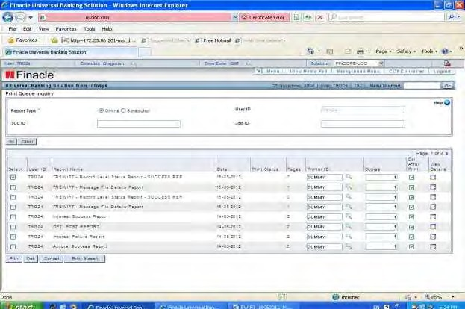CLICK ON **GO**

SELECT OR TICK TO **VIEW** THE REPORT DETAILS.

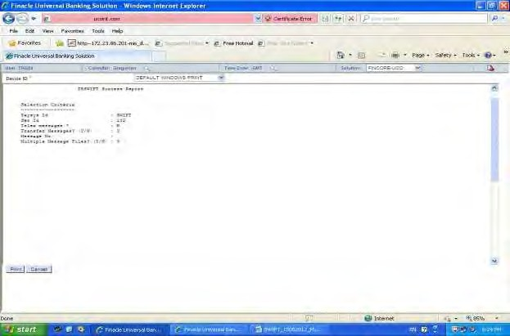

OUTWORD REMITTANCE TT/DD MENU-HORM

In **GENERAL DETAILS**

1. CIF ID
2. REMITTANCE CCY
3. CLICK ON **GO**
4. OPERATIVE A/C ID.
5. CHARGE DEBIT A/C ID
6. REMITTANCE AMT. In **PARTY DETAILS**
7. PUT BENEFECIARY DETAILS
8. PUT BENEFECIARY BANK DETAILS
9. CORRESPONDENT BANK DETAILS

In **INSTRUMENT DETAILS** TAB

1. INSTRUMENT AMOUNT
2. BENEFECIARY A/C ID.

In **EVENT DETAILS** TAB

1. PAYSYS ID
2. Click on EXPLODE ICON
3. SERIAL / COVER INDICATOR
4. SLA CATEGORY
5. CHARGE DETAILS Click on ACCEPT
6. BANK REMITTANCE
7. NOSTRO VALUE DATE

In **TRANSACTION DETAILS** TAB OBSERVE THE TRANSACTION CREATED

In **MESSAGE** TAB

OBSERVE THE MESSAGE CREATED MT 103

* Click on VIEW MESSAGE
* Click ACCEPT
* Click SUBMIT

NOW GO FOR **VERIFICATION** WITH SAME MENU

MAINTAIN TEXT –MTT

The menu option MTT - Maintain Text is used to add, inquire, modify, cancel or copy details of text messages required for a Documentary Credit and other modules in Trade Finance. Using the MTT menu option, user can also maintain different messages, instructions, lists of documents and conditions related to a Bank Guarantee.

**The** criteria screen consists of the following fields:

**Function**: It is a mandatory Alpha-numeric field and the various options areA - Add

C - Copy D – Del

I - Inquire

L - List

M - Modify V - Verify

X –Cancel

Module Id: Select the module for which the text is to be maintained Eg: Documentary credit or Bank guarantee.

Text Type: Select the code for the type of text to be maintained form the list.

**Valid Values:**

A - Amendment C - Conditions D – Documents I – Instructions F - Free

T – Template N – Insurance R - Freight

S –SWIFT

G –Goods description

Text ID: The Id assigned to the text being created is keyed here.

The field‟s new module Id, Next text Id and next text type are valid for copying an existing text.

Text description:You can type data up to 26000 characters in this field but cannot type blank lines. You can use the script hook TextData.scr to control the number of lines and the number of characters / line.

## ASSET CLASSIFICATION

As a part of the process of classification, provisioning is the first step for classification of the asset. Each asset, which is classified, will have two classifications viz.

A) Main Classification B)Sub Classification

The classification of an asset is mainly done depending upon the overdue position of the account, overdue period, and security available to the account. Classification is based on individual Banks practices and procedure and differs from Bank to Bank and Country to Country. However the basic principle of classifying the asset remains the same.

In Finacle ™, an asset can be classified by invoking a menu option HSASCAL– Systemasset classification. The screen interface for the menu is as under:

**SYSTEM ASSET CLASSIFICATION Menu - HSASCL**

**Default logic for asset classification:**

If no script is present at the HSRGPM level, system looks at the DPD counter (Days past due) specified at scheme parameters for Asset Classification details and classifies the asset. HSASCL –menu option selects the assets based on theselection criteria given by the user and classifies those assets according to the criteria given in the script.

For each asset, the script name is obtained from the menu option „Scheme / Register General Parameter Maintenance (HSRGPM)‟ menu option and the asset will get classified according to the conditions given in the script.

HSASCL menu option can be run in Trial or Update mode. If the „Trial mode‟ field in the screen is „Y‟ then only report gets generated and the database changes will not occur.

Past due movement of all accounts including Transaction Accounts is enabled in the existing menu options of HSASCL and HMAPD.

As a part of marking the account as “PastDue” system will transfer the uncollected interest which is lying in the interest (P&L) account and de-recognise the income. The

incomebooking done for the non performing accounts would be reversed by the Bank.

This will be done by the following entries:

Debit Interest income account (P&L account) – Account earlier credited during interest calculation

AND Credit Interest suspense account.

System generates reports for both failure and success.

The menu option for transferring accounts to past due is HMAPD

MODIFY EFFECTIVE USER CLASSIFICATION (MEAC)

In some cases, Bank wants to override the classification for various reasons. For this there is a facility to modify the default/system classification. This can be done by invoking menu option MEAC - Modify Effective Asset Classification. Any modification done is stored along with the system classification for future inquiry/information.

User has to give the criteria and <accept> to get the following screen where he will be able to modify the classification of all the selected records

The cursor is placed in the field “main user classification” of the first record which is selected (indicated by “*” mark). The user can go to any of the records using the keys

<arrow Down>, <arrow up>, <page up> or <page down>and modify the classification codes for both main and sub classification. Once the modification is over he can

<commit> for writing it to database.

Using this menu the user can change the classification code for either customer or Accounts/bills.

Whenever percolation happens because of the customer the corresponding customer info would be updated in the database as the percolation triggering entity id and entity type (for all the account assets under the customer).

If HMEAC is performed on delinquency rescheduled accounts (whether within probation period or after) then it will overwrite all the changes done for delinquency reschedule and make that account as a normal account.

ASSET PROVISIONING

Provisioning is a process where in Bank set aside a portion of its profit on a periodical basis (quarterly, half yearly, yearly etc.) for the purpose of writing off a loan which cannot be recovered. Provisioning of amount is based on status of the account. Status here means the classification of the account. As such provisioning is done after an asset is classified. As there is a feature of default classification based on DPD, there is a feature of default provisioning also based on a set up.

DEFAULT SET UP FOR PROVISIONING

The default set up for asset provisioning is done through a menu option HAPPM- Asset Provisioning Parameter Maintenance. This is basically on the DPD counter and the amount slabs.

###### Set up Menu

|  |  |
| --- | --- |
| System control file maintenance | HSCFM |
| Reference code maintenance | HRRCDM |
| Scheme parameter maintenance | HLAGSPM |
| Scheme/Register General parameter maintenance | HSRGPM |
| Report option table maintenance | HROTM |
| Asset provisioning parameter maintenance | HAPPM |
| Collateral based parameters maintenance | HCBPM |
| Asset Classification Ranking Table | HACRT |
| Recognition of Interest Suspense | HRSI |
| Portfolio Provisioning Parameter Maintenance | HPPPM |
| Rank Table Maintenance | HACRT |

## FORWARD CONTRACT

Exchange rate between two currencies is subject to change & depends on the volatility in the exchange market. Any entity having foreign currency exposure on account of any transaction is exposed to exchange risk. In order to mitigate such exchange risk entities hedge their risk by entering into forward exchange contracts with banks.

BOOK A FORWARD CONTRACT (MENU: MNTFWC)

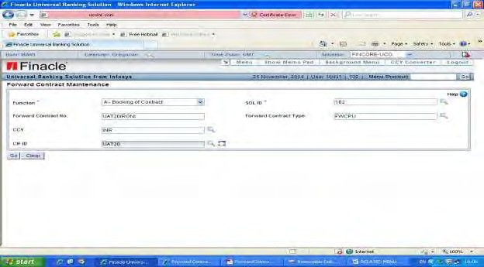

**FUNCTION:** A-Booking of contract

**Forward contract no:** Select or type the unique number assigned to a particular forwardcontract.

**Forward contract type**: Select the forward contract type to be booked.CCY: Select or type the currency code in which the contract is issued.

CIF ID: Select or type the CIF ID of the customer for whom contract is being booked. Click on Go Button. The following screen will appear and fill the relevant fields.

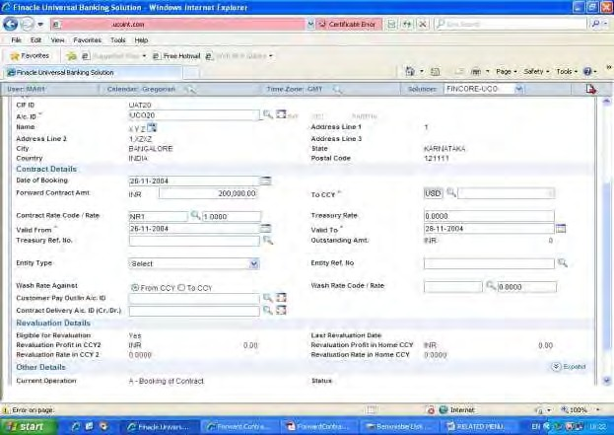

**Applicant Details**

A/cid: Select the account ID of the customer from the list. Or directly type the account no.

**Contract Details:**

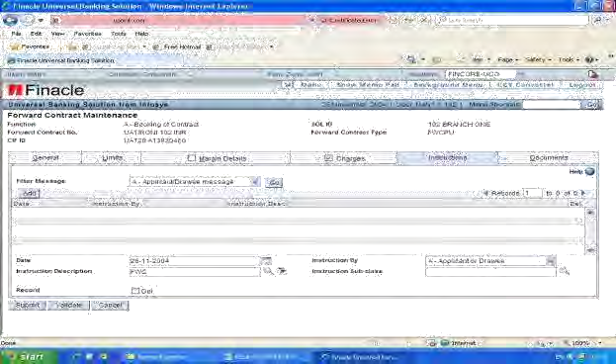

Date of Booking:The date of booking of contract.It should not less than BOD Date.

**Forward contract Amount**: The currency and the amount in which the contract isbooked. By default the currency is populated from the criteria screen value

**Valid From**: Select or type the date from which the contract is valid. Valid To: Select or type the date up to which the contract is valid.

**Contract Rate Code**:Enter the contract rate code.This is the rate at which the contract isentered into between the branch and the customer.

#### Charges

Charges are collected during booking, extension,cancellation and general modification. Charge event id needs to be created for these event types at HPTTM menu level and specified at register level.

Charge Event Id: Click on the searcher for appropriate charge event id and click on GO Button.

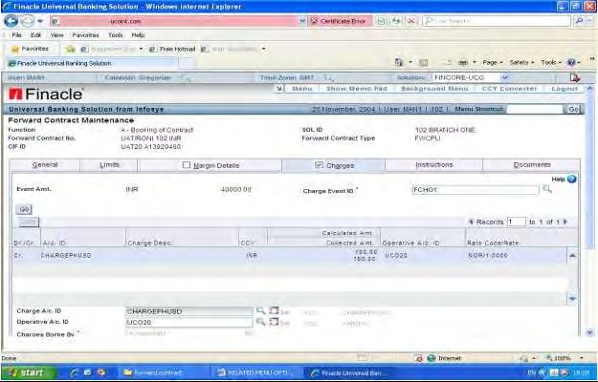

**Instructions**

Users will be able to input and store any customer messages through the instructions tab. The messages are entered as free text, in the message field. This message can be used while generating the FWC Note and in Reports. The date of message is also captured. The user can update the status of the message also.

The valid values for the Filter Messages are:

1. Applicant / Drawee Message
2. Beneficiary / Drawer Message

N. Collecting Bank Message

O. Other Message

S. Self-Message

L. All Messages

RELATED MENU OPTIONS FOR FORWARD CONTRACTS

|  |  |
| --- | --- |
| FORWARD CONTRACT BOOKING REGISTER | HFWCRG |
| PURCHASE /SALE REGISTER PRINTING | HFXPSRG |
| INQUIRY OF FORWARD CONTRACT | IFWC |
| INQUIRY ON HISTORY OF FORWARD CONTRACT | IFCH |
| FORWARD CONTRACT LIABILITY REGISTER | HFWCLIAB |
| LIST OF OVERDUE AND MATURED FWC | HFWCODLS |
| FOR FWC NOTE PRINTING | FWCNOTE |
| REMINDER TO PARTY ON MATURING CONTRACTS | FWCRMND |
| FORWARD CONTRACT REVALUATION | FECREVAL |
| SWAP CHARGE COLLECTION | HSWPCHRG |
| CLOSURE OF FWC | HFWCLOSE |
| CANCELLATION OF FWC | MNTFWC |

## BANK GUARANTEE

OVERVIEW

Bank Guarantee is an instrument issued by the Banks in which the Bank agrees to stand guarantee against the non-performance of some activity/event of a customer. The quantumof guarantee is called the „guarantee amount‟. The guaranteeis issuedonreceipt of a request from „applicant‟ for somepurpose/transaction in favour of a „Beneficiary‟. The guarantee amount will be paid by the „issuing bank‟ to the „beneficiary‟ of the guarantee on receipt of the „claim‟ from the beneficiary i.e., when the guarantee is

„invoked‟.

The guarantees issued by the banks can broadly be classified into:

* Performance Guarantee
* Financial Guarantee
* Bid Bond Guarantee
* Shipping Guarantee
* Deferred Payment Guarantee
* Advance Payment Guarantee
* Retention Money Guarantee
* Acceptances & Co-acceptances

**Deferred Payment Guarantee**is different from other types of guarantees. Here theIssuing Bank stands guarantee to some transaction between two parties; but the Bank undertakes to make regular periodic payment (say monthly/half yearly, etc) of some fixed amount to the „beneficiary‟ on behalf of the „applicant‟. The payment oftheguarantee amount is spread over a period of time.

**Performance guarantee**: The Bank, guaranteeing the performance of a task, issuesthese guarantees. Ex: A contractor who has taken up construction of a Building indicating that he would be completing it within a period of 6 months. Bank can issue a guarantee confirming the contractor‟s claim.

**Financial guarantee**: Guarantees issued for meeting financial obligation. Ex: A personwho avails loan from an Institution promises to repay the same over a period. Bank issues a guarantee for repayment of instalments.

**Shipping Guarantee**: Shipping guarantees are issued by the banks when the applicant(Buyer) has not yet received the original Bill of Lading, but wants to take

possession of goods from the shipping company.

**Counter Guarantee**: A guarantee received by the bank from its correspondent, againstwhich it is expected to issue a guarantee in favour of a named beneficiary.

**Open Guarantee**: A guarantee which does not have an expiry date.

**Beneficiary of guarantee**: The person in whose favour the guarantee is issued.

**Guarantor**: The person who guarantees. In case of BG,, guarantor will be Bank whichissues the Guarantee.

**Invoking of guarantee**: The beneficiary of the guarantee will demand payment of theguaranteed amount from the guarantor (in this case, Bank) if the guaranteed task is not performed. This process of demanding the payment for non-compliance is known as invoking of guarantee.

**Guarantee period**: The tenure of the guarantee up to which it will be in force.

**Brief descriptions about some of the fields**

1. **Address:** Address of the customer on account of which the guarantee is issued.
2. **Loan account** be debited to this account and paid to the beneficiary.
3. **Limit Margin:** Limit Margin should be zero.
4. **Ready Conv. Rate:** This is TT selling rate “TTS”payment of DPGs and payment of invoked amount in case of invocation of guarantees.
5. **Expiry Period:** The period for which the guarantee is issued. To be entered inMonths / Days.
6. **Claim Period:** The period allowed for the beneficiary to make the claim afterexpiry of the guarantee. To be entered in Months / days.

**CHARGE/COMMISSION DETAILS**: System will calculate charges for issue of BG. The system created charges can be modified.

**General Details**: User can input the details of BG.

**Limit details**: The user can view the details of limit node specified during issue of Bank guarantee.

**Audit details**: This is available only in the verification mode.From here the user can

<explode> further to see the audit details.

**Text Maintenance**: At the time of issue of the Bank guarantee, the user can invoke sub-option and go to Text Maintenance interface. From here he will be able to

attach/maintain conditions and instructions relevant to the guarantee. These can be created as templates through TXTMNT option and copied on to the BGs. From the data block, user will be able to invoke a text box to add text by using key.

**SHIPPING GUARANTEE DETAILS**:If the guarantee type in GTPM is a „Shipping Guarantee‟, the user will be able to go to this option.

MARGIN DETAILS:

Suppose the user has entered (collect) . The fields will have the following meaning

* Cash / Lien for Cash Margin and for Lien Margin.
* Margin/Lien Account - This is the margin credit account (office account) in case of cash margin and the customer operative account in case of Lien margin. This is defaulted from the GPM level
* Collected amount - Amount to be collected will be accepted here. This amount is to be given in the Margin office account currency.
* Released amount - This will be protected field and can be edited during
  + “Release‟ margin function.
* Del Flg - Whether an entered record has to be deleted.
* Oper Acct / Transfer Acct - This has meaning only for cash margin. This is the customer operative account. It can be in any currency.
* Rate Code - This will be meaningful when the margin account and operative account are in different currencies.

Suppose the user has entered “R‟ in the function block, and held, all the earlier verified collections will be displayed. User can decide the amount to bereleased from which of the records.

As shipping guarantees are follow up of Documentary credits, it is possible that user may require to “transfer‟ margin from Documentary Credits to Bank Guarantee. Event will be Transfer. The fields will have the same meaning as in „Collect‟.All the earlier verified collections of the Documentary Credits will be displayed.

**BILL LINKED DETAILS**: This option will show the bills which are linked to shippingguarantees. This is only information and no modification is possible.

**MARGIN HISTORY**: All the events which have happened on the margin front will belisted to the user in this option.

**BG HISTORY**: Users can see the various events which have happened on the givenguarantee.

**SWIFT DETAILS**: The swift-formatted message - MT760 (BG ISSUE) can be generatedif the guarantee is being routed through a swift enabled bank/branch. Swift message will be required if the guarantee is being routed through another bank, before being advised to the beneficiary. Through this option, MT767 will be generated during“MODIFY”event.

OPERATIONAL MENU OPTIONS FOR BANK GUARANTEE:

|  |  |
| --- | --- |
| **MENU** | **MENU DESCRIPTION** |
| OGM | Outward Guarantee master maintenance |
| IGM | Inward Guarantee Master Maintenance |
| HBGCLOSE | Guarantee Close |
| HBGLIMIT | Guarantee LIMIT |
| HDCC | Collection of Deferred Charges. |

GENERAL DETAILS

**Applicant Details**

CIF ID: Name of applicant fetched from CIF and it is modifiable. On clicking an icon the Swift Address screen will be populated with Swift Address if it is maintained at CIF level.

**Amount Details**

**\*Guarantee Amt:** Actual Amount of Guarantee to be issued to be filled here.

**\*Issue Date:** By default the issue date of the Guarantee would be BOD date.

**Rate Code**: This is the rate to be applied for conversion of BG amount to the currency inwhich the contingent liability is maintained. This rate code is also used for updating the limit node if limit node is in a currency other than BG currency.

**Other details**

**Other Bank Ref.No:**Optional field. User can capture the details of Account Id of theother bank.

**Paysys ID:** It is an optional field. If user wants to send the message through Swift, then itshould be entered here.

PARTY DETAILS

**Beneficiary Details**

* CIF ID:
* Name:
* Address Lines 1,2 and 3
* City:
* State:
* Country:
* Postal Code:
* Type: Government/Others
* Advising/Correspondent Bank: BIC:
* Party Identifier:

GUARANTEE DETAILS TAB

**Guarantee Sub Type:** gets defaulted from parameters. It defines the guarantee.

**Purpose of guarantee:** Description about necessity of Guarantee.

**Guarantee class:** Select or type the code that indicates the class of guarantee, forexample, financial guarantee, and performance guarantee and so on. It is used for MIS purpose.

**\*Effective Date:** The date from which the guarantee is effective. Effective date cannot beless than issue date. Issue date will be BOD and cannot be modified. A Bank guarantee can be issued for a future date. The guarantee will be effective from that date.

**Page2:**

**License details**

**Import License No.**Type the import or license number, of the customer to whom theguarantee has been issued.

**Import license Expiry date:** Select or type the date of expiry of the import license.

**Other Details**

* **Charges Borne By:** The user has to specify who is going to borne the charges Applicant,Beneficiary or Others.
* **Capital adequacy code**: It is a HRRCDM code
* **Details of guarantee:** Capture additional info**.**
* **Sender to Receiver Info:** capture sender to receiver info if any.
* **Fructified Liability:** Type the fructified liability present at the time the guaranteeis invoked or the fructified liability of instalment transactions.
* **Provision amount:** Type the amount provisioned for the beneficiary account
* **Original bank Guarantee received: Y/N Expiry details**

**Expiry Period**: The period for which the guarantee is issued. To be entered in Months/Days.

**Expiry Date**: Date on which the guarantee expires. It can be arrived based on expiry period and effective date. If the date specified is holiday, holiday exception arrives during verification Claim period.

**Claim Expiry date**: Date on which the claim expires. It is arrived based on claim period and expiry date.

**Rules**

*ApplicableRules: Drop Down with values as URDG, URCG, NONE or OTHR. Applicable sub Rules: If OTHR is chosen for Applicable Rules then this filed is mandatory.

**Counter Guarantee details**

**Link to Counter Guarantee**: Will be default populated with the value as Y/ N based onthe value specified at parameter level. If the counter guarantee details have been capturedin the application, the same can be linked to the guarantee being Guarantee Ref. No... The following validations exist for any guarantee is issued against acounter guarantee received:

Guarantee No. Counter Bg Number. On tab out or choosing from the Searcher theGuarantee Amount, Expiry Date, Claim Expiry Date, Bank code, Branch Code and Status.

**Expiry Date:** Counter Bg Expiry Date.

**Bank code:** Bank code of Counter BG where it was issued. **Remarks:** Addition information captured about counter BG details. **Guarantee amount:** Counter Bg Guarantee Amount.

**Claim Expiry Date:** Counter BG claim Expiry Date.

**Branch Code:** Branch code of Counter BG where it was issued.

**Status:** Displays the status of Counter BG.

LIMIT DETAILS

**Limit Information**

**Limit ID**: Limit Id is an enterable filed which has a searcher for value selection.

**Limit Margin**: This field accepts the margin percentage to be „utilised‟ from the limit node. When a limit is utilised for margin, then the available amount in the limit will bereduced by the margin amount. Limits can be utilised for margin only if the margin amount is less than the available amount for the limit. During utilisation of the guaranteefrom a bill or invocation or reversal of the guarantee the available amount for the limit willbe increased by the margin amount. This „margin‟ is apart from the cash / lien margin which may be held against the guarantee.

MARGIN DETAILS

Margin which has to be maintained/recovered/maintained for the guarantee can be specified through Margin Details Tab. This screen is a multi record screen. The margin can be recovered either as „cash‟ margin or „lien‟ margin. In the Event the user can enter the margin „action‟. Valid values are:

* Collect –Enabled in the Add mode
* Release –Enabled in the Modify, Amendment, Reversal, Close
* Transfer –Enabled only for Shipping Guarantee
* Event: option box(Collect,release,Transfer)
* Min Margin Pcnt
* Min Margin amt

**Type of margin**: Cash / Lien “C” for Cash Margin andbe marked against multiple term deposit accounts.

**Margin a/c ID**: This is the margin credit account (office account) in case of cash marginand the customer operative account in case of Lien margin. This is defaulted from the GTPM level.

**Operative a/c ID**: This will be the account into which the transferred margin has to becollected.

**Transfer a/c ID**: As shipping guarantees are following up of Documentary credits, it ispossible that user may require transferringmarginfromDocumentary Credits to Bank Guarantee. Event will be Transfer. All the earlier verified collections of the

DocumentaryCredits will be displayed. The fields will have the same meaning as in

„Collect‟.

* Oper Acct / Transfer Acct - This will be the account into which the transferred margin has to be collected. This will typically be the margin credit (office account) account for the Bank Guarantee. The transaction is created on verification of the entity.

**Release Amount**: This will be protected field and can be edited during„Release‟ marginfunction.

**Rate Code and Rate**: This will be meaningful when the margin account and operativeaccount are in different currencies.

REPORTS AND INQUIRY MENU OPTIONS ON BANK GUARANTEE:

|  |  |  |
| --- | --- | --- |
| **SL NO** | **MENU** | **MENU DESCRIPTION** |
| 1 | HBGPRINT | Printing of guarantee |
| 2 | HDPGR | Deferred payment guarantees print |
| 3 | HGILR | Guarantee issued and liability report |
| 4 | HPRR11A | Quarterly statement of guarantee |
| 5 | HPRR11B | Monitoring of guarantees |
| 6 | HPRR11C | Statement of guarantee |
| 7 | HBGMARGIN | BG Margin Printing |
| 8 | HBGSTMNT | Statement of Guarantee |
| 9 | HBNKGI | CRV based Bank Guarantee Inquiry |
| 10 | HBKGURI | Bank Guarantee Query |
| 11 | HGPLG | General purpose letter generator |
| 12 | HGPLM | General purpose letter maintenance |

## 30. DOCUMENTARY CREDIT

A Documentary Credit (also called as Letter of Credit in some Countries) is an undertaking by a bank to the Beneficiary (Exporter/ seller) that it would make payment to him against presentation of documents drawn in terms of the credit. The Documentary Credit (DC) would be issued at the request of the customer (Importer

/buyer) of the bank. DC is a widely prevalent mechanism for settlement of trade in international trade. It assures the exporter of payment. Also, he is assured that the importer is bona fide and that the formalities in the importer's country regarding the import have been complied with. As far as the importer is concerned, he will pay for the import only on receipt of the documents conforming to the terms and conditions of the credit.

FEATURES OF DOCUMENTARY CREDIT MODULE:

* Issuance of DC
* Maintenance of liability of the Bank / Parties
* Creation of contingent transactions
* Advising of a DC
* Amendment of a DC (Value / Validity / General amendment)
* Reinstatement of DC
* Transferring of the DC to a third party
* Calculation of charges for various activities either in Home currency or in DC currency
* Amortization of charges.
* Maintenance of Margins by way of cash and lien as security
* DC History maintenance
* Linking with the Bills module
* Linking with BG module
* Linking with Forward Contract module
* Maintenance DC / Amendment Texts
* Generation of DC / Amendments texts in Mail / Telex / Swift formats.
* Maintenance of messages of Drawee / Drawer / Negotiating Bank
* Opening/Modifying/Amending/Advising/utilising DC across SOLS

FLOW OF DC

▪

Buyer and Seller agree on the terms of a sale.

* Buyer arranges for his Bank to open a letter of credit in favour of the seller.
* The Bank would open the LC after taking a credit view of the buyer.
* The documents normally required for opening of an LC are:
  + Commercial Invoice
  + Transport document such as Bill of lading or Airway bill.
  + Insurance Document
  + Inspection Certificate
  + Certificate of origin.
  + Prices are to be stated in the currency of the LC and document to be supplied in the language of the LC.
* Buyers Bank sends the LC to the advising Bank in seller‟s country through SWIFT or bank.
* The advising Bank forwards the LC to the seller after rechecking the authenticity of the LC.
* In case seller cannot comply with any of the terms of the LC the same is immediately notified to the buyer through his Bank.
* Seller prepares the goods and arranges for shipment to the appropriate port, obtains bill of lading and other required documents.
* The seller presents the document to the Negotiating Bank which reviews the documents for compliance of the stipulated terms and forwards the same to the Issuing Bank or the confirming Bank in case there is a confirming Bank.
* The Negotiating Bank forwards a reimbursement claim to the reimbursing bank.
* The reimbursing bank pays the Negotiating bank as per instructions of the Issuing Bank.
* On receipt of Payment by Negotiating Bank, the beneficiary or the sellers account is credited.
* Once Issuing Bank receives documents, it notifies the buyer and in case all documents are in order he makes payment to the Bank and receives the documents to take possession of the shipment.
* In some cases the same Bank may play the role of advising, negotiating and the confirming Bank.

**RELATED MENU OPTIONS FOR DOCUMENTARY CREDIT**

|  |  |  |  |  |
| --- | --- | --- | --- | --- |
| SERIAL | MENU | DESCRIPTION | | |
| 1 | ODCM | Issue/Amend/Modify/Reinstate/Copy | | a |
| Documentary Credit | |  |
| 2 | IDCM | Advise Inward Documentary Credit | | |
| 3 | IDCM | Link Packing Credits to Documentary Credits | | |
| 4 | IDCM | Assign Proceeds | | |
| 5 | IDCM | Transfer Documentary Credits | | |
| 6 | APCHCOLL | Recover Charges | | |
| 7 | HCAM | Amortize Charges | | |
| 8 | HDCCLOSE | Close DCs in Batch | | |
| 9 | HSMI | Inquire on SWIFT Messages | | |
| 10 | DCQRY | Inquire on Documentary Credits | | |
| 11 | DDCPTM | Documentary Credit Parameter Type Maintenance | | |
| 12 | HDCGPR | Generate General Purpose DC Report | | |
| 13 | HDCREG | Generate Documentary Credits Register | | |
| 14 | HDCLIABR | Generate Documentary | Credits | Liability |
| Register |  |  |
| 15 | HDCSTMT | Generate Statement of Documentary Credit | | |
| 16 | HCHRGADV | Print Transaction Advice DC | | |
| 17 | HDCXFRPT | Generate Report on Transferred DCs | | |
| 18 | DCRPTS | Generate DC Reports and Advises | | |
| 19 | HDCEXPRP | Generate Report on Expiring Documentary | | |
| Credits |  |  |
| 20 | HBKDCI | Query on Documentary Credits | | |
| 21 | HEXPDCI | Inquire on Export DC | | |
| 22 | HINDCI | Inquire on Inland Inward DC | | |
| 23 | HINODCI | Inquire on Inland outward DC | | |
| 24 | MTT | Create Templates - Text Maintenance for DC | | |

EXCEPTION:

|  |  |
| --- | --- |
| Limit Node Expired | When the limit node attached to the DC has expired |
| Party's Limit | If the party‟s liability limit is exceeded by the DC. Available |
| Exceeded | amount of DC > (Sanctioned Limit of DC –Utilised limit) |
| System Charges | if the charges are modified during a particular event of the DC. |
| Modified |
| Max. Validity | The maximum validity period for the DC has exceeded i.e. |
| Exceeded | (Expiry- date –open-date) > Max. Valid. allowed(days) set in |
|  | DCTPM |
| Action after DC | Some action is being taken on a DC after it has expired |
| expiry dt |
| Cryst. Liability | If crystallized liability (Fructified DC amount under bills + |
| exists | Fructified DC amount without bills )> 0 exists for a particular |
|  | DC. |
| Margin not yet | if (Cash Margin percentage + Lien Margin percentage) at time |
| recovered | of issue < the value set in |
|  | FPCM |
| Usance maximum | If the usance period has exceeded the max usance period set in the DCTPM option. |
| exceeded |
| Max. Negot.days | If the negotiation period has exceeded the max negotiation |
| exceeded | period set in the DCTPM option |
| No documents/ | If there are no documents (no text for text type neither „C‟ nor „D‟) attached with a DC this is raised. |
| conditions |
| Acct.Bal. not | Bal. Of the party_acct < total charges collected. |
| sufficient |
| Back Dated | Bod_date > dc_open_date. |
| Transaction |
| Party Cautioned | If the party to whom the DC is being is a cautioned party then |
| Exception | this exception is raised. |
| Inward DC Max | Validates whether the effective maximum advance value of the |
| Advn exceeded | Inward DC is exceeded while doing amendment or transfer |
|  | event of the DC |
| Outward DC | Validates whether the current value of the outward DC exceeds |
| exceeds export advn | the effective maximum advance value of the export order |
|  | linked to the DC |

**ACCOUNT PLACE HOLDERS Parameter**

**Liab. Dr. A/c Pl. holder:** This account is used for maintaining customer liability as acontra to the Bank‟s liability.

**Liab.Cr. A/c Pl. holder:** This is the account that indicates the total amount of DC‟s issued bythe Bank on behalf of various customers.

**Margin Cr A/c Pl. holder:** Wherever margin money is collected for issue of DC, it willbe credited to this account.

**P&L Account Place Holder:** Account attached to this place holder is used to credit theCommission income on amortisation. This is specified in HPTTM option. (This is required to be created if the bank is going to amortise the charges).

### OUTWARD DOCUMENTARY CREDIT

The Menu option **ODCM** is used to issue and maintain Documentary credits established. In order to issue a Documentary Credit in ODCM menu option the General details tab, related party tab and the DC details tab need to be visited mandatorily.

GENERAL DETAILS TAB

**Applicant Details**: It captures the CIF ID, name and address of the applicant and the IDof the customer's operative account. The operative account can be used to debit charges, recover margin amount and also for payment to be made to the bank under import letter of credit

**Amount Details**: This captures the initial value of the documentary credit (DC), date ofissue of DC, the amount of pre shipment advance extended against red clause letter of credit and the percentage of tolerance permitted in the value of the documentary credit.

***Note:***

1. **DC Curr. Value**represents **„**DC open value‟ + or – „DC Amendment Amt‟
2. **DC Avail value** represents **:** {(DC_Current_Value – DC Carved Amt) * [1 + (Tolerance Percent /100)]} – (No_bill_Utilised amount) – (No_bill_Fructified amount) –(Advance amount) + (reinstated amount) + (Int_add_amount) – (Bills lodged)

**Purchase order details**: The date of issue of DC, purchase order number, the number

ofamendments issued and the last amendment date are captured here.

**Other details**: This captures the miscellaneous details like correspondent bank‟sreference number, payment system through which Documentary Credits are transmitted, the amount of unverified Documentary Credit in home currency, DC Carved Amt(amount of Documentary Credit pending verification) etc.

RELATED PARTY DETAILS TAB

**Beneficiary Details**: This captures the name, address and CIF ID of the beneficiary of aletter of credit. It also captures the ID of the operative account to be used for debiting letter of credit related charges and for making payment under the letter of credit.

**Applicant Bank**: This captures the name, address, bank, branch code and BIC address ofthe applicant bank.

**Issuing Bank**: This captures the name, address, bank, branch code and BIC address ofthe issuing bank.

**Advising Bank**: This captures the name, address, bank, branch code and BIC address ofthe advising bank.

**Drawee Details**:This captures the name, address, bank, branch code and BIC address ofthe drawee bank. The drawee bank is the one which is mentioned as the drawee of the draftor bill of exchange to be submitted under the letter of credit. The bank confirming the import letter of credit is the drawee bank.

**Available with Bank**: This captures the name, address, bank, branch code and BICaddress of the bank with whom the letter of credit is available for negotiation.

**Reimbursing Bank**: This captures the name, address, bank, branch code and BICaddress of the reimbursing bank.

**Advice through Bank**: This captures the name, address, bank, branch code and BICaddress of the advice through bank.

DC DETAILS TAB

**Form of Documentary Credit**: Indicates the type of DC.

**Revolving DC Details**: Gives the following details Reinstatement Type, MaxReinstatements, Day, Reinstatement by Amt , Reinstatement date

**Back to Back Details**: Gives the Back to back DC No

**Rules:** The rules and sub rules are keyed here.

**Tenor Details**: The duration details are keyed here and the fields are Tenor, UsancePeriod, Tenor Details, and Period for presentation.

**Expiry Details**: The expiry details of the DC are keyed in these fields.

**Shipment Details:** The mode and the last date of shipment of the goods are keyed inthese fields. This captures Partial Shipment, Trans shipment,Latest date of shipment, Negotiation Period, Shipment Period, Shipment Mode, Shipment terms, Place of taking charge, Port of Loading/ Airport of departure,Port of discharge/ Airport of destination, House Airway Bill, Consolidated/ shipping agents.

**Commodity Details:** This captures the origin of goods, code of the commodity,description of goods and the details of the license which covers import of goods specified in the documentary credit.

**Insurance Details**:This captures the details of insurance such as the name of theinsurance company, insurance policy number/date, insured amount/ percentage of the value of the goods insured, premium amount and the place of payment of claim under the policy.

**Reimbursement message details**: This captures the details of the reimbursementmessage if any and the date and rules of the message.

INSTRUCTIONS DETAILS TAB

It captures the date of instruction, the person who has given the instructions (applicant, Beneficiary, collecting bank, self and others) and the text of the instruction.

During Issue, Instruction Details tab is available in enterable mode and user can enter the necessary details.Using this tab user can perform the following:-

1. Adding Instructions
2. Deleting Instructions
3. Modify Instructions 4)Inquiry/View Instructions

5) Filtering Instructions

**ADD AN INSTRUCTION:** To add an instruction user must enter 3 field details i.e.Instruction Date, Instruction By and Instruction displayed on the lower panel of the

screen. (The instruction length should be less than or equal to 80). Same way instructions can be deleted, modified,inquired and viewed. **FILTER AN INSTRUCTION:**

**Instructions can be filtered based on**

A –Applicant/Drawee Message B –Beneficiary/Drawee Message N –Collecting Bank Message

O –Other Messages S –Self Messages

L –All Messages

CHARGE DETAILS TAB:

In ODCM menu charges screen is used to display the calculated charges and to collect the same.This menu captures details such as the Event ID (used for calculation of the charge), the ID of the charge account, the ID of the operative account to which charges are to be debited and the person who has to bear the charges (applicant, beneficiary and both). There is a facility to split the charges if it is payable by both applicant and the beneficiary. There is a facility to collect the charges either immediately or on a later date. You can specify a deferment schedule for recovery of charges. It also captures the amount of charge to be waived and remarks related to charge waiver. During DC event for example ***Issue*** charges can be collected by visiting the charges tab. On visiting the charges tab for the first time data will be fetched from the **PTTM** set up for the corresponding ***charge event id***.

NOTE:

It is important to note that during charge collection, User can either collect full amount as **immediate** or part as **waiver** and part as **later.** Also during each individual event likeIssue, Amend etc default charges will be displayed. It is important to note that the records cannot be added and existing record cannot be deleted but only be modified. Hence a recalculate button has been provided.

If user modifies the event Id, he has to press Recalculate button, to trigger the calculation of charges. Further, in the same event, if user visits already visited tabs and change some numeric value, which may affect charge calculation, then he has to visit the Charge Tab and press Recalculate button to trigger the charge calculation again.

**Charge A/c. ID:** It allows the user to enter operative a/c id.

**Charges Borne By:** Mandatory Field. Valid values for this field are A-Applicant, B- beneficiary & T-Both.

**Calculated Amt.:** It displays the user to pay part of the system calc amount asimmediate, part later and part can be waived off or whole of the system calc amt can be collected as immediate, whole of it can be collected as later or whole can even be waived off. Therefore,

*Calculated Amt = Immediate Amt + Later Amt + Waiver Amt + Split Amt*

MODIFICATION OF CHARGE DETAILS:

In case of Modify mode the details entered during the ISSUE event for charges tab will be shown to the user and these details are in modifiable form. If the charges tab has not been visited during Issue then in modify mode the *default charges* from pttm set up will be shown. That means if the user has not collected charges previously, he can do the same in Modify mode.

VERIFICATION OF CHARGE DETAILS:

During verify mode on Submit, the charge transactions will be created only for immediate collection amt .Transaction Posting is to be done by the caller of this tab. It is important to note that *modification of charges* after verification is *not possible* and once verified charges *cannot be viewed* again in charges tab. Charges can only be inquired in *Historyscreen*.

MESSAGE DETAILS TAB:

Select the **Message Details** tab in the General Details screen of ODCM menu option to capture message details and generate appropriate SWIFT Messages. The screen shows the type of message, the details of the receiver of the message, mode of transmission and the message option. The **Message Type** field is auto populated with values like issuance, amendment, reimbursement instructions and so on. The S - Swift mode is shown as the default value under the **Mode of transmission** field. The **Receiver** field shows the name of the receiving bank or branch. The **Message option** field indicates if the related message is to be generated by the system. The message option field cannot be changed for mandatory messages. You can un-check the message option box, if you do not want to send a non-mandatory message. Click on the explode icon appearing under the **view** field to see the generated Swift message. This does not support other transmission modes like telex and mail. The **Print** button provided in the swift message screen can be used to take a print of the concerned swift message.

Message details can be visited only if a valid Paysys Id is entered e.g. SWIFT in general details page In **ODCM** (Outward Documentary Credits Maintenance) following messages can be generated during different events:

**MT700**: During issue mode, mandatory message.

**MT740**: During issue mode, non-mandatory message, will be generated only ifreimbursing message is required.

**MT707**: During Amendment mode, mandatory message.

**MT747**: During amendment mode, generated only if an MT740 is already sent to thereimbursing bank-branch.

**VERIFICATION AND CANCELLATION of swift messages:**

Swift messages generated during issue, advice, modify, amend, transfer events should be accepted during verification or cancellation for their processing.

SWIFT MESSAGE HISTORY:

In the history details tab of IDCM/ODCM menus message history is available if explode function is clicked. On click of explode, system will open up a listing of all the verified messages available for that entity. This listing can have multiple generated messages. Each record is provided with another explode to message details screen. User can view the generated message through history after verification only.

TEXT DETAILS TAB

Text Details Tab can be used across various menu options of Trade Finance Module in Finacle. The Text Details related to documentary credit are captured here. Using this tab user can perform 1) Adding Text 2) Deleting Text 3) Modify Text 4) Inquiry/View Text.

There are four columns namely Text Type, Template Id, Text Desc and Del Flg. To add a text user must enter Text Type and Text Description displayed on the lower panel of the screen. The field Module id in the lower panel gets auto populated with the module id for which text data is being maintained, i.e. DOCCR in case of documentary credit related menus or BNKGR in case of guarantee menu options. Template Id is not a mandatory field, however if user enters any value for template id. Delete flag is provided in case user has to delete any particular text record.

**Text Type**: Mandatory Field, user must select a value in order to add a text record.

**Template Id**: It is an optional field, basically provided to select an existing text templatefrom the database

**Text Description**: It‟s a mandatory Field. It can be entered only if text type is given. Itcan be entered using a text editor and the text length is restricted as per the Text Type entered. Text description will be fetched by system, if user selects an existing template from searcher. This text description further can be modified for current record. If text data is entered in any other tab for any of the text type provided in this tab, same will be auto populated in this tab and vice-versa.

**Del Flg**: Del Flag is a checkbox. If delete flag is checked during addition, the record willnot be considered for insertion into the database. If delete flag is checked during modification, the record will be logically deleted from database.

ADD A TEXT

A Text can be added in one of the two ways listed below.

* Through Add New button

•Down Arrow

DELETE A TEXT

User can delete a text by selecting DEL FLG check box provided on the text screen. On submitting this record, system will logically delete it from database and same will be available for undelete operation. Value for delete flag column is YES for the deleted record.

MODIFY A TEXT

User can modify any of the 4 fields displayed on lower panel of the Text Details Screen. Also, a new record for the entity can be added through multirec during modification using Add new button or down arrow.

INQUIRY/VIEW A TEXT

Only Non Deleted records will be listed in the multirec. User can inquire/view a text either by clicking on a particular record in the Multi-Rec. Details of the record will be visible in the panel below the Multirec.

LIMIT DETAILS TAB:

Limit Details of DC is maintained using Limit Details Tab. This screen captures details such as the limit ID, limit margin percentage and the related limits (bank limits, country limits). This displays the approved limit and the amount available under the limit for further utilization. You are taken to HLNI screen on clicking on the explode button provided against the Limit ID field. This provides additional information about the limit under consideration.

Validation check to ensure whether user has correctly entered the limit Id field which includes limit prefix and limit suffix, and if not respective error message is displayed on

the screen. Validation check of date for limit expiry for respective limit node entered. If the date less than BOD then error message **“Limit node has expired”** isdisplayedon the screen.

**Limit Node field: It** is an enterable filed which has a searcher for value selection.

**Related Limits:** Related Limits can be checked as the value required.

MARGIN DETAILS TAB:

System is capable of collecting/maintaining margins either as Cash Margin or as Lien margin. Margins held can be modified during the life of DC, by using the margin tab option. User can select the valid values Collect, Release or Transfer. The user can specify the amount (based on the percentage to be collected) at the time of collecting the margin.

**Type of Margin**: Valid values are Cash and Lien.

**Margin Account Id**:This is the margin credit account (office account) in case of cashmargin which is default populated from the register level or the customer operative account in case of Lien margin. Lien can also be marked for more than one Term Deposit account. Operative account - This is applicable only for cash margin. This is the customer operative account which will be debited. It can be in any currency.

**Transfer a/c id**: Suppose the user wants to transfer margin from Documentary Credits toBank Guarantee, transfer option in margin would be used. All the earlier verifiedcollections of the Documentary Credits will be displayed. The transfer account id will be the account into which the transferred margin would be collected.

**Margin amount** - Amount to be collected will be accepted here. This amount is to be given in the Margin office account currency.

**Released amount** - This will be protected in case of margin collection while during release user has to enter the amount to be released.

**Rate Code** - This will be meaningful when the margin account and operative account are in different currencies. The transaction is created on verification of the entity.

MODIFICATION OF ISSUED DC

You can modify some of the details of a DC after issue. This is done by invoking the Function - M of the ODCM menu option. The buttons enabled for Modify mode is the

same as that for Issue Mode.

The following fields can be modified.

Applicant A/c, Drawee name, Address, Place of Expiry, Party Limit ID,FWC SOL. / Contract No., Available with, Avail.by details, Beneficiary address, Part ship, Transshipment. Back to back House Air way Bill, Other Bank Reference, Back to back DC No. Drawee details, Purchase Order No. Licence code & Licence description, Port of Origin,Port of Destination, Available with Bank Charge Event ID, Mode of Transmission of Messages

**VERIFICATION OF ISSUED DC:**

In case of Verify mode the details entered during the issue of the documentary credit will be shown to the user for verification and appear in non-modifiable form. Only Submit and Cancel buttons are enabled in Verify Mode.

COPY A DOCUMENTARY CREDIT

The Copy function of ODCM Criteria screen is used, when some of the details of a Documentary Credit to be issued are similar to the details contained in a documentary credit already issued. Even an unverified DC can be copied. Select Copy function to copy the details of an existing documentary Credit. Select or type the number of the Documentary Credit which must be copied and also specify details in the other fields appearing in ODCM Criteria screen. The **New DC No.** must be specified in ODCM criteria screen, if the **DC ID Generation** field in the General Details screen of DCTPM menu option is not enabled for generation of ID by the system You can change the value of the various fields based on your requirement.

**AMENDMENT OF DC:**

Amendments to the DCs established can be made effected through ODCM menu, Sub- Option - A. Combination of three types of amendments is possible. Viz., Change in value, validity and general. An amendment can involve (a) Enhancement/Reduction of the value,(b) Extension of the validity and (c) General amendment: Following is the screen shot of ODCM for Amendment:

This captures details such as the amount by which the value of the DC must be enhanced or reduced, changes in tolerance percentage, change in tenor (sight, usance, mixed and so on), usance period, tenor details, the person who has to bear charges, last date of shipment, expiry date of DC, shipment period, negotiation period and the port of loading and port of discharge. The details related to confirmation of letter of credit can also be amended here. The values of the fields DC Current Value and DC Available Value get updated by the Core Banking Solution on verification of the amendment involving change in DC value. In Amendment Details three fields have a text area popup; these fields are Shipment Period, Narrative and Sender to Receiver Information.

VERIFICATION OF AMENDED DC:

As is the case of verify mode the details entered during the amendment of the documentary credit will be shown to the user for verification and appear in non- modifiable form. Only Submit and Cancel buttons are enabled in Verify Mode.

AMENDMENT STATUS MAINTENANCE OF DC

After a DC is amended, the user is required to update the „Status of the Amendment‟ by using this sub-option to one of the values viz: „A – Accepted‟, „R – Reject‟ or „W – Waiting for Acceptance‟. By default the value will be „A – Accepted‟. The user can change the status as per the need. If the amendment takes place with the status as –“Waiting for acceptance” then the status has to be changed to either Accepted or Rejected. Till then the amount (if amended) will be reflected as a carved amount in the general details screen isaffected.

**REINSTATEMENT OF DC:**

**Reinstatement** is the process of reinstating the utilized amount of a revolving Documentary Credit. You cannot reinstate more than the utilized amount. The screen interface is the same as that of utilization without bills, except that you can type only reinstatement details and not the Utilization details. You can also visit the charge details screen by clicking on Charge Details tab in ODCM General Details screen. Specify the appropriate chargeevent ID for calculation of charges.The following fields in the Revolving DC Details Section in DC details tab should be entered during Issuance of DC for Performing Reinstatement operation on a DC.

**Form of Documentary Credit**:Mandatory for Reinstatement to perform on a DC.Revolving Flag should be checked.

**Reinstatement Type**:Mandatory Field. It allows the user to select a specificReinstatement type. (Either A - Advice Based or B- Bill Based).

**Max. Reinstatements**:Mandatory Field. Max no of times Reinstatement can be done fora DC. (It is a numeric field.).

***Note:***

**Non Bill Utilization:**Before reinstatement Non Bill Utilization Operation should be performed on the DC. (Only the utilised portion of the DC will be reinstated.)

**MODIFICATION OF REINSTATED DC:**

In case of Modify mode the details entered during the reinstatement of the documentary credit will be shown to the user and these details are in modifiable form. The buttons enabled for Modify mode is the same as that for Reinstatement Mode.

**VERIFICATION OF REINSTATED DC:**

In case of Verify mode the details entered during the Reinstatement of the documentary credit will be shown to the user for verification and appear in non-modifiable form. Only Submit and Cancel buttons are enabled in Verify Mode.

**UTILIZATION DETAILS:**

This shows the total amount of DC adjusted by submission of bills, the amount of fructified bill liability, the shipping guarantee amount and the amount of non-bill utilization made under the letter of credit under consideration. Click on the explode icon appearing against **Total shipping guarantee** amount field. You are taken to shipping guarantee detailsscreen which shows details such as SOL ID, Guarantee No, Currency, Guarantee amount, Issue date, Bill of lading no and the status of the guarantee (Issued, invoked , closed and so on . Click on the Explode icon appearing against Total bill utilization Amt field. You are taken to bill utilization details screen which shows details such as SOL ID, Bill ID, Currency, Bill amount, DC linked Amt, Currency Bill Liability, Lodge date and status of the Bill.

##### UTILISATION WITHOUT BILLS (U)

It is possible that some of the DCs are not utilized at all for some trade reasons (Bills not drawn / DC not linked to the related bill during purchase event in MEOB / any residual balance in the DC). In that case the user can use this option and specify in the particulars field, that utilization by bills has not taken place & mark the value as reversed without utilization. This will ensure that System will pass appropriate Liability entries and the DC value is reduced. This shows the total amount of DC adjusted by submission of bills, the amount of fructified bill liability, the shipping guarantee amount and the amount of non-bill utilization made under the letter of credit under consideration. Click on the explode icon appearing against **Total shipping guarantee amount** field. You are taken to shipping guarantee details screen which shows details such as SOL ID, Guarantee No, Currency, Guarantee amount, Issue date, Bill of lading no and the status of the

guarantee (Issued, invoked , closed and so on) . Click on the **Explode** icon appearing against **Totalbill utilization Amt** field. You are taken to bill utilization details screen which showsdetails such as SOL ID, Bill ID, Currency, Bill amount, DC linked Amt, Currency Bill Liability, Lodge date and status of Bill

##### NON BILL UTILIZATION DETAILS TAB:

The Non bill utilization details of the DC are mandatory for reinstatement of a revolving DC as only the Utilized portion of the bill can be reinstated.

Non Bill Utilization data of DC is maintained using this Tab. Non Bill Utilization Tab is used in ODCM and IDCM menu options. The following five operations can be performed with Non Bill Utilization Tab 1) Addition 2) Modification 3) Inquiry 4) Cancel

5) Verify.

Preconditions for performing addition operation are:

No DC Event and No DC data should be pending for verification.

CANCEL MODE:

This operation is used to cancel the earlier changes performed on a DC like Issuance/Modification/Reinstatement/Amendment/Non Bill Utilization etc. before its verification. Cancel operation should be performed by the same user who has done earlier modification to DC. On Click of Submit in the details page the previous changes to the DCwill be reverted back. In Cancel Mode all the fields are disabled & Only Submit and Cancel button is displayed in all the tabs which cancels previous operation on the record & takes back control to criteria page respectively. All the data which was entered/modified can be seen using cancel mode. Cancellation can be done only for unverified records.

**CLOSE A DOCUMENTARY CREDIT**

A DC may be closed at any time during the tenure of the DC or on expiry. A DC can be closed only if no amount is outstanding. The value in the DC Avail Value field must be zero.

Note*: You cannot utilize and close a DC when outstanding bills still exist under the DC.When you click* ***Accept*** *from the function block, the following error message is displayed: “Cannot Delete / close as Outstanding Bills exist for this DC.”*

**UNCLOSE THE DOCUMENTARY CREDIT:**

This functionality is used to reopen a closed DC in order to apply charges and key in

details

**INWARD DOCUMENTARY CREDITS MAINTENANCE (IDCM)**

Details of documentary credits to be advised to the beneficiary of the DC are maintained here. The functions available are:

E - Advise

W- Process Message M - Modify

C - Copy

A - Amendment

T - Amendment Status Maintenance Q –Transfer

N - Retransfer

R - Reinstatement

U - Non-Bill utilization X - Cancel

V –Verify I - Inquire Z - Close

Y –Unclose

ADVISE OF A DC (E):

The Documentary Credit received from the issuing bank or from the correspondent bank is advised to the beneficiary by the bank by using IDCM menu option. The Documentary Credit (DC) can be advised either with confirmation or without adding confirmation basedon the instructions received and also based on the arrangement with the correspondent bank.

One can handle various types of Documentary Credits such as Revocable DC, Irrevocable DC, Transferable DC, Standby DC, Revolving DC, Deferred DC and Red Letter DC. The **IDCM** menu option is also used to maintain documentary credits.

The contingent liability is normally created only for inward documentary credits confirmed by the bank. No contingent liability is created for inward documentary credits which are advised by the bank without adding confirmation.

**IDCM**is used to advise and maintain Documentary credits. The menu can be invoked

asan online menu option.

On entering the required criteria and on click of GO, general details screen will be displayed and on top a panel consisting of nine different tabs is displayed.

In order to advise a Documentary Credit in IDCM menu option following tabs need to be visited mandatorily –

* General Details
* Related Party Details
* DC Details

GENERAL DETAILS

Following is the screen shot of General Details Screen:

The general details screen captures the beneficiary detail, amount of documentary credit, purchase order detail and pre advice detail. This screen shows the following details: **Beneficiary details**: It shows the CIF ID of the beneficiary and captures details likename, address and the ID of the operative account of the beneficiary.

**Amount Details**: This captures the initial value of the Documentary Credit (DC), date ofadvice of DC, the date of issue of DC, the percentage of tolerance permitted in the value of the Documentary Credit. You can specify either positive or negative value in the **Tolerance Pcnt.** field. It also captures amount of advance given against DC, the details ofpercentage of interest and any additional interest payable under the letter of credit. This screen shows the current value of DC and also the value available under the DC.

**Purchase Order Details:** This captures the details of the purchase order which formsthe basis for issue of documentary credit.

**Pre Advice Details:** You can indicate if the Documentary Credit received is to be preadvised.

This screen also shows other details like the ID of the payment system through which the messages are received, reference number of the other bank, Maximum pre- shipment advance that can be extended against Red Clause DC and the percentage of margin to be retained on pre shipment advance granted against the DC. This captures the details of the forward contract like forward contract number and the ID of the SOL through which the forward contract is booked to cover payment for shipment made against the DC.

Click on **Submit** to update the data base.

The fields are the same as in ODCM menu except for the following: The applicant details are replaced by the Beneficiary details in whose favour the Dc has been issued.

The additional fields are DATE of Advice, Pre shipment margin %, Pre shipment Max.Adv. Amount: The second and the third fields are useful to appropriate the

proceeds of the DC towards liquidating the Preshipment finance availed by the beneficiary.

RELATED PARTY DETAILS:

Click on RELATED Party tab in IDCM General Details screen. You are taken to Party details screen. This screen captures details of the applicant, issuing bank, advising bank, drawee, available with bank, reimbursing bank and advice through bank.

**The details in this tab are similar to the ODCM menu except that the related party shall be the applicant on whose behalf the DC was issued.**

DC DETAILS:

Click on **DC Details** tab in IDCM General Details screen. You are taken to DC details screen. This captures the details:

**Form of Credit:** This field indicates if the documentary credit under consideration isrevocable, irrevocable, transferable, standby, revolving, deferred and red clause letter of credit. It captures the details of revolving letter of credit such as reinstatement type, Day of the month when it is to be reinstated, Max number of reinstatements allowed, reinstatement amount and reinstatement date.

LIMIT DETAILS

This screen captures details of the limit such as ID of the limit under which the DC must be issued or confirmed and the percentage of margin to be maintained. It also displays the amount of the approved limit and the amount available under the limit. This screen captures details such as the limit ID, limit margin percentage and the related limits (bank limits, country limits). This displays the approved limit and the amount available under the limit for further utilization. You are taken to HLNI screen on clicking on the explode button provided against the **Limit ID** field. This provides additional information about the limit under consideration.

CHARGE DETAILS:

The charge calculation and collection is triggered, on clicking the **Charge tab**. The Charge Details screen captures information such as the ID of the charge event, ID of the operative account to which charges are debited, the ID of the charge account, the person who must bear the charges (applicant, beneficiary and both), the split percentage and the split amount (applicable to cases where charge is payable by both the applicant and the beneficiary). The **Charge Code** is auto populated based on the set up made at the parameter level. It is modifiable.

The system calculates charges as per the specified **Charge Event ID** which is displayed in the **System Calculated Amount** field. You can specify if the charges are to be collected immediately or can be collected later on. There is a provision to specify the charges to be waived.

An **Explode** button is made active, in case the value of **Defer Schedule Applicable** field is set as Yes. A Deferred Payment Details screen is shown on clicking on the **Explode** button where schedule for payment of charges can be specified. You are not prompted to specify the data in the deferred payment details screen even if you set the value of **DeferSchedule Applicable** field as Yes. There is an option to specify value in the**Later collection date** field which appears in the main screen, if you do not specify any data inthe Deferred Payment Details screen. A single deferred record is created in the system on entering the value in the **Later collection date** field. No record is created in the system if you do not specify any value in the **Later Collection Date** field in cases where value of the **Defer Schedule Applicable** field is set as Yes and no details are specified in the deferred payment details screen.

Select Both in the **Charges Borne by** field, if charges must be collected from both the parties. The **Split percentage** and **split amount** fields are enabled on selection of bothoptions in the **charges borne by** field. The user can specify either the **Split Pcnt** or the **Split Amt** field in the main charges screen. It is mandatory for the user to enter any one ofthese fields, if the charges must be paid by both the parties. The user is prompted to enter the **Split Amt.** field if none of the two fields are specified in the system. A screen for capturing split details is invoked on licking on the **Explode** button. You may specify the amount to be immediately collected from the applicant; amount to be collected later on from the beneficiary, the later collection date and so on.

MESSAGE DETAILS:

* In Documentary credits module, through **IDCM** (Inward Documentary Credits Maintenance) following messages can be generated during different events: **MT710**: During advise mode, non-mandatory message.
* **MT730**: During advise/amend mode, non-mandatory message.
* **MT720**: During transfer mode, one message each for every transfer record, mandatorymessage
* **MT710 (Advise of a Third Bank‟sDocumentary Credit): Criteria to be satisfied for MT710 generation:**
* Advising Through bank-branch details should be entered as this is the receiver of MT710. Advising bank-branch should be entered and should not be equal to

advising through bank-branch details for MT710 generation

* DC should be either revocable or irrevocable. Both the flags cannot be null at a time.
* **MT730 (Acknowledgement):**
* **Criteria to be satisfied for MT730 generation:**
* This message is sent as an acknowledgement. It can be generated during advice or during amendment event in IDCM menu option.
* Issuing bank-branch details should be entered as they are the receiver of the message MT730.
* Date and place of expiry are mandatory.
* Other bank reference number is mandatory and should be limited to 16 chars. Available by is mandatory for swift.
* If advice through bank-branch code is same as home bank-branch code, MT730 cannot be generated.
* If advice through bank-branch code is not entered, MT730 cannot be generated. Acknowledgement date is mandatory.

**MT720 (Transfer of a Documentary Credit):**

**Criteria to be satisfied for MT720 generation:**

* Advising bank-branch details for transfer sub details for each transfer record should be entered for MT720 generation as they are the receiver of the message.
* Date and place of expiry are mandatory for swift message generation.
* Applicable rule is mandatory,if applicable rule is „OTHR‟, sub rule is mandatory.
* Beneficiary name-address details in swift icon should be entered.
* Allocation party name-address details in the swift icon should be entered as they are the second beneficiary for the message.
* Available with…By details should beentered, i.e., available by is mandatory and available with bic or bank-branch code or name-address details in swift icon should be entered.

TEXT DETAILS TAB

For maintaining text details in Trade Finance Module, a common module has been developed .Using this tab user can perform following four operations:-

* Adding Text
* Deleting Text
* Modify Text

ASSIGNMENT OF PROCEEDS

It is possible to assign the proceeds of Inward Documentary Credit to multiple beneficiaries at the time of advising the DC or later during modification of the DC by using IDCM menu option. You may assign the entire proceeds available under a documentary credit or a part of the proceeds to one or more parties who may or may not be a customer of the bank. You may increase or decrease the assigned amount and also change the settlement account. The assignment cannot be done on an expired DC. No other events like amendment, transfer, no bill utilization, reinstatement and so on are allowed till the assignment process is verified. You can make fresh assignments as well as modify the existing records.

When you invoke IDCM, you are taken to the criteria screen. Select the **Advice** or **Modify** function as per requirement. Specify valid data in the other fields. Click Go. You are taken to IDCM General Details screen. Click on Assignment tab in IDCM General Details screen.

You are taken to Assignment Details screen. This is a multi record screen. This shows the details of assignment such as the date of assignment, settlement amount, mode of settlement (Swift, DD and so on), CIF ID of the assignee, ID of the account related to the assignment and the person who has to bear the charges related to assignment (Applicant, Beneficiary and others). This screen also displays the current value available under the documentary credit.

MODIFICATION OF ADVISED DC:

In case of Modify mode the details entered during the advise of the documentary credit will be shown to the user and these details are in modifiable form. The buttons enabled for Modify mode is the same as that for Advise Mode.

VERIFICATION OF ADVISED DC:

In case of Verify mode the details entered during the advise of the documentary credit will be shown to the user for verification and appear in non-modifiable form. Only Submit and Cancel buttons are enabled in Verify Mode.

NON BILL UTILIZATION OF DC:

Non Bill Utilization data of DC is maintained using Non Bill Utilization Tab. Non Bill Utilization Tab is used in ODCM and IDCM menu options of Trade Finance Module in

Finacle. The following five operations can be performed with Non Bill Utilization Tab –

* Addition
* Modification
* Inquiry
* Cancel
* Verify

REINSTATEMENT OF DC:

**PREREQUISITE: 1)**ONLY REVOLVING DC‟S CAN HAVE REINSTATEMENT**.**

During **Advise** of a DC, it should be classified as a Revolving DC for Reinstatement to be performed on it.

Following fields in the Revolving DC Details Section in DC details tab should be entered during Advise of DC for performing Reinstatement operation on a DC.

**Form of Documentary Credit:** Mandatory Field. Revolving Flag should be checked. **Reinstatement Type:** It allows the user to select a specific Reinstatement type.(Either A - Advice Based or B- Bill Based).

**Max. Reinstatements:** Mandatory Field. Max no. of times Reinstatement can be donefor a DC.

1. **Non Bill Utilisation:**Before reinstatement Non Bill Utilisation operation should beperformed on the DC.

**VERIFICATION OF REINSTATED DC:** in case of verify mode the details enteredduring the reinstatement of the documentary credit will be shown to the user for verification and appear in non-modifiable form. Only submit and cancel buttons are enabled in verify mode.

AMENDMENT OF DC:

In order to perform amendment of DC, user should select ‟A‟–Amendment as the Function code on the criteria screen. On giving the required criteria and on pressing GO, Amendment Details screen will be displayed. Amendment Details tab contains the required field for a DC amendment. Fields get auto populated as per the advised DC.

There are no mandatory fields in Amendment Details tab, but there are some fields which are mandatory while advising the DC and they get auto populated with respect to the advised DC which is being amended.

**Date of Amendment:** Date on which amendment is being done i.e. BOD. **Tolerance %:** Default populated value is 100.

**Rate Code/Rate:** Amendments in rate code can be done here.

**Charges Borne By:**Charges Borne By refers to and is populated from the other

detailssection of DC details tab.

**Latest Shipment Date:** Latest Shipment Date refers to and is populated from theShipment details section of DC details tab.

**Expiry Date:** Expiry Date refers to and is populated from the Expiry details section of DCdetails tab.

**Negotiation Period:** Negotiation Period refers to and is populated from the Shipmentdetails section of DC details tab.

**Confirmation Instructions:** Confirmation Instructions refers to and is populated fromthe Confirmation details section of DC details tab.

**Text area Popup Screens:**

The text area popup screen is brought up on clicking of the icon provided in the dynamic screen of DC Details .It can contain message text.In Amendment Details three fields have a text area popup; these fields are Shipment Period, Narrative and Sender to Receiver Information.

**VERIFICATION OF AMENDED DC:**

In case of Verify mode the details entered during the amendment of the documentary credit will be shown to the user for verification and appear in non-modifiable form. Only Submit and Cancel buttons are enabled in Verify Mode.

AMENDMENT STATUS MAINTENANCE OF DC

In order to perform amendment of DC user should select ‟T‟**–Amendment StatusMaintenance** as the Function code on the criteria screen. In order to change the **amendment status** of a Documentary Credit in IDCM menu option only **amendment tab** need to be visited mandatorily.

AMENDMENT DETAILS

Amendment Details tab in Amendment Status Maintenance mode has only one modifiable field which is **Amendment Status**. Rests all other fields are auto populated like Amendment but are disabled and cannot be modified.

**Amendment Status:** This is a drop down which can be set to three values: Accepted,Waiting For Acceptance and Rejected. Based on the status of Amendment, value is set here. A DC can be opened in Amendment Status Maintenance mode only if the Amendment Status is **waiting for Acceptance**. It is mandatory to change the status to either Accepted or Rejected during Amendment Status Change.

VERIFICATION OF AMENDED STATUS CHANGE:

In case of Verify mode the amendment status changed during the amendment status maintenance of the documentary credit will be shown to the user for verification and

appear in non-modifiable form. Only Submit and Cancel buttons are enabled in Verify Mode.

INQUIRE MODE:

The following are the criteria fields for Inquire:

**Function Code(„I‟),Sol Id, DC Number**

Other Fields on the criteria screen will be disabled during Inquire. The Inquire mode allows the user to visit all the tabs namely In Inquire Mode all the fields are disabled & Only Ok button is displayed in all the tabs which takes control back to criteria page. All the data which was entered can be seen using Inquire mode. Inquiry can be done only for verified records.

CANCEL MODE:

This operation is used to cancel the earlier changes performed on a DC like Advise/Modification/Reinstatement/Amendment/Non Bill Utilization etc. before its verification. Cancel operation should be performed by the same User who has done earlier modification to DC. Cancellation can be done only for unverified records.

TRANSFER MODE:

The beneficiary of a transferable documentary credit can transfer full or part amount of a documentary credit to one or more parties. The IDCM menu option is used to transfer the benefits of a letter of credit to one or more parties.

When you invoke the IDCM menu option, you are taken to the criteria screen. Select the **Transfer** function in IDCM criteria screen. Specify valid data in the other fields. Click **Go**.You are taken to IDCM Transfer Details screen.

This is a multi-record screen. This shows the details such as the date of transfer, reference number, transfer amount, mode of settlement (Swift, DD and so on), CIF ID of the transferee, name and address of the transferee, ID of the transferee‟s account, the person who has to bear the charges related to transfer (Applicant, Beneficiary, both) and the transfer details field. You are taken to transfer details page if you click **Explode** in the**Transfer Details** field.

The Transfer Details page shows or captures details such as the number of the transferred DC, last date of shipment, negotiation period, date of expiry, unit price of the goods to be shipped, the number of units of goods to be shipped, the percentage of the value of the goods for which insurance is to be taken and the insured amount. This shows that, if the amendment to the original DC must be advised to the transferee, then it must be advised directly or through an advising bank. This captures the code of the advising bank, advising branch, the type of address of the advising bank which is to be

captured (BIC, address and name and so on) and the BIC (Bank Identifier Code) of the advising bank

You may use **Add New** to transfer the documentary credit to more than one transferee. You must enter details in all the mandatory fields. The validations that occur when you click on **Submit** are:

* The transfer currency is the same as the DC currency
* The CIF ID of the transferee is not the same as the CIF ID of the beneficiary
* authorized to transfer the DC
* The transfer can be done only once for the same party
* The transfer amount cannot be zero
* The settlement accounts must be of the type SBA or CAA or CCA or ODA or OAB or DDA
* The settlement account if required can be partitioned by Assets or Bills or FBILL
* The charges are calculated based on the details of the charge event ID specified in the Charge Details screen. The **Event ID** is defined using HPTTM menu option for the event type DCTRM.
* MT720 (Swift message for Transfer of DC) is generated for each transfer if the message is to be transferred by SWIFT. The SWIFT message (MT 720) is displayed in the Message details block and is modifiable.

**Modifying a transfer record(s) during Amendment, Amendment Stat Change Event, Modification of Amendment & Amendment Stat Change Event.**

In this operation, System displays all existing verified transfer records. User has to select the record by one of following ways to initiate modification.All validations are applicable as mentioned in previous section.

RETRANSFER

The Beneficiary of the DC can transfer the proceeds of the DC to a third party. However this third party cannot further transfer the DC to another beneficiary. In case the third party is not in a position to utilise the proceeds on account of non-execution of the contractor other reasons he can retransfer the proceeds of the DC to the original beneficiary through this option.

PROCESS MESSAGE MODE:

In IDCM, user is provided with a function code „Process Message (W)‟ which isused to select an incoming swift message from the database and process the same for advising aDC. In IDCM, as of now only MT700 is supported for processing.

In order to perform transfer of DC user should select ‟W‟**–Process Message**as the Function code on the criteria screen.

**Packing Credit A/CS LINKED TO DC (P):**

The IDCM menu option is used to view the various packing credit accounts linked to the documentary credit under consideration.

When you invoke the IDCM menu option, you are taken to IDCM criteria screen. Specify the values on this screen and click Go option. You are taken to IDCM General Details screen. Click on the History tab in IDCM General Details screen. You are taken to IDCM History Details screen. Click on the Explode icon in the Linked Preshipments field. This shows details of pre shipment credits linked to the documentary credit such as SOL ID, ID of the pre shipment account, disbursement ID, disbursement date, currency of pre shipment credit, total disbursed amount and the amount outstanding against the pre shipment account. You may click on Explode icon under View Details field to see further details.

You may also get details of pre shipment credits linked to documentary credits by specifying the relevant DC Number in HACS menu option.

**Disbursement List (E):**

Through this sub option, you can view the disbursements made to RPCs to which this DC is attached.

**RECOVERY OF CHARGES: APCHCOLL**

Finacle provides for recovery of charges related to DC either at the time of execution of the transaction related to the DC or at a later date. Further the charges may be recovered either from beneficiary or applicant. The charges are calculated at the time of executing the transaction while the same can be recovered / collected later.

(Apart from APCHCOLL menu option the pending charges can also be recovered while doing transactions in the bills through MEOB/MIIB menu option.)

Partial recovery of pending charges is also possible, However, the users must ensure that charges have been either collected or waived before closure of the entity.

Important Points in recovery of charges in IDCM/ODCM menu option:

Either the applicant or the beneficiary can pay the charge/commission amount. This value will be captured in field with literal Payable By. Valid values to this filed are: A

(Applicant), B (Beneficiary).

In IDCM/ODCM during issue event Payable flag will be defaulted as A (Applicant) and during advising the default value will be B (Beneficiary). This is only for informationpurpose, no validation has been provided against the flag value to check whether Account belongs to beneficiary or applicant.

In charge details of IDCM/ODCM operative account is mandatory. While issuance/advising of the DC in case the user wants to collect the charge later as the user doesn‟t know the account to be debited, then the user can retain default populatedoperative account or office account can be entered in the „operative account‟ fieldin charge details. This account can be changed during collection through menu option (APCHCOLL).

In the Charge History screen, all history of a particular charge will be displayed in a group. User can also know whether charge has been collected upfront or later.

**Important points in recovery of charges in APCHCOLL menu option:**

* 1. Pending as well as new miscellaneous charges can be collected though this menu option.
  2. Function code, Entity type and Sol Id are mandatory in function block. User either can give party code or entity id (DC reference number or BG serial number) during pending charge collection, whereas entity id is mandatory for Misc. Charge collection.
  3. Event type will be defaulted as DCMIS during misc. charge collection for DC.
  4. Event Id will be listed from parameter setup of that entity. Bank must setup the MISC charges in Register or Parameter level, if they want to collect this type of charges.
  5. All the basic data related to that entity will be dumped in the script. Banks can write their own logic to calculate the MISC charges in the script
  6. Records will be displayed in multi record block. User will be able to modify
  7. collection amount, debit credit account, credit account, rate code, rate, remarks.
  8. User will be able to waive pending charges , in that case “Waive flag” should be marked as Y (Yes) and reason code ( List will be provide) has to be entered.
  9. Partial collection of pending charges will be possible, however new charges has to be collected upfront for full amount.
  10. In case, user changes the Charge credit account in new menu, currency of the
  11. given Account has to be same as it was previously.
  12. User needs to select the record and selected record will be processed.
  13. Transaction will be created using MTT script. Substitute transaction logic hasn‟t been provided. Only one transaction

will generated for each commit.

* 1. In case, transaction posting fails, TM interface will be invoked so that user can post the transaction.
  2. Amortization is not supported for the charges which will be collected later. Miscellaneous charged cannot be amortized; this feature will be available only for upfront collected charges.
  3. Bank will be able to collect new additional charge after closures of entity whereas, pending charges have to be collected or waived before closure. Entity with pending charges cannot be closed.

**AMORTIZATION OF CHARGES**

MENU OPTION –**HCAM**

As the charges collected on a DC event for future period, banks may like to treat the charges as “ADVANCE INCOME” at the time of collection and may like to amortise the same over the period of the DC. Facility is available in the system to do the same. Chargescan be amortized in charge collection currency only. Charges are amortized from the **issuedate** of the DC. Charges are amortized up to the **Expiry date** of the DC.

Income account will not be credited at time of issue of DC, but will be credited only at the end of each amortization period (depending on amortization frequency), after amortization process is run.

An example for the above process can be:

Let us assume that a bank has earned an income of INR 1000 on issuance of a DC. The tenor of the DC spans for 1 year and the bank recognizes all income falling due in a quarter as income earned into its P&L account. Based on this, INR 750 / - needs to be credited to the Income earned in Advance account and INR 250/- to be credited to P&L for charges pertaining to the running quarter, on the last day of that quarter. At the end of one year, the entire amount would have been transferred to the credit of the P&L account.

Similarly, if the DC is extended, then the unamortized commission will be amortized over the extended period.

Only Straight-Line Method of Amortization is applied to these charges where the amortization will be considered proportional to the ratio of current amortization period over total period for amortization. The period will be considered in days.

An example for the above process can be Let us assume that a DC with a tenor of one year opened for USD 100000. Charges collected are INR 12000, amortized over a period of 12 months.

Amortization frequency is monthly. (Tenor: 01/01/01 to 31/12/01) Step 1

System to calculate the “Per Day” charge levied by the bank to the customer, i.e. INR 12000 / 365 = INR 32.87 / Day

Step 2

On the date of Amortization, (derived based on the frequency specified by the user) the amount to be transferred to the P&L account, i.e. On 31st Jan in above example, amount to be transferred to P&L would be INR 32.87 X 30days = INR 1019.178. This process should be continued till the expiry date. On the last day of amortization, the remaining balance in the advance account will be completely reversed, as the entire commission would have been transferred to the P&L.

Step 3

Amendment to the Instrument where the period can be extended/new charge can be collected during the lifetime of the DC.

The menu option to be invoked for amortizing the charges manually/online mode is

**HCAM**. The Screen interface is given below:

The user to specify, among other things, the following parameters:

Collect Today flag -It is default populated as „N‟. If the**HCAM**isrun with valuesetto “Y‟, then the entire un amortised amount will be amortised immediately. User would resort to this, when he does not want to wait till the next amortisationfrequency for amortising the charges collected. Ideally this may be the case when

1. charge un-amortised is less than the minimum amount for amortization (set up in HPTTM); and
2. the DC is prematurely closed;

□ *Amortize Till Date* is the date up to which amortization needs to be done.

The amortisation process can be also automated i.e., can be set as a batch job through the BJSTM menu option.

The accounting entries which are passed as under:

1. At the time of Issue of Documentary Credit Dr -

Customer Operative A/c Cr - Advance Income A/c

1. On running HCAM

Dr Advance Income A/c (to the extent of Amortised Amount) Cr P & L A/c

**HCAM**execution will result in generation of following reports regarding the amortizationdone:

* + Success Report
  + Failure Report
  + Summary Report

It is also possible to set the amortisation process of a batch job, to ensure that the amortisation happens at a pre-determined frequency. However, Bank may want to amortise the entire commission collected in some cases, without following the frequency defined, e.g., where a BG/DC is pre-closed or when the commission amount is equal to minimum commission.

One job for regular amortization, (with frequency set as per the bank‟s policy).The other job is to be set with frequency as daily and “Collect TodayFlag” = Y. Itwill pickup all the records that are required to be amortizedcompletely, on the same day. E.g.

* Charge amount is less than the minimum amount for amortization (set up in HPTTM).
* The BG/DC is closed.

**DC REPORTS AND ADVISES (DCRPTS):**

This option is used to generate the letters and advises to be sent to the opener of the DC, advising bank, reimbursing bank, correspondent bank, and beneficiary. Based on the choice, the letters and advises to be generated are listed.

Enter your choice of Letter to be generated. Above is the list of letters to be generated.

Above are the list of advises to be generated. The report is generated using mrt file. The mrt file name used for all the above letters/ advises are specified using HROTM option.

**COVERING LETTER TO DC OPENER (DCRPTS):**

**REPORT ON TRANSFERRED D.C.**

A menu option HDCXFRPT is available to generate reports on the transferred DCs. It accepts the following criteria from the user to generate the reports based on the entered criteria:

**BATCH CLOSURE OF DC**

The HDCCLOSE menu option facilitates batch closure of DCs. Batch closure of DCs can be done using this menu option or as a batch job setup through the HBJSTM menu option.

**GENERAL PURPOSE REPORT FOR DC**

The HDCGPR menu option facilitates printing a report of a DC or a set of DCs that can be used for general reference purposes. Expired and closed DCs can also be printed using this menu option

**REPORT FOR DC REGISTER**

The HDCREG menu option allows you to print a report for a particular DC or a set of DCs. A set of DCs may be selected based on the DC number, party code, currency, and a range of dates between which the DCs were lodged. You can also specify whether closed DCs must be considered and whether only history details or full details of the DCs are required in the

**DC LIABILITY REGISTER**

Party‟s Liability register with regard to DC‟s can be generated through the menu option HDCLIABR.

**DC STATEMENT GENERATION**

The HDCSTMT menu option is used to generate the statement of Documentary Credits based on the criteria specified. The party code, currency or the DC Register can be specified. You can also specify the type of DC that you require in the report. A statement of the DC matching the selection criteria is generated

**DC EXPIRY REPORT**

Through the HDCEXPRP menu option, you can generate a list of DCs that have already expired and DCs that are going to expire

**TRANSACTION ADVICE FOR DC**

The HCHRGADV menu option is used to generate advices for all transactions Documentary Credits, which can be sent to the customer for reference

**DOCUMENTARY CREDIT QUERY**

Inquiry on documentary credit can be made in Finacle using HBKDCI. It‟s a CRV option. The report generated is based on the selection criteria input such as DC type (Sight, Usance), Set ID, Foreign/Inland, Inward/outward, Customer ID (CIF ID), DC Number, DC Register, DC Status (issue, advised, amendment, bill utilization, closed, deleted.

**INQUIRY ON EXPORT DC EXPIRING**

The user can make inquiry on Export DC using HEXPDCI menu option. The report/ inquiry is made on the selection criteria input such as customer ID, set ID, DC number, issuing bank, issuing branch, issuing bank reference, DC type etc.

**INQUIRY ON INLAND INWARD DC**

The user can make inquiry on Inland Inward DC using HINDCI menu option. The

report/ inquiry is made on the selection criteria input such as customer ID, set ID, DC number, issuing bank, issuing branch, issuing bank reference, DC type, Date issued etc.

**INQUIRY OF INLAND OUTWARD DC**

You can inquire on Inland outward DC using HINODCI menu option.

## 31. SIGNATURE VERIFICATION SYSTEM (SVS)

OVERVIEW

Finacle stores signatures and photographs of customers and its employees through Signature Verification System. This system can be used to scan the image of the customer and store in the database and later use the signature for verification at the time of doing atransaction. This also helps in automating the process of verification of the signatures during normal business operations thus reducing the effort and time.

SVS stores photographs and signatures of banking customers in its database and fetches them quickly when required.

Salient features of SVS:

* Complies with the core fundamentals of Anywhere Banking system
* User group management for creating and managing user groups
* Administrative tasks for carrying out administrative operations such as assigning roles and maintaining parameters like password expiry period can be handled.
* User management for creating and managing users.
* Signature management for uploading and maintaining signatures.
* Photograph management for uploading and managing photographs
* Verification procedure for any activity carried out in the application. The concept of maker & checker holds good here also.
* Audit Info for viewing the audit information carried out on a particular activity
* Signature manipulation to display signature in multiple modes like original, negative, rotate, zooms in, and zoom out

SVS has multiple menus like User Group, Admin, User, Rule, Signature, Photograph, Verify, Audit Info, Change Password and Logout in the main screen. Most of the menus have common options like add for adding a new record, update to update an existing record and delete for deleting a record.

Steps to create a new user in SVS for viewing and administrating signatures: -

USER GROUP MANAGEMENT

In SVS system each and every user has to belong to a group and only then he can have access tomultiple options in SVS. Under the user group management bank can perform operations like add, update, delete, purge, recover and upload.

ADDING A USER GROUP

To add a new user group, in the **User Group** menu, click **Add**. The following screen appears:

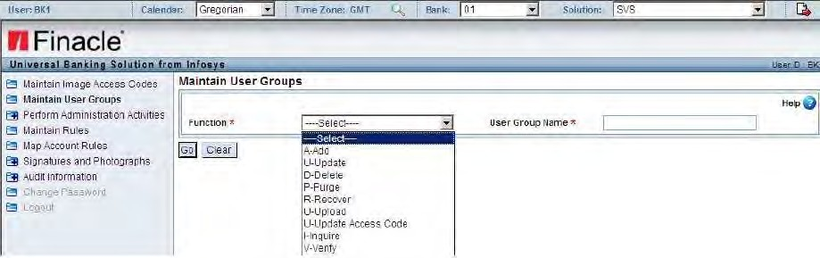

Enter a unique name for the user group and a description. You can attach Image Access Codes to the User Groups and unless an image access code is assigned to a user group no user who belongs to that User Group will be able to access the images which have the same image access code. Each User Group can have more than one Image Access Codes. Images access codes are the codes which are created in order to restrict a user from viewing a specific signature or photograph.

UPDATING USER GROUP

In the User Group menu, click Update. All the existing user groups along with ids and description are displayed. User is allowed to change the name as well as description of the user group. To update a user group, edit the name/description, check the Update checkbox next to the user group, and click on SUBMIT.

PERFORM ADMINISTRATION ACTIVITIES

Administrative operations can be carried out using the Admin menu. User can assign roles and maintain Application parameter, Session, Users and Account Status. Also User can define the Verify option for all the menu options.

MAINTAIN ROLES

**Assign Role**

This option can be used to assign or remove permissions to the various user groups. The roles are basically the permissions/access rights assigned to various user groups based on their operations. For example a Teller is responsible only to view the signature and he is not associated with creation of users and user groups. So he needs access to menu related to signature like add, update, delete, etc.

In order to assign permissions or define roles select Role under the Admin menu. In the Assign Role screen all the user groups are listed. Select the user group for which youwant to assign permissions.

MAINTAIN USERS

Users in SVS are maintained through the User option.

Under Administration Action, through the maintain User option, we can do the routine user management operations like add, update, delete, purge, recover and upload. The User ID has to be entered along with the UserGroup.

MAINTAIN RULE

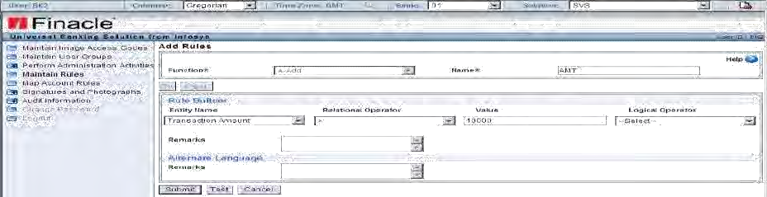Rules are basically conditions defined by an account holder for performing a banking transaction. These rules generally refer to the conditions required for verifying signatures and photographs. For each banking transaction, whenever a signature comes for verification, the operator applies these rules for verifying the signatures and/or photographs

.

MAP ACCOUNT RULES

The rules defined can be mapped to account signatures using the A/C. Signature Map option. An account may be associated with more than one rule, and each rule may be mapped to different sets of signatures. Similarly, signatures can also be mapped to rules associated with customers or employees. From the Rule menu select A/C SignatureMap.

SIGNATURES AND PHOTOGRAPHS MAINTAIN SIGNATURE AND PHOTOGRAPH

SVS supports upload of signatures/ photographs by scanning a new signature/ photograph, upload a file which has already been scanned, selection of signature from other account. Another advantage of this system is it supports upload of signature file of any format like JPEG, TIF, GIF, BMP, etc. So user need not worry about the format of the file.

**Adding a Signature / Photograph: To** add a signature**/ photograph**, go to the

**Signature / photograph** menu and click **Add**. The following screen is displayed.

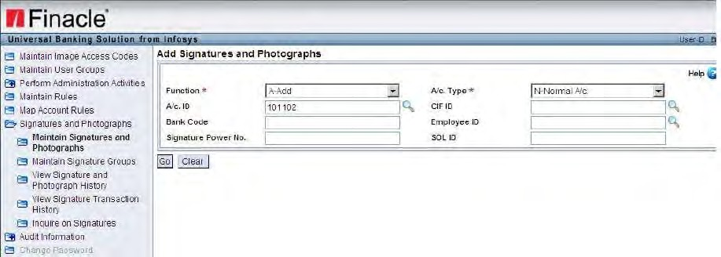

User can add signature in three ways.

1. Scan newly
2. Upload from file that is stored in local hard disk
3. Can be selected from other accounts.

Then image access code is a mandatory field. This must be entered while adding signature as it decides the access given to the user.

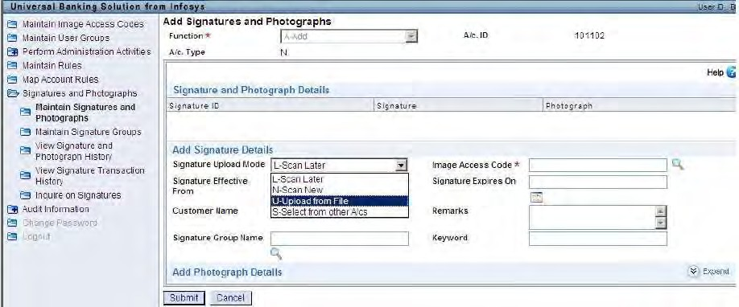

**Signature / Photographs –update /Modify**

After adding signature, if user wants to modify the details of the signature can be done through this menu option. If the user has added only signature and wants to add photograph to that account ID/CIF id can be done through this menu option. User can enter Account Id/CIF ID or select by clicking on the icon. And click on Find to view the existing details.

The Signature details can be updated only when the particular user‟s User group have permission on image access code of that signature. Otherwise the user will not be able to edit the information.

VIEW SIGNATURE TRANSACTION HISTORY

You can know why a particular transaction failed or succeeded, the inputs that were given for the activity, the name of the verifier who verified it and the date on which the activity was carried out through this option. To view the transaction details, from the Signature menu, click Trans History.

Enter Transaction ID or Transaction Date or select by clicking on the calendar icon. Click on SUBMIT to view the transaction details. The A/C ID and Cust. ID associated with the transaction is displayed along with the transaction ID, name of the verifier who verified the signature or photograph and the status of the transaction. Click on PRINT to print the report.

Click on Details icon. You can view the transaction ID, transaction date, CIF ID, account ID, employee ID, image access code, SOL ID, signing power number, credit or debit, transaction amount, status of the transaction whether failed or succeeded and the matched rule ID.

INQUIRE ON SIGNATURE

The signature added to the account can be viewed through this menu option. When a User is inquiring from CORE or any application, it will be displayed as displayed in this menu option.

Select Signature Inquire from Sign maintenance, to invoke this menu. The search can be narrowed down by entering Account ID/CIF ID/ Image access code etc.

## GENERAL LEDGER BALANCE PRINTING

The **General Ledger (GL)**, in a bank is a consolidated position of both customer accounts and internal accounts, grouped according to the bank‟s requirements. Every transaction has a debit phase and a credit phase. Both these are consolidated to arrive atthe consolidated position.

**Scheme Type**: This is a grouping / segregation based on type, nature and behaviour ofaccount. The rule applicable for each group of accounts can be defined at this level and any account opened under this scheme type will be applied with all the rules defined.

**Scheme Code**: This is one set of rules defined by the user on a scheme type for particular behaviour of a group of account. For each scheme type the user can define any number of scheme codes as per the banks requirements.

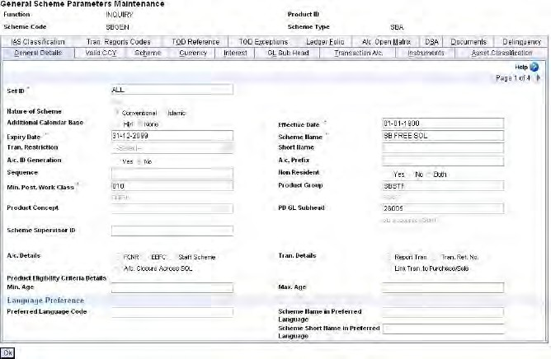There are some menu options for inquiry purpose. MENU : **HGSPI**

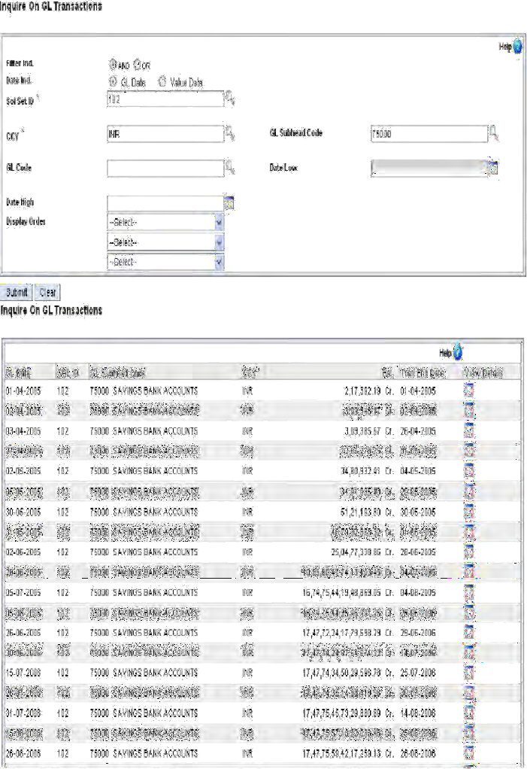MENU : **HIOGLT**

MENU : **HPDB** Generate GL Report.

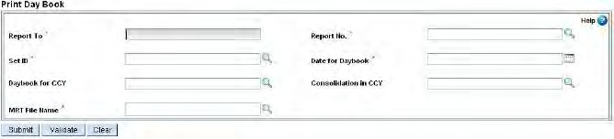

It may be used as a Day Book cum trial balance since this contains opening and closing balances at GL level. The Day Book can be generated for dates earlier than the current date of operation.

## GENERAL INQURIES RELATED TO CUSTOMER / ACCOUNT

|  |  |
| --- | --- |
| MENU RELATED TO CUSTOMER | DESCRIPTION |
| HCUMP | CUSTOMER MASTER PRINT |
| HCUIR | CUSTOMER INTEREST REPORT |
| HCBM | CUSTOMER BECOMING MAJOR |
| HCUSBALP | CUSTOMER BALANCE PRINTING |
| HCIPPRPT | CUSTOMER INTEREST PREF AND PEG REPORT |
| HCUPSD | PORTFOLIO STATEMENT OF CUSTOMER |
| HCUSWP | SWEEP DETAILS OF CUSTOMER |
| HNRDCSR | NON RESIDENT DEPOSIT COMPREHENSIVE SINGLE REPORT |
| HCUSB | SAVINGS ACCOUNTS OF CUSTOMER |
| HCUCA | CURRENT ACCOUNTS OF CUSTOMER |
| HCUOD | OD ACCOUNTS OF CUSTOMER |
| HCUCC | CC ACCOUNTS OF CUSTOMER |
| HMCSR | MULTI CURRENCY POOL STATUS REPORT |
| HCUMAT | INQUIRE ON FORTHCOMING MATURITIES |
| HCUMI | INQUIRE ON MULTI CURRENCY ACCOUNTS |
| HCUDET | INQUIRE ON GENERAL DETAILS OF A CUSTOMER |

|  |  |
| --- | --- |
| MENU RELATED TO SB/CA/OD/CC | DESCRIPTION |
| HACM | CUSTOMER ACCOUNT MAINTENANCE |
| HACLI | ACCOUNT LEDGER INQUIRY |
| HACCBAL | COMPONENTS OF A/C BALANCE INQUIRY |
| HALM | ACCOUNT LIEN MAINTENANCE |
| HACMP | ACCOUNT MASTER PRINT |
| HACS / HACSP | ACCOUNT SELECTION PRINT |
| HACTI | ACCOUNT TURNOVER INQUIRY |
| HACLPCA | CUSTOMER A/C LEDGER PRINT |
| HINQACHQ | INQUIRE A/C NUMBER FOR A GIVEN CHEQUE |
| HAITINQ | INQUIRE AIT TABLE FOR A GIVEN A/C NUMBER |
| HJHOLDER | LIST JOINT HOLDERS/RELATED PARTIES OF AN  A/C |
| HPBP | PASS BOOK PRINTING |
| HPSP | PASS SHEET PRINTING |
| HADVC | PRINT Cr./Dr. ADVICE TO CUSTOMER |
| HABMR | REPORT OF A/Cs BELOW MINIMUM BALANCE |

RECONCILING ISO TRANSACTIONS

The Inter-SOL transactions, which have occurred for the day must be reconciled or squared off before the End-of-Day operations are initiated. The menu option HRIST can be invoked to Square off the pending Inter-SOL Transactions.

**MENU OPTION: HRIST** Reconciliation

OPENING TRANSFER TRANSACTIONS

**MENU OPTION: HOXFT-** Enter the sol id of the sol for which transfer transactionsshould be opened and commit

CLOSING OF TRANSFER TRANSACTION MENU OPTION: CXFT

Close

OPENING OF CASH TRANSACTION:

**MENU OPTION: HOCST-** Enter the sol id of the sol for which cash transaction shouldbe opened and commit

CLOSING OF CASH TRANSACTION: MENU OPTION: HCCST

**EVENTS IN SOL DATE CHANGE AND CLOSURE**

1. HISCOD
2. HSCOD
3. PRESCOD
4. POSTSCOD
5. HSOLCOP
6. HSCOLD

SOL END OF DAY AND BEGIN OF DAY CYCLE

SOL level:

**HISCOD** - Initiate SOL business date change operation

During this a message will be sent out to all logged in users warning them of impending date change for the sol.

**HSCOD** - Sol Change of Operating Date. The menu option HSCOD is used to run all thebatch jobs set up in the HSCOD event

**HSOLCOP** - SOL CLOSURE OPERATION

This menu SOLCOP is Optional step in Sol Date Change Cycle To reduce the load in EOD-BOD or to make the date change period short this functionality has been provided in which user will proceed with date change of SOL then he can run the batch jobs for previous day.

**HSCOLD** - Sol Closure of Last DayConsists of Closure validations, scold batch jobs and Mark sol as closed. There are some pre-requisites in each step to complete the cycle successfully. Before starting of each step all the below mentioned fields should have proper values.

Sol Matrix

Assume SOL is on 10/01/2006 and wants to move to 11/01/2006.

There is dependency between SOL and DC also.SOL can move from 10/01/2006 to 11/01/2006 only when either DC has closed for 09/01/2006 and moved to 10/01/2006.

The date difference between Sol Operating Date and Data Centre Operating Date cannot be greater than 1.

BANK STATUS INQUIRY –HBSI

Inquiry on Bank Status in Finacle is initiated using the menu option HBSI

##### FLASHBACK (DC LEVEL)

As a part of daily operations there are certain operations that need to be carried out during the beginning of day and End of Day. These are termed as EOD/BOD operations.

The EOD processes are executed as under: In case there is only one SOL:

ABH –After business hours

SOLEOD - Service Out Let End of Day

SOLBOD –Service out let beginning of day

In case there are multiple SOLs in the database ABH –After business hours

SOLEOD –Service out let end of day CEOD –Central end of day

CBOD –Central beginning of day

SOLBOD –Service out let beginning of day SCOD: Sol Change of Date

BKOD: Bank Change of Date